Press release

Liebherr mobile crane erects “Ottifant” artwork in Hamburg

⸺
LTM 1230-5.1 from Knaack Krane erects world’s largest mobile work of art
Crowned with “Ottifants”: numerous works by Otto Waalkes were exhibited on the Global Gate in Hamburg
Artist Otto Waalkes as well as art curator Marcus Schäfer were there in person
Covering an area of 2,000 square metres, the Global Gate offers an enormous exhibition platform for artists. Consisting of sea containers arranged in the shape of the Brandenburg Gate, the installation offers artists the opportunity to present their works in a public space. The Global Gate was erected and crowned with four “Ottifants” – cartoon elephants in the comic style of Otto Waalkes – with help from the latest addition to the fleet of Hanseatic crane rental company Knaack – a Liebherr LTM 1230-5.1.
Ehingen (Donau), (Germany), 16 November 2023 – A temporary attraction for Hamburg: The world’s largest mobile work of art – the Global Gate – has found its way to the Hanseatic city on the Elbe. The construction consisting of 37 sea containers has been on display in the port of Hamburg from mid-October until mid-November. With Global Gate, art curator Marcus Schäfer has created a platform to exhibit works beyond the traditional boundaries of galleries and museums. After stops in Dubai and Frankfurt, the containers were presented in the Hanseatic city, under the motto "Hello Hamburg! – Hallo Otto!", to accommodate numerous paintings by German comedian and artist Otto Waalkes. A Liebherr LTM 1230-5.1 mobile crane stacked the containers in the shape of the Brandenburg Gate and placed a quadriga of four “Ottifants”, designed in comic style by Otto Waalkes, on the 20-metre-high installation.
The entire construction, including the installation of the works, took four days. Proximity to the water, uneven ground and strong winds – due to the exposed location directly at the Cruise Center Altona, the construction of the Global Gate required precise logistics and technology. Equipped with 22 tonnes of ballast and a boom that was extended to 48 metres, the crane erected the work of art. The 5-axle crane had itself only been in use for four weeks: “The LTM 1230-5.1 is the perfect addition to our fleet of Liebherr cranes. The mobile crane with its long boom can be used for construction crane assembly in particular,” says Uwe Schulze, crane operator at Knaack Krane.
Stacked, screwed and clad
To ensure the stability of the installation, each of the 3.9-tonne containers was filled with sand and ballasted to a weight of 15 tonnes. In addition, supports with attached water tanks were welded to the containers in the lower row – to ensure the installation would withstand a storm surge. The containers, stacked with centimetre precision, were finally bolted together, and covered with an aluminium frame with a total length of 980 metres, to which the banners with works by Otto Waalkes were mounted. The installation will be on view until mid-November 2023.
About Knaack-Krane and the Hüffermann Group
Knaack-Krane is a crane service provider from Northern Germany that belongs to the Hüffermann Group. With its modern fleet, it operates as a full-service provider for crane and heavy-duty logistic services. Customers benefit from being able to obtain all services from a single source. Projects and major construction sites are carried out throughout Germany and Europe. In addition to modern mobile and crawler cranes as well as tower cranes from Liebherr, loader cranes, working platforms, heavy-duty assembly and project engineering is offered. In addition to heavy-duty transports and transport logistics SPMT (self-propelled modular transporter) and lifting systems are provided from a single source. Various rental equipment such as trailer cranes, mini cranes and glass mounting equipment, a comprehensive approval service and all topics related to construction site security and traffic technology round off the offer.
About Liebherr-Werk Ehingen GmbH
Liebherr-Werk Ehingen GmbH is a leading manufacturer of mobile and crawler cranes. Its range of mobile cranes extends from 2-axle 35 tonne cranes to heavy duty cranes with a lifting capacity of 1200 tonnes and a 9-axle chassis. Its lattice boom cranes on mobile or crawler travel gear deliver lifting capacities of up to 3000 tonnes. With universal boom systems and extensive additional equipment, they can be seen in action on construction sites throughout the world. The Ehingen site has a workforce of 4,300. An extensive, global service network guarantees the high availability of Liebherr mobile and crawler cranes. In 2022, the Liebherr plant in Ehingen recorded a turnover of 2.37 billion euros.
About the Liebherr Group
The Liebherr Group is a family-run technology company with a widely diversified product range. The company is one of the largest manufacturers of construction machines in the world. However, it also supplies high quality, user-focused products and services in many other sectors. The group currently comprises more than 140 companies based in every continent of the world. In 2022, it had a workforce of over 50,000 and recorded a consolidated total turnover of more than 12.5 billion euros. The company was founded in 1949 in Kirchdorf an der Iller in southern Germany. Since then, its aim has been to win customers by supplying high quality solutions and to contribute to technological progress.
Images
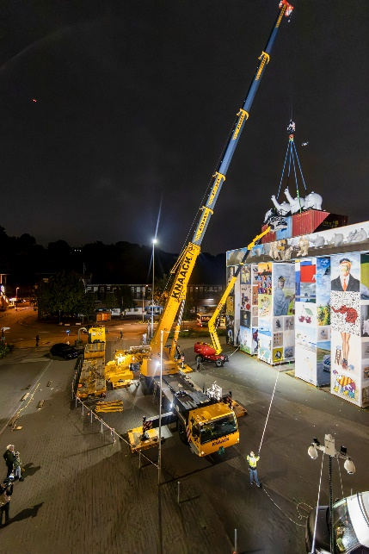
liebherr-knaack-ltm-1230-5-1-nacht.jpg
Crowned with four Ottifants: The Global Gate is the world’s largest mobile work of art.
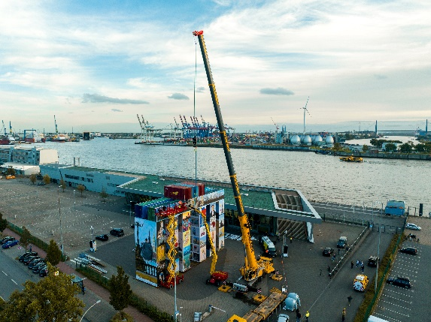
liebherr-knaack-ltm-1230-5-1-tag.jpg
Built with an LTM 1230-5.1 belonging to the crane rental company Knaack Krane: the Global Gate in Hamburg.

liebherr-knaack-ltm-1230-5-1-otto.jpg
East Frisian comedian and artist Otto Waalkes (left) and art curator Marcus Schäfer (right) supervised construction of the Global Gate in Hamburg.
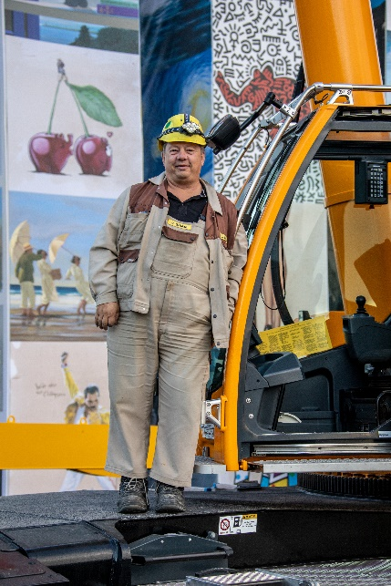
liebherr-knaack-ltm-1230-5-1-fahrer.jpg
After the lift: Crane driver Uwe Schulz from Knaack-Krane next to the LTM 1230-5.1 in Hamburg.

Contact
Berenike Nordmann
Marketing and Communication
Phone: +49 7391 / 502 - 0
Email: berenike.nordmann@liebherr.com
Published by
Liebherr-Werk Ehingen GmbH
Ehingen (Donau) / Germany
www.liebherr.com

