Press release

Closing the gap in Leipzig: Richter takes delivery of a Liebherr LTM 1250-5.1 mobile crane
⸺
LTM 1250-5.1 fills a gap in Richter's crane fleet
Its high load capacity and powerful hydraulic lattice jib tipped the balance
All of the company's mobile cranes are from Liebherr

Richter Kran und Schwerlast GmbH has taken delivery of a new Liebherr LTM 1250-5.1 mobile crane. The 5-axle vehicle sits between an LTM 1160-5.2 and an LTM 1450-8.1 in the Leipzig-based company's fleet. High lifting capacities and a powerful hydraulically adjustable lattice jib were the deciding factors in favour of the LTM 1250-5.1.
Ehingen (Donau) (Germany), 15 November 2023 – Company founder and owner Matthias Richter personally attended the handover of the LTM 1250-5.1 at the Liebherr manufacturing plant in Ehingen. "The LTM 1250-5.1 closes the gap between our LTM 1160-5.2 and our LTM 1450-8.1. We can now offer a crane in every segment. We deliberately opted for the 250-tonne crane because it's very powerful and also has a very powerful hydraulically adjustable lattice jib, ideal for erecting electricity pylons, for example."
The LTM 1250-5.1 is based on the concept of extracting the maximum lifting capacity from the available weight of a 5-axle mobile crane. VarioBallast® enables it to deliver maximum lifting capacities with a large ballast radius, making it perfect for use on constricted sites with a small ballast radius. And it achieves this by quickly adjusting the ballast in seconds.
All ten mobile cranes at Richter Kran und Schwerlast GmbH are from Liebherr. "We are very satisfied with the cranes and we appreciate their standardised controls. This allows us to deploy our crane drivers flexibly on all crane types, from 50-tonne to 750-tonne models. Innovative technology supports us on the construction site. For example, we now order the pulley head camera with all cranes. This system improves visibility and therefore precision during assembly and safety during use. We simply feel well looked after by Liebherr," says Richter.

From building materials transport to full-service provider
Matthias Richter founded the company in 2007 as a "one-man business" in Grimma with a lorry-mounted loading crane. More and bigger cranes were soon added. Initially, the company focussed on transporting building materials. In 2016, Richter purchased its first Liebherr crane, an LTF 1060-4.1 telescopic truck-mounted crane: "We use this crane throughout Germany to construct the foundations for wind turbines, for example to lift formwork. Our loading cranes were not sufficient for that."
More Liebherr cranes followed in the form of an LTM 1070-4.2 and an LTM 1090-4.2. In 2019, Richter, which had around 20 employees at the time, moved into new company premises in Leipzig. Today, the company employs 55 people and offers transport and crane work as a complete package.
The number and size of its Liebherr mobile cranes has continued to increase over the years. Used cranes were also on Richter's shopping list: in 2021, the company took delivery of the very first crane delivered from the new Liebherr repair centre in Ehingen-Berg, an LTM 1160-5.2. More cranes followed, including an LTM 1450-8.1 and an LTM 1750-9.1. "We picked it up from Sicily. It's now our largest crane and is very busy – tower crane assembly, bridge construction, repairs to wind turbines, dismantling old turbines and, when building new turbines, it assembles the lower concrete segments of the wind turbine towers," explains Richter.

About Liebherr-Werk Ehingen GmbH
Liebherr-Werk Ehingen GmbH is a leading manufacturer of mobile and crawler cranes. Its range of mobile cranes extends from 2-axle 35 tonne cranes to heavy duty cranes with a lifting capacity of 1200 tonnes and a 9-axle chassis. Its lattice boom cranes on mobile or crawler travel gear deliver lifting capacities of up to 3000 tonnes. With universal boom systems and extensive additional equipment, they can be seen in action on construction sites throughout the world. The Ehingen site has a workforce of 4,300. An extensive, global service network guarantees the high availability of Liebherr mobile and crawler cranes. In 2022, the Liebherr plant in Ehingen recorded a turnover of 2.37 billion euros.
About the Liebherr Group
The Liebherr Group is a family-run technology company with a widely diversified product range. The company is one of the largest manufacturers of construction machines in the world. However, it also supplies high quality, user-focused products and services in many other sectors. The group currently comprises more than 140 companies based in every continent of the world. In 2022, it had a workforce of over 50,000 and recorded a consolidated total turnover of more than 12.5 billion euros. The company was founded in 1949 in Kirchdorf an der Iller in southern Germany. Since then, its aim has been to win customers by supplying high quality solutions and to contribute to technological progress.

Image
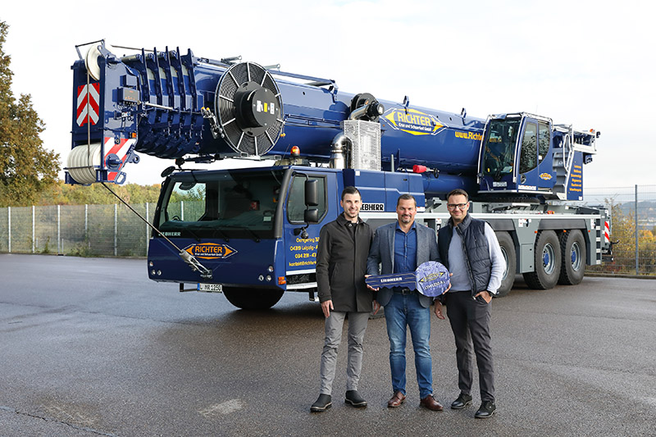
liebherr-ltm1250-5.1-richter-handover.jpg
Company owner Matthias Richter (centre) collects the LTM 1250-5.1 from Liebherr in Ehingen together with Martin Krusche, Head of the Crane Department (right), and Anton Pätzold, Head of Transport.
Contact
Wolfgang Beringer
Marketing and Communication
Phone: +49 7391/502 - 3663
Email: wolfgang.beringer@liebherr.com
Published by
Liebherr-Werk Ehingen GmbH
Ehingen (Donau) / Germany
www.liebherr.com

