Press release

Wasel modernises its crane fleet with innovative and powerful Liebherr cranes
⸺
An LTM 1110-5.2 with the LICCON3 control system and an LTM 1750-9.1 joined its fleet in October
An LTM 1100-5.3 and an electrically driven LTC 1050-3.1E will soon join them
WASEL expands its fleet with three LR 11000s in two years

WASEL GmbH continues to modernise its crane fleet with Liebherr mobile and crawler cranes. The subsidiary of the Hagedorn Group recently took delivery of an LTM 1750-9.1 and an LTM 1110-5.2. Deliveries of an LTM 1100-5.3 and an LTC 1050-3.1E, a compact crane with an additional electric crane drive, are imminent. WASEL has already signed the order for its third LR 11000 crawler crane. In addition to performance, both innovation and sustainability are the focus of its fleet upgrade programme.
Ehingen (Donau) (Germany), October 2023 – In October, WASEL GmbH took delivery of one of the first LTM 1110-5.2s delivered by Liebherr with the new Liebherr LICCON3 control system. The second type with the new control system, the LTM 1100-5.3 (presented at Bauma 2022) will be delivered to the Bergheim-based company very soon. Managing Director Matthias Wasel explained: "Wasel was and remains a pioneer of new technologies. We can't afford to ignore innovations, because they ultimately move our industry forward. Control technology plays an important role in this. Especially if the basis for future developments is laid in the process."
WASEL was also among the first companies to place an order for Liebherr's first electrically driven mobile crane, the LTC 1050-3.1E. "Alongside occupational safety, sustainability is one of our main goals and is also increasingly demanded by our customers. The electric version of the compact Liebherr 50-tonne crane is an important step for us in this respect." During crane operation, either the combustion engine or electric motor can be flexibly selected depending on the operating conditions. The newly developed power unit featuring an electric motor develops 72 kW and therefore enables the crane to be operated without restriction, in other words with almost the same performance as using the 6-cylinder engine. Only the electric motor and a distributor gear as well as the required control equipment was added to the conventional LTC 1050-3.1 model to transform it into an electric version.
"We already have twelve LTC cranes in use and work with them a lot indoors, where the issue of exhaust fumes and noise is becoming increasingly important. We also plan to use the LTC 1050-3.1E for indoor jobs, especially for set-up and dismantling work at trade fairs," says Wasel.
WASEL also relies on Liebherr whenever it needs large and extremely powerful cranes. Its LTM 1750-9.1 was procured for a long-term project for one of WASEL's customers. Developments in the wind power sector heavily influenced the company's decision to acquire another LR 11000 crawler crane. Matthias Wasel explains: "As the wind turbines get bigger, we are seeing a growing need for crawler cranes in the 1,000-tonne class. For this reason, we are expanding our fleet with three LR 11000s within two years. And our investments in modern mobile and crawler cranes will continue in 2024 – despite rising interest rates and cost increases. 20 new Liebherr cranes are already scheduled."
About WASEL GmbH
WASEL GmbH, with its headquarters in Bergheim in the Rhineland and ten other locations in North Rhine-Westphalia and Berlin, offers complete services for heavy load logistics. WASEL GmbH is also a Liebherr factory dealer for tower cranes. For over seven decades, the name WASEL has been associated with sophisticated project planning, innovative technology and consistent safety thinking.
Today, the company has an equipment and vehicle fleet of over 700 units: Mobile, lattice and crawler cranes of the latest design, heavy-duty vehicles and tower cranes. With more than 400 specialists, WASEL GmbH solves the demanding tasks for customers from industry, petrochemistry and many other areas of the economy.
About the Hagedorn Group of Companies
The Hagedorn Group is Germany's most efficient all-round service provider in the fields of demolition, waste disposal, civil engineering and land revitalisation. The Group's process chain also includes the remediation of contaminated sites, recycling and material flow management, the creation of industrial outdoor facilities and the development of new utilisation concepts. Since the merger with WASEL GmbH in July 2021, heavy load logistics and crane services have supplemented the portfolio. The family business headed by Barbara and Thomas Hagedorn achieved a turnover of over 440 million euros in the 2022 financial year. This makes the company – founded in 1997 by Thomas Hagedorn – one of the top 4 largest and most successful demolition companies in the world with over 2,000 employees. In addition to the headquarters in Gütersloh, Hagedorn is now active throughout Germany with additional locations.

About Liebherr-Werk Ehingen GmbH
Liebherr-Werk Ehingen GmbH is a leading manufacturer of mobile and crawler cranes. Its range of mobile cranes extends from 2-axle 35 tonne cranes to heavy duty cranes with a lifting capacity of 1200 tonnes and a 9-axle chassis. Its lattice boom cranes on mobile or crawler travel gear deliver lifting capacities of up to 3000 tonnes. With universal boom systems and extensive additional equipment, they can be seen in action on construction sites throughout the world. The Ehingen site has a workforce of 4,300. An extensive, global service network guarantees the high availability of Liebherr mobile and crawler cranes. In 2022, the Liebherr plant in Ehingen recorded a turnover of 2.37 billion euros.
About the Liebherr Group
The Liebherr Group is a family-run technology company with a widely diversified product range. The company is one of the largest manufacturers of construction machines in the world. However, it also supplies high quality, user-focused products and services in many other sectors. The group currently comprises more than 140 companies based in every continent of the world. In 2022, it had a workforce of over 50,000 and recorded a consolidated total turnover of more than 12.5 billion euros. The company was founded in 1949 in Kirchdorf an der Iller in southern Germany. Since then, its aim has been to win customers by supplying high quality solutions and to contribute to technological progress.

Image
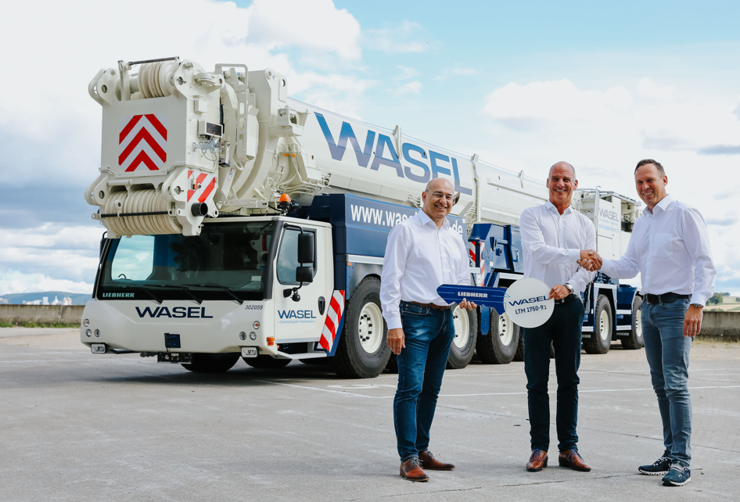
liebherr-ltm1750-9.1-wasel.jpg
Crane handover in Ehingen (from left to right): Erich Schneider (Liebherr-Werk Ehingen GmbH), Matthias Wasel (WASEL GmbH), Dieter Walz (Liebherr-Werk Ehingen GmbH)
Contact
Wolfgang Beringer
Marketing and Communication
Phone: +49 7391/502 - 3663
Email: wolfgang.beringer@liebherr.com
Published by
Liebherr-Werk Ehingen GmbH
Ehingen (Donau) / Germany
www.liebherr.com

