Press release

A Liebherr LTM 1120-4.1 heads to Saudi Arabia: RISAL invests in a used crane

⸺
RISAL relies on a young used crane equipped with modern technology
The Liebherr LTM 1120-4.1 is the most powerful 4-axle mobile crane on the market
Saudi Liebherr Company Ltd. offers reliable customer service for new and used Liebherr cranes
The Saudi Arabian company RISAL has taken delivery of a used Liebherr mobile crane: the LTM 1120-4.1, built in 2022, represents the start of a long-standing partnership. The 120-tonne crane is the most powerful 4-axle mobile crane on the market and also has the longest telescopic boom in its class. At RISAL, the Liebherr LTM 1120-4.1 will be used for loading work.
Ehingen (Donau) (Germany), 2 November 2023 – The young LTM 1120-4.1 is a used crane and the first mobile crane to join the fleet at Rawabi industrial services (RISAL). The modern crane is optimally equipped with Liebherr's innovative technologies such as VarioBase® and VarioBallast®. Mr. Mahmoud Mansy, Supply Chain Manager at RISAL explained: “We chose this crane because it matches our requirements perfectly in terms of lifting capacity and boom length. It is exceptionally powerful, has a long telescopic boom and can be used flexibly. We were also looking for a young used vehicle with a low number of hours of use. And that's exactly what we found at Liebherr.”
The LTM 1120-4.2 is from 2022 and was previously used in Germany. Together with Saudi Liebherr Company Ltd. and in consultation with the used crane experts based at the manufacturer's plant in Ehingen, RISAL decided to have some minor maintenance and servicing work carried out on the crane. Following its adaptation to the country-specific requirements and thanks to the renowned long-lasting quality of Liebherr mobile cranes, the used crane was nearly a brand-new crane.
The company RISAL, which employs around 1,500 people, offers a full range of industrial and environmental services. These include, for example, a wide range of cleaning and waste disposal services. Mr. Mahmoud Mansy reports: “We will use the LTM 1120-4.1 for loading and offloading operations in Saudi Arabia at one of the largest energy and chemical companies in the world. For this, we need reliable equipment. Liebherr mobile cranes have convinced us due to the high quality of their products and their reliable after sales service. We are looking forward to a long-term partnership with Liebherr.”

Reliable service in Saudi Arabia
In Saudi Arabia, the Liebherr Group serves the local market from three locations in Jeddah, Dammam and Riyadh. Saudi Liebherr Company Ltd. ensures a reliable supply of spare parts and offers after-sales and repair services by extensively trained specialists – for both new and used Liebherr cranes.

About Liebherr-Werk Ehingen GmbH
Liebherr-Werk Ehingen GmbH is a leading manufacturer of mobile and crawler cranes. Its range of mobile cranes extends from 2-axle 35 tonne cranes to heavy duty cranes with a lifting capacity of 1200 tonnes and a 9-axle chassis. Its lattice boom cranes on mobile or crawler travel gear deliver lifting capacities of up to 3000 tonnes. With universal boom systems and extensive additional equipment, they can be seen in action on construction sites throughout the world. The Ehingen site has a workforce of 4,300. An extensive, global service network guarantees the high availability of Liebherr mobile and crawler cranes. In 2022, the Liebherr plant in Ehingen recorded a turnover of 2.37 billion euros.
About the Liebherr Group
The Liebherr Group is a family-run technology company with a widely diversified product range. The company is one of the largest manufacturers of construction machines in the world. However, it also supplies high quality, user-focused products and services in many other sectors. The group currently comprises more than 140 companies based in every continent of the world. In 2022, it had a workforce of over 50,000 and recorded a consolidated total turnover of more than 12.5 billion euros. The company was founded in 1949 in Kirchdorf an der Iller in southern Germany. Since then, its aim has been to win customers by supplying high quality solutions and to contribute to technological progress.

Images
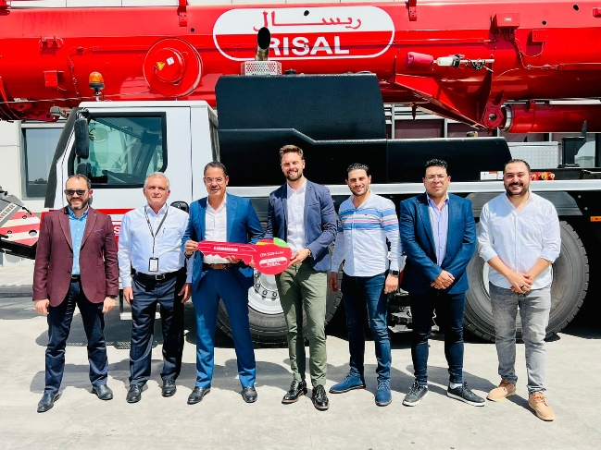
lwe-ltm1120-4-2-risal-1.jpg
from left: Khaled Fahmy (Operation Support Manager, RISAL), Mohammad Fagori (Sales Manager, Saudi Liebherr Co.), Abdullah Alsayed (Managing Director, RISAL), Daniel Tuerkis (Regional Sales Director, Saudi Liebherr Co.), Hany Albarbary (Operation Manager, RISAL), Mahmoud Mansy (Supply Chain Manager, RISAL), Ahmed Ali Soffar (Senior Procurement specialist, RISAL)

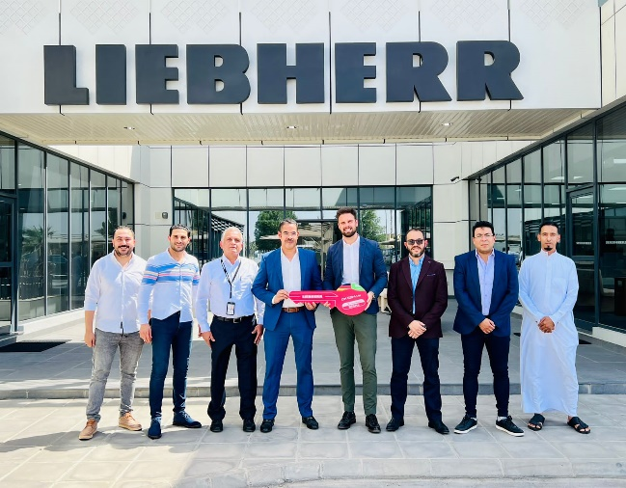
lwe-ltm1120-4-2-risal-2.jpg
from left: Ahmed Ali Soffar (Senior Procurement specialist, RISAL), Hany Albarbary (Operation Manager, RISAL), Mohammad Fagori (Sales Manager, Saudi Liebherr Co.), Abdullah Alsayed (Managing Director, RISAL), Daniel Tuerkis (Regional Sales Director, Saudi Liebherr Co.), Khaled Fahmy (Operation Support Manager, RISAL), Mahmoud Mansy (Supply Chain Manager, RISAL)

Contact
Wolfgang Beringer
Marketing and Communication
Phone: +49 7391/502 - 3663
Email: wolfgang.beringer@liebherr.com
Published by
Liebherr-Werk Ehingen GmbH
Ehingen (Donau) / Germany
www.liebherr.com

