Press release

Revitalizing Chicago one lift at a time

⸺
- Stevenson rebuilds Chicago based Server Farm Data Center with Liebherr mobile crane LTM 1300-6.3
- LTM 1300-6.3 reached all necessary areas from one location
- Stevenson’s entire All Terrain crane fleet is comprised of Liebherr models
Midwest lifting company, Stevenson Crane, Rigging, and Heavy Haul (Stevenson) continue to rebuild Chicago’s industrial areas with their expansive fleet and specialized support equipment. Utilizing Liebherr’s LTM 1300-6.3 mobile crane, Stevenson supported the rebuild of the Server Farm Data Center based out of Chicago, IL. This project required a replacement upgrade of all of the cooling systems including demolition of old structures, new piping, new steel platforms to support added weight, and a variety of updated equipment to better serve the data center. As the project site faced multiple access issues, Stevenson found Liebherr’s LTM 1300-6.3 to be the ideal crane for the job.
Newport News, VA (USA), Liebherr USA, Co., Mobile and Crawler Cranes, October 31st, 2023 – “The Server Farm Data Center had difficult site access issues where the North, South, and East sides were inaccessible due to underground utilities and elevated roadways. Another obstacle of this project were 40 ft. tall power lines running along the sidewalk that we needed to maintain a safe distance from,” noted Stevenson’s Director of Business Operations, Wesley Austin.
Located in a busy industrial park, the data center building is over 112 ft. tall and required a reach of over 110 ft. high. With careful consideration of the surrounding areas, it was important for Stevenson to set up in one location, making the west side the ideal option. “Liebherr’s LTM 1300-6.3 gave us the best option for maintaining an optimal distance off the power lines, while still reaching all the areas needed from one location,” noted Austin. “This crane also did not require a luffer setup which would have been less advantageous for a crane that will have to periodically perform work over the next several months.”
The LTM 1300-6.3 mobile crane is a 300 tonne (360 USt) 6-axle model that can carry a 90 meters (295 ft) telescopic boom on public roads with an axle load of 12 tonnes (26,450 lbs). This crane offers a versatile, economical, and compact option with a peerless telescopic boom length within its class.
Safety comes standard
Each of Stevenson’s projects require immense safety and professionalism for each lift. Greater safety and engineering requirements have pushed the industry towards crane services capable of servicing all the needs and requirements of the project. Liebherr continually equips Stevenson with the tools needed to accomplish this task.
As safety is a top priority with all Liebherr cranes, Liebherr-Werk Ehingen continuously develops new technologies to make further improvements to quality and safety. The focal points of the research extend from materials and design principles to control and monitoring systems.
Due to a high emphasis on safety on Stevenson project sites, the LTM 1300-6.3 mobile crane was an ideal choice as it features all of Liebherr’s latest innovative technologies to ensure safe and powerful crane operations including ECOmode, ECOdrive, VarioBase®Plus, VarioBallast®, Auto-Ballast, single-engine concept and windspeed load charts.
Loyal partners
Founded in 1989 by Donna Stevenson, the crane, rigging, and heavy haul company is Chicago’s first woman-owned crane service. Offering over 2,000 lifts, telehandlers, and support equipment, Stevenson is one of the largest-locally-owned crane service providers in the Midwest supporting over 300 employees. The family-owned company specializes in comprehensive lifts within the commercial, large residential, and heavy industrial markets.
Stevenson also offers additional services including project management, parts and maintenance service, new and used equipment sales, as well as equipment planning and engineering services.
Although Stevenson has a large presence in the mid-west, the company also provides services across the nation. Their expansive fleet is currently equipped with 200 cranes of which all of the all-terrain cranes are Liebherr products. The company currently has 40 Liebherr mobile and crawler cranes within their fleet with many more on the way.
“Stevenson has been a loyal partner with Liebherr for many years,” said Liebherr Regional Sales Manager, Erik Peterson. “They pride themselves on having the most modern fleet of cranes in the industry and they trust in Liebherr to provide that to them. When we introduce a new model of crane to the market, Stevenson is right there with us.”
Stevenson continually chooses to purchase Liebherr cranes due to the dependability of the machines and innovative equipment, new capabilities, and functionality that benefits tight access and tall structures of both urban-area and large plant industrial construction.
“Liebherr has been a steady partner we've been able to depend on for the full range of all-terrain crane needs. Loyalty is earned, and Liebherr continues to demonstrate why our relationship is well placed,” noted Robert Stevenson, Vice President of Stevenson Crane, Rigging, and Heavy Haul.
Stevenson will take delivery of multiple new cranes at the end of 2023 and throughout 2024 at their Bolingbrook and South Holland locations including an additional LTM 1300-6.3 mobile crane.
About Liebherr USA, Co.
Liebherr USA, Co. based in Newport News, VA provides sales and service on behalf of ten different Liebherr product segments: earthmoving, material handling, mining, mobile and crawler cranes, tower cranes, concrete technology, deep foundation machines, maritime cranes; components, and refrigeration and freezing.
About Liebherr-Werk Ehingen GmbH
Liebherr-Werk Ehingen GmbH is a leading manufacturer of mobile and crawler cranes. Its range of mobile cranes extends from 2-axle 35 tonne cranes to heavy duty cranes with a lifting capacity of 1200 tonnes and a 9-axle chassis. Its lattice boom cranes on mobile or crawler travel gear deliver lifting capacities of up to 3000 tonnes. With universal boom systems and extensive additional equipment, they can be seen in action on construction sites throughout the world. The Ehingen site has a workforce of 4,300. An extensive, global service network guarantees the high availability of Liebherr mobile and crawler cranes. In 2022, the Liebherr plant in Ehingen recorded a turnover of 2.37 billion euros.
About the Liebherr Group
The Liebherr Group is a family-run technology company with a widely diversified product range. The company is one of the largest manufacturers of construction machines in the world. However, it also supplies high quality, user-focused products and services in many other sectors. The group currently comprises more than 140 companies based in every continent of the world. In 2022, it had a workforce of over 50,000 and recorded a consolidated total turnover of more than 12.5 billion euros. The company was founded in 1949 in Kirchdorf an der Iller in southern Germany. Since then, its aim has been to win customers by supplying high quality solutions and to contribute to technological progress.

Images
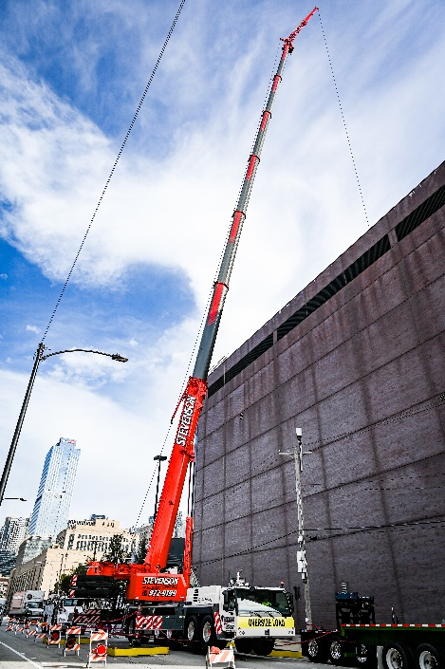
liebherr_Stevenson_1300-6.3_1.jpg
The LTM 1300-6.3 mobile crane is a 300 t (360 USt) 6-axle model that can carry a 90 m (295 ft) telescopic boom on public roads.
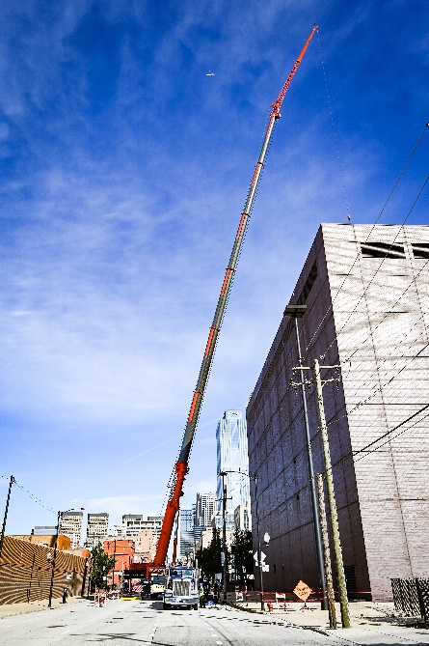
liebherr_Stevenson_1300-6.3_2.jpg
This crane offers a versatile, economical, and compact option with a peerless telescopic boom length within its class.

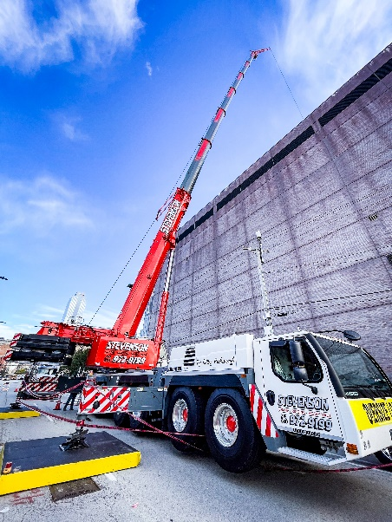
liebherr_Stevenson_1300-6.3_3.jpg
The LTM 1300-6.3 mobile crane features all of Liebherr’s latest innovative technologies to ensure safe and powerful crane operations.

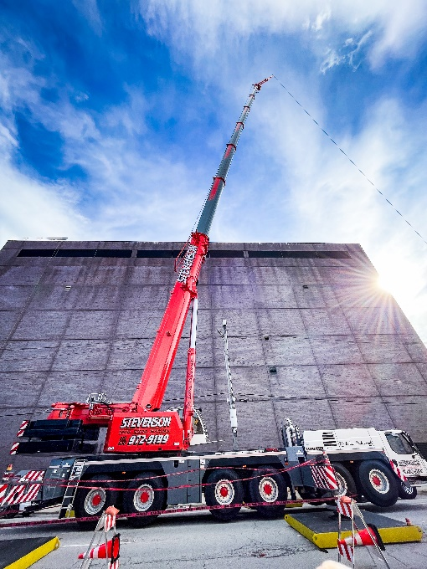
liebherr_Stevenson_1300-6.3_4.jpg
Due to difficult site access, Stevenson utilized the LTM 1300-6.3 from one location on the west side.

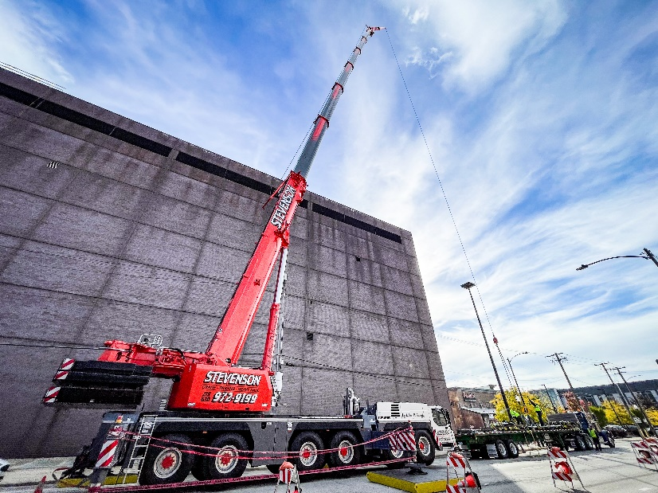
liebherr_Stevenson_1300-6.3_5.jpg
The LTM 1300-6.3 will periodically perform work at this site throughout the end of 2023.
Contact
Ana Cabiedes
Head of Marketing
Liebherr USA, Co
E-Mail: ana.cabiedes@liebherr.com
Published by
Liebherr USA, Co.
Newport News / USA
www.liebherr.com

