Press release

Exceptional performance: Sistermi chooses Liebherr LTM 1250-5.1

⸺
Sistermi invests in LTM 1250-5.1 for industrial assembly and maintenance application
Power, safety and precision are decisive factors for the Liebherr mobile crane

The high reliability, strong lifting capacities and modern technologies of the Liebherr mobile crane were the main factors in the purchase decision of the Brazilian crane contractor Sistermi for the LTM 1250-5.1. The 5-axle crane will be used in chemical, petrochemical, steel, mining and pulp industries, operating in assembly and industrial maintenance.
Guaratinguetá (Brazil), October, 27th 2023 – With more than 40 years of experience in assembly and industrial maintenance, Sistermi Locação de Máquinas e Equipamentos Ltda. has expanded its fleet with the all-terrain crane LTM 1250-5.1. The demand for a more powerful mobile crane with longer boom systems has increased in the rental company's operation area: “We have chosen the 250 tonne model intending to increase the load capacity and lifting height of our equipment in this crane class, meeting the needs of our customers”, explains Juliano Martins, director of Sistermi.
The decision in favour of the Liebherr crane is based on the quality of the products and the reliability of the brand. “Our customers have high expectations when it comes to operational safety. That is why Liebherr cranes are immensely popular with them, as they are equipped with the well-known technologies needed to ensure high safety in operations. In addition, these cranes stand for reliability and high availability, so that deadlines can be met easily”, concludes Martins.
The LTM 1250-5.1 was designed to achieve maximum load capacity with a 5-axle mobile crane. It is equipped with the latest technologies developed by Liebherr, which guarantee safety and adaptability of the crane, such as the VarioBallast®. This system allows a quick change between small ballast radius for constricted job sites and a large ballast radius for maximum lifting capacities. The 250-tonne mobile crane also features the proven VarioBase®, ECOmode and ECOdrive technologies, which makes it even more efficient due to its variable applications.
“The LTM 1250-5.1 is a versatile crane that comes with Liebherr’s unique technologies, ensuring a safe and flexible operation. It is an excellent addition to any fleet: offering unmatched capacities on five axles”, explains Divisional Manager of mobile and crawler cranes at Liebherr Brasil, Rene Porto.

About SISTERMI Locação de Máquinas e Equipamentos Ltda.
Founded in 1979 in Serra/ES – Brazil to meet the growing regional demand for industrial maintenance and cargo handling services, Sistermi has 380 machines in its fleet. The crane contractor operates in significant projects within steel, mining, cellulose, ports and oil & gas industries. The company currently has 560 employees and has branches in Minas Gerais, Espírito Santo, Rio de Janeiro and in the southern region of Bahia.

About Liebherr-Werk Ehingen GmbH
Liebherr-Werk Ehingen GmbH is a leading manufacturer of mobile and crawler cranes. Its range of mobile cranes extends from 2-axle 35 tonne cranes to heavy duty cranes with a lifting capacity of 1200 tonnes and a 9-axle chassis. Its lattice boom cranes on mobile or crawler crane chassis deliver lifting capacities of up to 3000 tonnes. With universal boom systems and extensive additional equipment, they can be seen in action on construction sites throughout the world. The Ehingen site has a workforce of 4,300. Extensive, global service guarantees the high availability of Liebherr mobile and crawler cranes. In 2022, the Liebherr plant in Ehingen recorded a turnover of 2.37 billion euros.
About the Liebherr Group
The Liebherr Group is a family-run technology company with a highly diversified product portfolio. The company is one of the largest construction equipment manufacturers in the world. It also provides high-quality and user-oriented products and services in a wide range of other areas. The Liebherr Group includes over 140 companies across all continents. In 2022, it employed more than 50,000 staff and achieved combined revenues of over 12.5 billion euros. Liebherr was founded in Kirchdorf an der Iller in Southern Germany in 1949. Since then, the employees have been pursuing the goal of achieving continuous technological innovation, and bringing industry-leading solutions to its customers.

Images
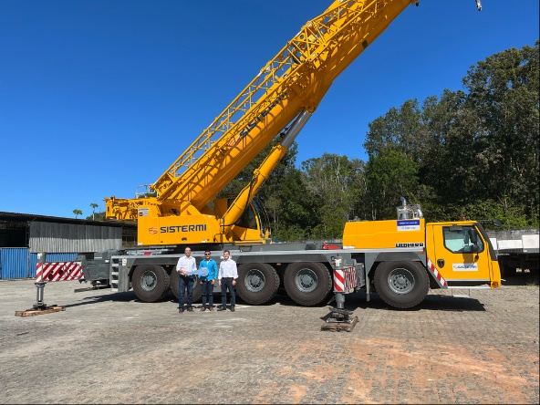
sistermi-ltm1250-5.1-01.jpg
Left to the right: Fabio Azevedo (Liebherr Brasil Ltda), Julio Martins (Sistermi Locação de Máquinas e Equipamentos Ltda.) and Rene Porto (Liebherr Brasil Ltda)

Contact
Tatiana Bielefeld
Marketing
Telefone: +55 12 2131 4640
E-mail: Tatiana.bielefeld@liebherr.com
Published by
Liebherr Brasil Ltda
Guaratinguetá/Brasil
www.liebherr.com

