Press release

First new Liebherr mobile construction crane for Poland

⸺
New MK 88-4.1 goes to Piomar
Taxi crane concept: multiple construction sites possible in one day
Existing Liebherr partnership and quality customer service decisive for purchase
An MK 88-4.1 mobile construction crane is the first new machine from the MK series in Poland. The company Piomar sp. z o.o. owns several mobile cranes built at Liebherr’s Ehingen site and has also decided in favour of Swabian manufacturing for its new taxi crane.
Biberach/Riß (Germany), 29 September 2023 – Łukasz Fuksa, CEO of the Polish lifting company Piomar, came to Biberach/Riß in person to collect the new crane, “We have had some really positive experiences with Liebherr’s Customer Service regarding our mobile crane fleet. Our existing partnership with Liebherr and the crane's parameters proved decisive for us.” The crane will carry out its first lifts at a logistics centre, where roof panels are being fitted.
A wide range of uses
Roof renovations of this kind are a typical area of operation for Liebherr mobile construction cranes. Densely populated inner city environments allow the MK to work to its full potential. Its compact design and luffed position options allow the crane to work close to buildings. The length of its jib is used to maximum effect. A special hybrid power concept supplies the MK with the power it needs. In addition to self-sufficient operation via a diesel generator, the crane can also be operated in electric mode. By using on-site electricity, it is able to operate with zero local emissions and very little noise. This is ideal for residential areas as well as construction sites where work is also carried out at night. If a road closure is necessary, the crane can be used with half-sided support, depending on its operating parameters, which reduces its footprint and therefore the area to be closed off.
Flexible taxi crane
The MK 88-4.1 can lift up to eight tonnes; up to 2,200 kilograms are still possible at maximum radius. It can be operated in different luffed positions: a 45-degree angle enables a hook height of up to approx. 59 metres and a maximum radius of 45 metres. A height-adjustable elevating operator's cab offers a clear view of the load, and smart assistance systems support the crane operator.
Different steering programmes ensure that the MK 88-4.1 fits into any number of construction gaps. Only one person is needed for transport, assembly, and all crane operation. The crane unfolds at the push of a button within just a few minutes, and without the need for any other resources. It can be dismantled again just as quickly and is then ready to set off for its next construction site. This taxi crane concept makes it easy to cover several locations on the same day.
About Piomar
Piomar sp. z o.o. is based in Krakow and has 31 cranes in its fleet. 28 of these are Liebherr mobile cranes from the company's production site in Ehingen. The first mobile construction crane from Liebherr-Werk Biberach GmbH has now joined the fleet. The lifting company engages 450 employees.
About the Liebherr Tower Cranes Division
More than seven decades of experience have made Liebherr a recognised specialist for lifting technology on all types of construction sites. The range of Liebherr Tower Cranes encompasses an extensive selection of high-quality tower cranes that are used worldwide. This includes fast-erecting, top-slewing, luffing jib and special-purpose cranes as well as mobile construction cranes. In addition to these products, Liebherr also offers a wide range of services that complete the company’s portfolio: Tower Crane Solutions, the Tower Crane Center and Tower Crane Customer Service.
About the Liebherr Group
The Liebherr Group is a family-run technology company with a highly diversified product portfolio. The company is one of the world's largest manufacturers of construction machinery. It also offers high-quality, user-oriented products and services in multiple other areas. Today, the group consists of more than 140 companies across all continents. In 2021, it employed more than 49,000 people and achieved combined revenues of over 11.6 billion euros. Liebherr was founded in 1949, in Kirchdorf an der Iller in southern Germany. Ever since then, the company’s employees have been committed to satisfying customers with advanced solutions and to helping drive technological progress.
Image
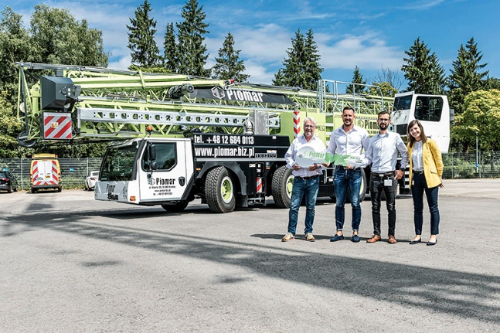

liebherr-handover-mk-88-4-1-piomar.jpg
The first mobile construction crane for Poland was collected in person by Erwin Kloos and Łukasz Fuksa (both Piomar) in Biberach/Riß.

Contact
Astrid Kuzia
Communication Specialist
E-mail: astrid.kuzia@liebherr.com
Published by
Liebherr-Werk Biberach GmbH
Biberach / Germany
www.liebherr.com

