Press release

Liebherr crawler cranes build second largest wind farm in Switzerland

⸺
Emil Egger AG erects six wind turbines in the Swiss Jura Mountains
LR 11000 and LR 1700-1.0 lift loads of over 70 tonnes to a height of 100 metres
“Liebherr crawler crane technology is state of the art".
In an eight-week operation, two Liebherr crawler cranes from Emil Egger AG, based in St. Gallen, Switzerland, have erected the country's second largest wind farm. The six turbines now installed, manufactured by Enercon, are expected to produce 22 million kilowatt hours of electricity annually. An LR 11000 as well as an LR 1700-1.0 have completed the wind turbines, which are almost 140 metres high.
Ehingen (Donau) (Germany), 27 September 2023 – Wind power plays a subordinate role in Switzerland's national energy mix. Only about a quarter of one percent of the country's total electricity production, most of which comes from hydropower, is supplied by the country's 50 wind turbines. Six turbines were erected during the summer months on the Jura mountain range in the canton of Vaud near the border with France. Two modern crawler cranes from Liebherr installed the wind turbines with a total output of 13.8 MWh. With the LR 1700-1.0 as well as the LR 11000, the crane company Emil Egger AG had sent its two most powerful hoisting units to work in the hilly terrain at an altitude of around 1,200 metres.
"The heaviest load cases on this construction site occur during the lifts of the generators. Together with the hook block and slings, I have a gross weight of 71 tonnes hanging from my LR 11000," reported Peter Stricker in the cab of his crawler crane. The crane operator had equipped his machine with a 114-metre-long main boom in order to be able to handle the greatest assembling heights of around 100 metres. With a gross weight of 65 tonnes, the rotors were somewhat lighter, but visually more spectacular than the generator or nacelle. The 40-metre-long rotor blades were mounted to the hub on the ground to form complete blade stars, lifted and installed. With a special device, these huge components could be swivelled into a vertical position during the lifting process.
In parallel with the 1,000-tonne crawler crane, the LR 1700-1.0 completed the erection of other wind turbines a few kilometres away. On the 99-metre main boom, a 12-metre jib angled at ten degrees provided sufficient lifting height.
"Practice-oriented and user-friendly"
"All the crawler cranes in our fleet are from Liebherr," explains Managing Director Michael Egger. In addition to an LR 1250 from the Liebherr factory in Nenzing, Austria, the large load & transport company also operates some of the most powerful cranes in Switzerland with a new LR 1700-1.0 and, most importantly, the LR 11000. "We rely completely on the Liebherr brand for crawler crane technology because these modern machines are extremely practical and user-friendly. The machines are simply 'state of the art'. And Liebherr's service leaves little to be desired - and not just for reasons of physical proximity to the manufacturer. If we have a major problem with our equipment, a mechanic is on site within two hours. And that's worth a lot."
About Liebherr-Werk Ehingen GmbH
Liebherr-Werk Ehingen GmbH is a leading manufacturer of mobile and crawler cranes. Its range of mobile cranes extends from 2-axle 35 tonne cranes to heavy duty cranes with a lifting capacity of 1200 tonnes and a 9-axle chassis. Its lattice boom cranes on mobile or crawler travel gear deliver lifting capacities of up to 3000 tonnes. With universal boom systems and extensive additional equipment, they can be seen in action on construction sites throughout the world. The Ehingen site has a workforce of 4,300. An extensive, global service network guarantees the high availability of Liebherr mobile and crawler cranes. In 2022, the Liebherr plant in Ehingen recorded a turnover of 2.37 billion euros.
About the Liebherr Group
The Liebherr Group is a family-run technology company with a widely diversified product range. The company is one of the largest manufacturers of construction machines in the world. However, it also supplies high quality, user-focused products and services in many other sectors. The group currently comprises more than 140 companies based in every continent of the world. In 2022, it had a workforce of over 50,000 and recorded a consolidated total turnover of more than 12.5 billion euros. The company was founded in 1949 in Kirchdorf an der Iller in southern Germany. Since then, its aim has been to win customers by supplying high quality solutions and to contribute to technological progress.
Images
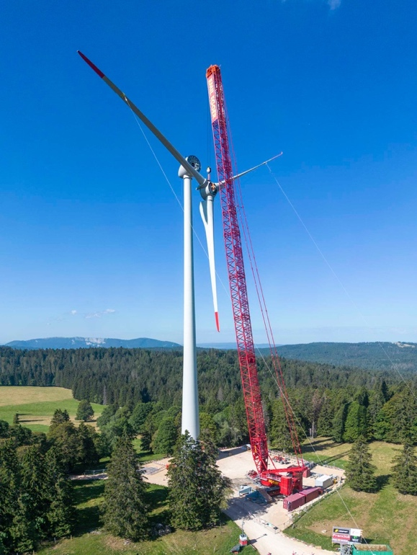
liebherr-lr11000-egger-01.jpg
Emil Egger AG is erecting wind turbines in the Swiss Jura using a Liebherr LR 11000.

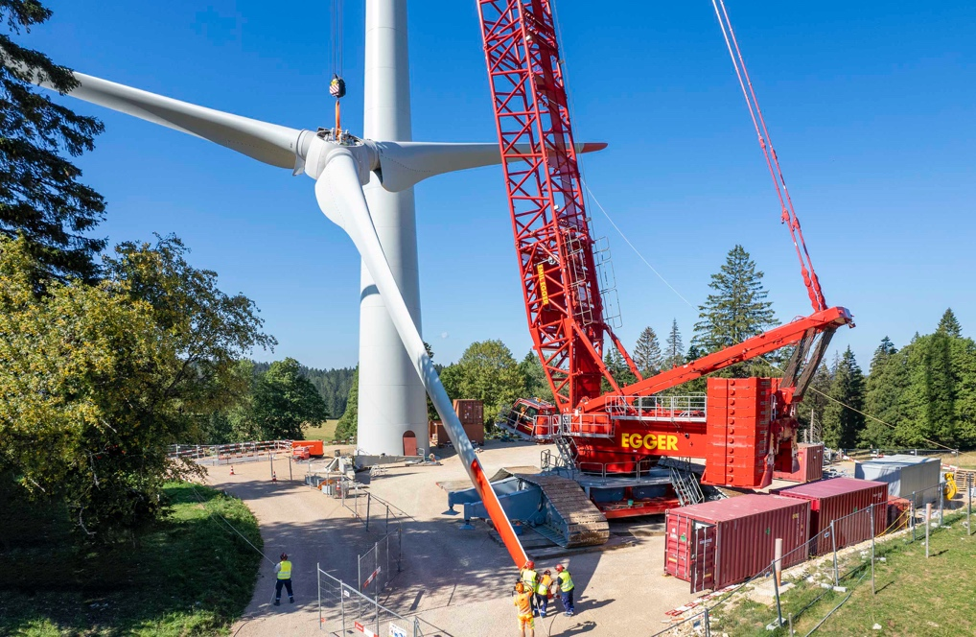
liebherr-lr11000-egger-02.jpg
This ground-mounted rotor star with its 40-metre-long blades is swung into a vertical position here during lifting. The two lateral outriggers on the left of the LR 11000's crawler carrier allow the lattice boom to be raised without using the derrick boom and derrick ballast.

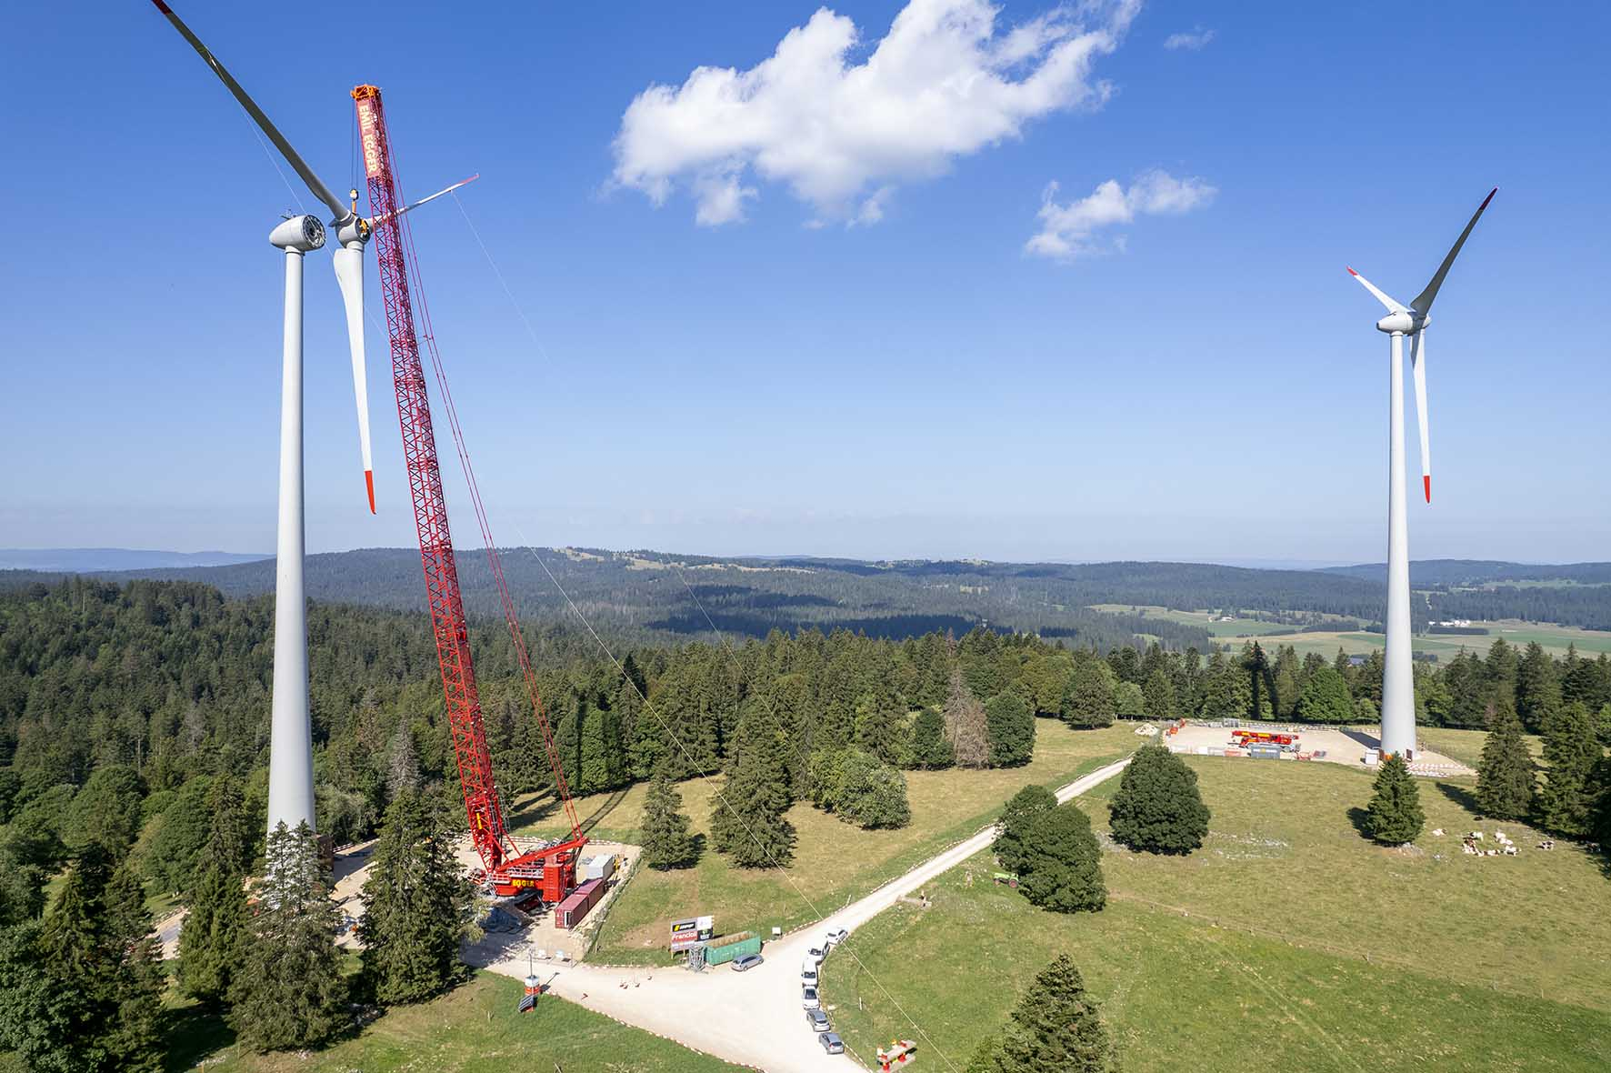
liebherr-lr11000-egger-03.jpg
Here, the LR 11000 lifts 65 tonnes when lifting the rotor star, which had to be attached at a hub height of 98 metres. On the right in the picture, another of the total of six Enercon turbines of the new wind farm.

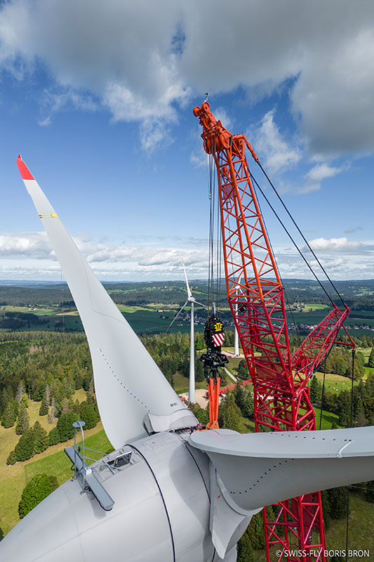
liebherr-lr1700-1-0-egger.jpg
Also present in the Swiss Jura was the latest crawler crane from Emil Egger AG. The Liebherr LR 1700-1.0 was equipped with a 12 metre long F-jib on the construction site.
(Picture: Swissfly)

Contact
Wolfgang Beringer
Marketing and Communication
Phone: +49 7391/502 - 3663
Email: wolfgang.beringer@liebherr.com
Published by
Liebherr-Werk Ehingen GmbH
Ehingen (Donau) / Germany
www.liebherr.com

