Press release

Liebherr LTM 1150-5.3 allows hotel to stay open during construction work

⸺
Liebherr LTM 1150-5.3 mobile crane from Steil-Kranarbeiten is the only crane to master the requirements for a long radius and a small footprint
Thanks to VarioBase® there is enough space left for rescue vehicles
The large telescopic boom and double folding jib bridged the 65-metre distance to the construction site
In Homburg, Saarland, the company Steil Kranarbeiten GmbH & Co KG has made it possible for the Schlossberg Hotel to stay open during construction work at the site by using a Liebherr LTM 1150-5.3 mobile crane. No other mobile crane in the required load class would have been compact enough to achieve this feat. Access to the hotel for guests, suppliers and, above all, emergency vehicles had to be guaranteed at all times.
Ehingen (Donau) (Germany), 22 September 2023 – A required radius of 65 metres, an underground tunnel system and a very compact footprint were the challenges faced by the crane company Steil Kranarbeiten GmbH & Co. KG, based in Trier. At a hotel complex on the Schlossberg in Homburg, considerable amounts of material had to be lifted over the building and moved to its opposite side to construct a 220-square-metre terrace.
However, due to the 17th century tunnels running under the site, it was not possible to position the mobile crane close to the construction site. "With the LTM 1150-5.3, we have exactly the right mobile crane that can meet these requirements with its large radius, while also leaving enough space for hotel guests and delivery vehicles," explains Frank Nicklas, head of Steil's Saarwellingen branch.
Nicklas had carefully planned the job on the Schlossberg in advance. In doing so, he was able to draw on the company's impressive range of vehicles. Steil's yellow-painted fleet comprises around 120 cranes, including mobile and crawler cranes as well as some mobile construction and special cranes. When he first looked over this job with its small set-up area, Frank Nicklas quickly realised that the LTM 1150-5.3, which was based at the company's headquarters in Trier, would be ideal for use on the Schlossberg in Homburg. A check in the LICCON work planner confirmed his assessment. Several weeks later, the Liebherr mobile crane was fighting its way up the steep serpentine road with gradients of up to 15 per cent to the summit of the Schlossberg in Homburg.

With VarioBase®, each crane support can be positioned individually
"Without the options that VarioBase® offers us, we wouldn't have been able to complete the job in this format. No chance," explains the branch manager on site. "We would have had another 160-tonne mobile crane from another manufacturer available, but we couldn't have set it up under these conditions because of the less convenient outriggers." Jörg Schmidt, the driver of the new 5-axle crane, had to extend each of the four outriggers to different lengths to create enough room for cars and delivery trucks to pass through.
With the fixed double folding jib angled at 40 degrees and the 66-metre boom almost fully extended, around 150 lifts were completed over a period of two weeks. Steel girders weighing up to one tonne hung from the crane hook, which were then installed on the other side of the hotel complex. Precise load handling by the crane driver was essential, as most of the construction elements were mounted in a suspended position.
Should another job come along for which the LTM 1150-5.3 is the ideal machine, Frank Nicklas will no longer have to ask his colleagues in Trier for a favour. In September, the crane and heavy load company with 250 employees and locations in Rhineland-Palatinate, Saarland and Luxembourg will take delivery of another crane of this type. And this particular Liebherr mobile crane will then be stationed at the Frank Nicklas branch in Saarwellingen.

About Liebherr-Werk Ehingen GmbH
Liebherr-Werk Ehingen GmbH is a leading manufacturer of mobile and crawler cranes. Its range of mobile cranes extends from 2-axle 35 tonne cranes to heavy duty cranes with a lifting capacity of 1200 tonnes and a 9-axle chassis. Its lattice boom cranes on mobile or crawler travel gear deliver lifting capacities of up to 3000 tonnes. With universal boom systems and extensive additional equipment, they can be seen in action on construction sites throughout the world. The Ehingen site has a workforce of 4,300. An extensive, global service network guarantees the high availability of Liebherr mobile and crawler cranes. In 2022, the Liebherr plant in Ehingen recorded a turnover of 2.37 billion euros.

About the Liebherr Group
The Liebherr Group is a family-run technology company with a widely diversified product range. The company is one of the largest manufacturers of construction machines in the world. However, it also supplies high quality, user-focused products and services in many other sectors. The group currently comprises more than 140 companies based in every continent of the world. In 2022, it had a workforce of over 50,000 and recorded a consolidated total turnover of more than 12.5 billion euros. The company was founded in 1949 in Kirchdorf an der Iller in southern Germany. Since then, its aim has been to win customers by supplying high quality solutions and to contribute to technological progress.

Images
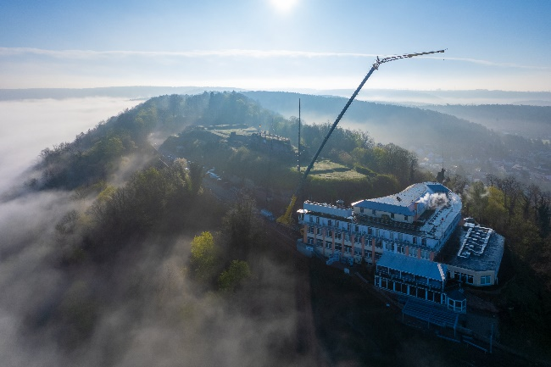
lwe-ltm1150-5-3-steil-01.jpg
Construction work in a fairytale setting: a Liebherr LTM 1150-5.3 from Steil-Kranarbeiten was deployed at the Schlossberg Hotel in Homburg.

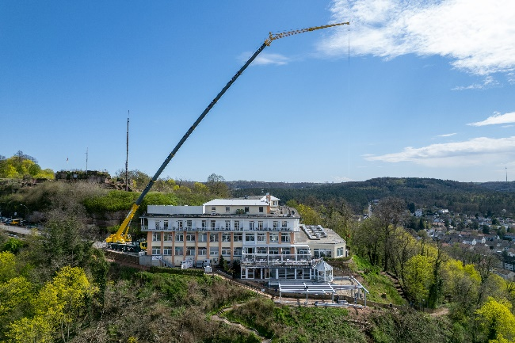
lwe-ltm1150-5-3-steil-02.jpg
The components for the metal structure of the hotel terrace had to be lifted over the considerable distance of 65 metres – the ideal task for the Liebherr LTM 1150-5.3 with its 66-metre telescopic section. The 19-metre-long double folding jib was also used.

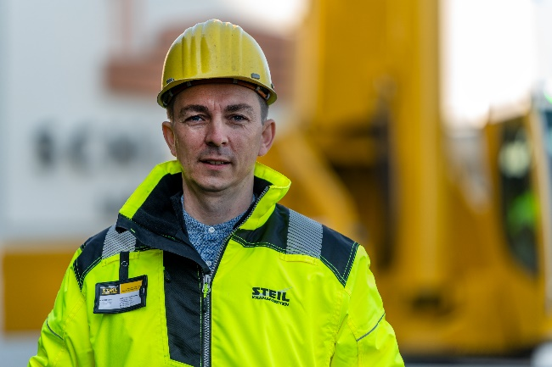
lwe-ltm1150-5-3-steil-03.jpg
"Only with this crane." Frank Nicklas, branch manager of Steil Kranarbeiten in Saarwellingen, planned and was responsible for the job at the Schlossberg Hotel in Homburg.

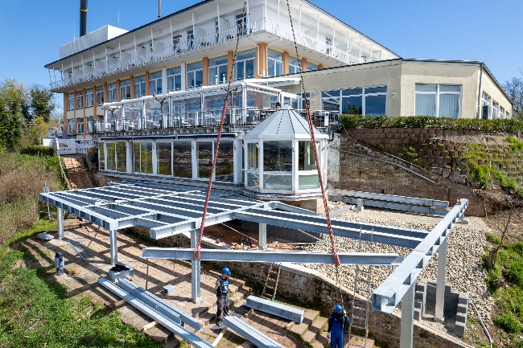
lwe-ltm1150-5-3-steil-04.jpg
The LTM 1150-5.3 was used to move loads weighing up to one tonne to the maximum required distance and position the components for assembly.

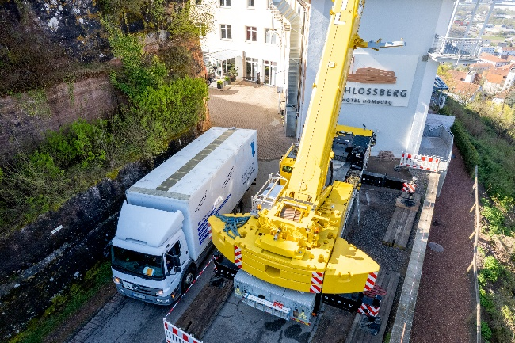
lwe-ltm1150-5-3-steil-05.jpg
Thanks to the VarioBase® crane outriggers, enough space was left to allow access to the hotel.

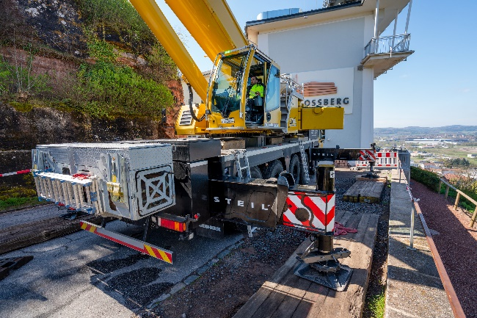
lwe-ltm1150-5-3-steil-06.jpg
Jörg Schmidt positioned each of the crane's outriggers individually and thus made optimal use of the limited space available.

Contact
Wolfgang Beringer
Marketing and Communication
Phone: +49 7391/502 - 3663
Email: wolfgang.beringer@liebherr.com
Published by
Liebherr-Werk Ehingen GmbH
Ehingen (Donau) / Germany
www.liebherr.com

