Press release

Grand Paris Express: Liebherr tower cranes build new train station

⸺
1000 EC-H 40 Litronic cranes in operation
Lifts of up to 35 tonnes completed
New station forms hub for major Grand Paris Express project
The highlight of the new Noisy-Champs train station is a 25-metre high spiral-shaped dome. Two Liebherr 1000 EC-H 40 Litronic tower cranes have played a significant part in constructing both the dome and building. The new station, part of the major French Grand Paris Express project, will form a hub for metro lines in south-eastern Paris. Liebherr machines are at work on 13 sites belonging to the infrastructure project, which aims to improve connections between the centre of Paris and surrounding areas.
Paris (France), 22 September 2023 – The heaviest part weighed 35 tonnes, the lightest 15 tonnes – not a problem at all for the two 1000 EC-H 40s involved. The two high-top cranes were used for structural work on the station building and for roof-related tasks. The cranes' enormous lifting capacities together with sound customer service and the fast availability of spare parts convinced the site operators to rely on Liebherr tower cranes for this particular Grand Paris construction site as well.
Highlight: a dome made from wood, steel and glass
The construction site for Noisy-Champs station encompasses a forecourt, the station building itself and an underground section stretching 250 metres with tracks for parking and turning trains.
The 150-metre-long station building will feature three storeys when the shell is completed later in 2023. A 25-metre-high dome made from wood, steel and glass, supported by twelve steel columns, will form the focal point of the building. The dome’s supporting structure will weigh 450 tonnes in total, while the metal frame of the dome itself will weigh in at 1.5 tonnes. Accordingly, the parts the cranes had to move were both massive and heavy. The prefabricated supports and masts weighed up to 20 tonnes each, the formwork around 30 tonnes. 35-tonne elements were involved during the lifting and placing of metal roof struts, and the metal and wood dome frame sections weighed up to 25 tonnes. The walkway system consists of 24 metal modules that were pre-assembled on the ground and then lifted into position by crane.

Lifts of up to 40 tonnes possible
The 1000 EC-H 40 is capable of lifting up to 40 tonnes; lifts of up to 11.5 tonnes are still possible at maximum radius. The two 1000 EC-H 40 Litronic high-top cranes reached a hook height of 49.43 metres and 35.19 metres respectively. Both machines used the same jib length of 65 metres. The maximum possible hook height for this type of crane stands at 88.4 metres, the maximum radius at 80 metres.
Both cranes are equipped with the LiUP crane driver elevator, which is able to transport two people. The lift provides crane operators and service technicians with an alternative to climbing steps. Once at the top, the ergonomically designed LiCAB cabin promotes fatigue-free working. The high-top cranes also feature the “Micromove” fine positioning system and “Load-Plus”, which enables a load increase of up to 20 %. In-house manufactured high-performance drives, which are both fast and low maintenance, ensure an impressive handling capacity. Getting the crane to site is cost-effective and doesn't require special transport.
Design symbolising the geographical border of two towns
The name Noisy-Champs stems from the location of the station. It’s named after the two towns of Noisy-le-Grand and Champs-sur-Marne, the first to the east and the second to the south-east of Paris. This coming together of the two towns is also reflected in the station’s architecture by way of the dome’s two intertwined spirals. The spirals meet above their geographical border.
Noisy-Champs is one of the 68 new stations included in the Grand Paris Express project. A total of six new metro lines are being built across 200 kilometres. Noisy-Champs will form a hub for lines 15 South and 16 of the Grand Paris Express, above and below the existing “RER A” rapid transit line, at the intersection of the two towns. It is scheduled to open at the end of 2025. The two cranes started work on the site in 2019 and were successfully dismantled in spring 2023.
About the Liebherr Tower Cranes Division
More than seven decades of experience have made Liebherr a recognised specialist for lifting technology on all types of construction sites. The range of Liebherr Tower Cranes encompasses an extensive selection of high-quality tower cranes that are used worldwide. This includes fast-erecting, top-slewing, luffing jib and special-purpose cranes as well as mobile construction cranes. In addition to these products, Liebherr also offers a wide range of services that complete the company’s portfolio: Tower Crane Solutions, the Tower Crane Center and Tower Crane Customer Service.
About the Liebherr Group
The Liebherr Group is a family-run technology company with a highly diversified product portfolio. The company is one of the world's largest manufacturers of construction machinery. It also offers high-quality, user-oriented products and services in multiple other areas. Today, the group consists of more than 140 companies across all continents. In 2022, it employed more than 50,000 people and achieved combined revenues of over 12.5 billion euros. Liebherr was founded in 1949, in Kirchdorf an der Iller in southern Germany. Ever since then, the company’s employees have been committed to satisfying customers with advanced solutions and to helping drive technological progress.

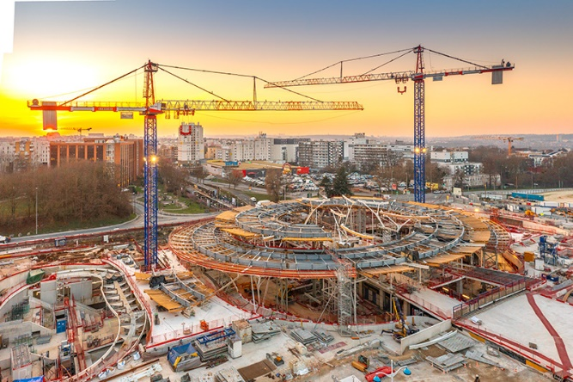
Images

liebherr-1000-ec-h-40-litronic-noisy-champs-01.jpg
The spiral dome of Noisy-Champs station, shown here during construction, measures 25 metres in height.

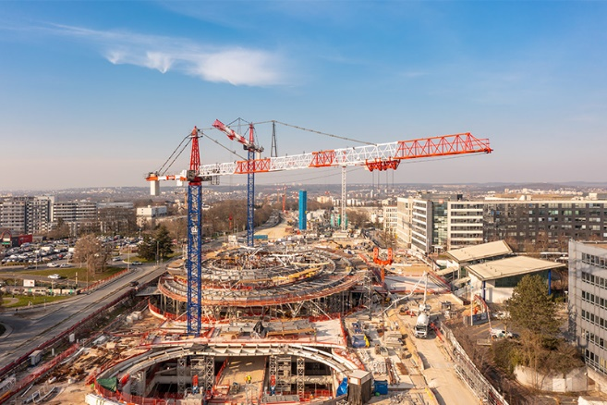

liebherr-1000-ec-h-40-litronic-noisy-champs-02.jpg
The two 1000 EC-H 40s moved parts weighing between 15 and 35 tonnes on site.

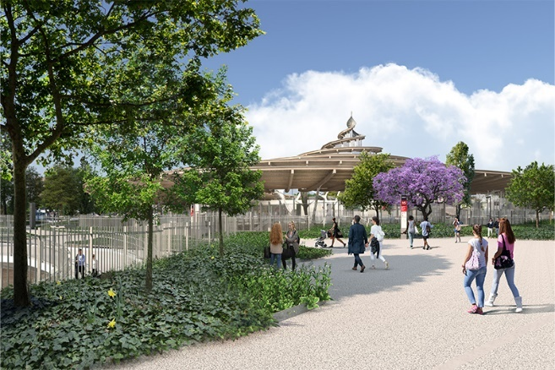

liebherr-1000-ec-h-40-litronic-noisy-champs-03.jpg
The station is set to open in late 2025. The imposing dome made out of wood, steel and glass, will be visible from afar before then. Copyright: Société du Grand Paris

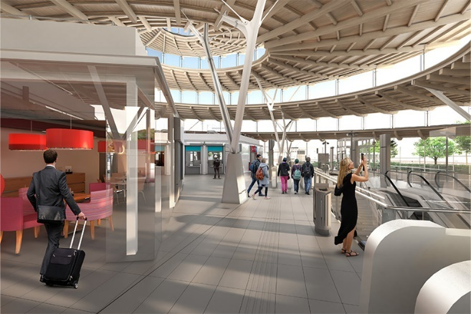

liebherr-1000-ec-h-40-litronic-noisy-champs-04.jpg
The spiral structure symbolises the geographical border between the two towns Noisy-le-Grand and Champs-sur-Marne – it incorporates a spiral for each town. Copyright: Société du Grand Paris

Contact
Astrid Kuzia
Communication Specialist
Email: astrid.kuzia@liebherr.com
Published by
Liebherr-Werk Biberach GmbH
Biberach / Germany
www.liebherr.com

