Press-release

New Liebherr mobile and crawler cranes to expand Milplan fleet

⸺
- First Liebherr cranes for Brazilian company Milplan
- Two new LRT 1100-2.1 and one new LTR 1100
In June, two new Liebherr LRT 1100-2.1 cranes arrived in Brazil. These rough-terrain mobile cranes are part of Milplan’s fleet expansion project. In addition, a new LTR 1100, a 100-tonne class telescopic crawler crane from Liebherr, completes Milplan’s order. These machines will be used for construction operations and electromechanical assembly projects, pipeline construction, maintenance shutdowns in mining, steel, energy, as well as the oil and gas industries.
Guaratinguetá (Brazil), September 9, 2023 – According to Leonardo Mendes, CEO of Milplan, the choice of Liebherr cranes was driven by their quality, advanced technology, and operational safety. “We were looking for versatile and powerful cranes that would bring agility and strength to our operations. That’s why we opted for a telescopic crawler crane and two RT cranes. We aim to provide our customers with maximum availability, quick set-up times, and maximum safety,” says Leonardo. With these three machines, Milplan closes its first deal with Liebherr. Rene Porto, Divisional Manager of mobile and crawler cranes at Liebherr Brasil, is delighted: “For us, it’s a source of pride to deliver these machines to Milplan. We are confident that this is the beginning of a very long-lasting relationship.”
LRT – the safe choice
Liebherr’s rough-terrain cranes, the LRT series, have been developed to provide maximum safety during operations. With Liebherr’s VarioBase® outrigger technology, these cranes can achieve higher load capacities with variable outrigger positions, while loads are constantly monitored to ensure operational safety. The cabin is adjustable, allowing the operator to have the best view of the operation. Liebherr LRT cranes come with comprehensive monitoring systems. Whether during telescoping or counterweight adjustments, the operator has access to indicators that signal the safe operation methods.
“The Liebherr rough terrain cranes have been designed with operational safety in mind. Equipped with tires suitable for challenging terrains and using Liebherr’s telescopic boom technology, the LRT cranes provide a practical, safe, and efficient solution for operations that require mobility and power,” says Porto.

Telescopic crawler cranes
With a capacity of 100 tonnes, the Liebherr LTR 1100 is perfectly suited for assembly and maintenance operations that require quick setup times. It can also transport the lifted load, making operations agile. Liebherr’s LTR cranes combine the advantages of crawler cranes – robustness and high capacities – with those of telescopic cranes – versatility and quick assembly.
“The versatility of an LTR is undeniable. In addition to combining the best features of crawler cranes and telescopic booms, this equipment is particularly easy to transport: its entire design takes into account every possible transportation situation around the world,” says Porto.
Milplan has over 40 years of experience in industrial construction. The company has more than 5,000 employees, twelve construction sites, a fleet of 25 cranes, and over 100 other large-scale equipment. Based in Belo Horizonte (Minas Gerais, Brazil), the company operates throughout Brazil. Currently, Milplan serves major mining companies such as Vale, Anglo American and Hydro; major energy as well as oil and gas companies like Petrobras and Cobra Brasil; and steel mills such as Usiminas and Gerdau.

About Liebherr-Werk Ehingen GmbH
Liebherr-Werk Ehingen GmbH is a leading manufacturer of mobile and crawler cranes. Its range of mobile cranes extends from 2-axle 35 tonne cranes to heavy duty cranes with a lifting capacity of 1200 tonnes and a 9-axle chassis. Its lattice boom cranes on mobile or crawler crane chassis deliver lifting capacities of up to 3000 tonnes. With universal boom systems and extensive additional equipment, they can be seen in action on construction sites throughout the world. The Ehingen site has a workforce of 4,300. Extensive, global service guarantees the high availability of Liebherr mobile and crawler cranes. In 2022, the Liebherr plant in Ehingen recorded a turnover of 2.37 billion euros.
About the Liebherr Group
The Liebherr Group is a family-run technology company with a highly diversified product portfolio. The company is one of the largest construction equipment manufacturers in the world. It also provides high-quality and user-oriented products and services in a wide range of other areas. The Liebherr Group includes over 140 companies across all continents. In 2022, it employed more than 50,000 staff and achieved combined revenues of over 12.5 billion euros. Liebherr was founded in Kirchdorf an der Iller in Southern Germany in 1949. Since then, the employees have been pursuing the goal of achieving continuous technological innovation, and bringing industry-leading solutions to its customers.

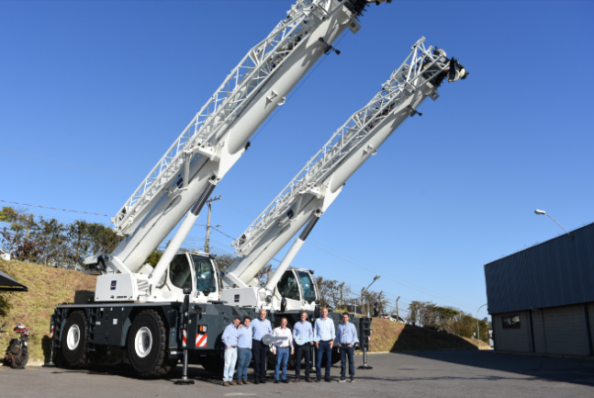
Image

liebherr-milplan-takes-over-lrt1100-2.1
Milplan takes-over two new rough terrain cranes, Liebherr LRT 1100-2.1.
Contact
Tatiana Bielefeld
Marketing
Telefone: +55 12 2131 4640
E-mail: Tatiana.bielefeld@liebherr.com
Published by
Liebherr Brasil Ltda
Guaratinguetá/Brasil
www.liebherr.com

