Press release

Liebherr deploys autonomous haulage fleet for onsite validation

⸺
Liebherr Mining will perform onsite validation of the Liebherr Autonomous Haulage Solution
The autonomous T 264 trucks commenced onsite system validation in Q3, 2023, at a mine site in Western Australia
The Liebherr autonomy project team has expanded to provide onsite support for the full duration of the AHS Validation Program
Colmar (France), 29 August 2023 – Having completed comprehensive internal validation of their Autonomous Haulage Solution (AHS) at Liebherr’s Mining Technology Development Centre in the USA, Liebherr Mining has announced that it has deployed a fleet of four T 264 trucks to support onsite validation. This onsite validation marks a new stage of Liebherr’s strategy to accelerate development of a new autonomy product for the mining industry.
“After significant research, development, and program planning, Liebherr is excited to announce the commencement of onsite Autonomous Haulage Solution validation as we move to deploy the next generation of autonomy technology for mining equipment,” says Scott Bellamy, Divisional General Manager, Product Management, for Liebherr Mining. “This deployment not only represents Liebherr Mining’s market introduction of the AHS, but also highlights Liebherr’s continued expansion as a technology solution provider for the mining industry.”
Full scope of supply: for autonomy with open protocol architecture
Liebherr’s flexible scope of supply solutions provide customers with scalable options – from autonomy ready haul trucks through to the fully integrated Liebherr AHS, also including a fully integrated Fleet Management System.
Liebherr’s philosophy is to provide open architecture solutions, allowing customers the freedom to choose which best-in-class base machines, automation, traffic management, and fleet management systems will work best for their purposes.

On the customers’ site: Long-term support from Liebherr experts
“Along with the first deployment of the autonomy solution, Liebherr has expanded its autonomy project team to include onsite support for the duration of the AHS validation program,” continues Scott Bellamy.
“However, our focus is to ensure the organisation can support in the future not only this exciting project, but also future AHS deployments across multiple customers and regions.”
About the Liebherr Group
The Liebherr Group is a family-run technology company with a highly diversified product portfolio. The company is one of the largest construction equipment manufacturers in the world. It also provides high-quality and user-oriented products and services in a wide range of other areas. The Liebherr Group includes over 140 companies across all continents. In 2022, it employed more than 50,000 staff and achieved combined revenues of over 12.5 billion euros. Liebherr was founded in Kirchdorf an der Iller in Southern Germany in 1949. Since then, the employees have been pursuing the goal of achieving continuous technological innovation and bringing industry-leading solutions to its customers.
Images
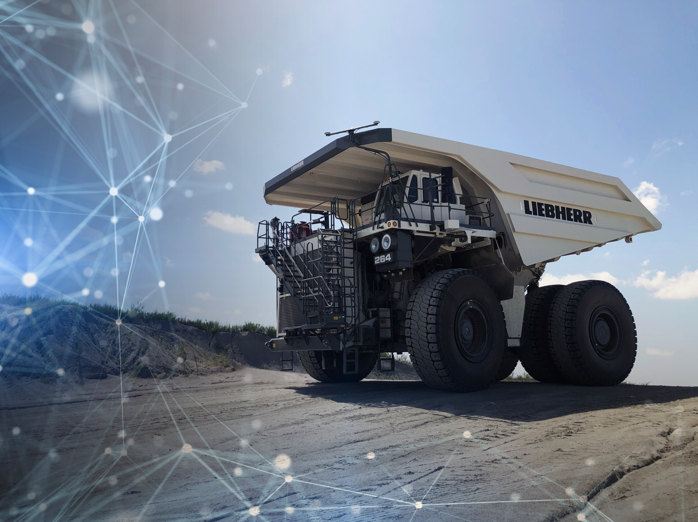
Liebherr_T264_AHS.jpg
Liebherr T 264 Autonomous Haulage Solution.
Contact
Swann Blaise
General Manager Marketing
Mining Division
E-mail: swann.blaise@liebherr.com
Published by
Liebherr-Mining Equipment SAS
Colmar / France
www.liebherr.com

