Press release

After an impressive trial: Rubner Holzindustrie buys the L 580 LogHandler XPower®

⸺
The new model of the Liebherr L 580 LogHandler XPower® showcases impressive innovations of the lift arms and grabber
Significant reduction in fuel consumption and less tyre wear thanks to the power-split XPower travel drive boost which increases productivity and profitability
Versatile and time-saving wood handling due to the new lift arms and larger grabber
The one-of-a-kind Liebherr customer service during the test phase and at the time of purchase made a very favourable impression on Rubner Holzindustrie
With the L 580 LogHandler XPower®, Liebherr offers the timber industry a very special wheel loader. Liebherr has recently revamped this model and has optimised numerous aspects of the wheel loader in the course of the revision, such as the lift arms and the associated grabbers developed for log handling. A model of this latest generation has now been in operation for six months at the family-owned company Rubner Holzindustrie in Rohrbach an der Lafnitz, Austria. First of all, they started with a test operation lasting several months to try out the innovations on the L 580 LogHandler XPower® for the Liebherr plant in Bischofshofen. The Liebherr special wheel loader was so convincing that Rubner Holzindustrie decided to buy it right away.
Rohrbach an der Lafnitz (Austria), 29 August 2023 – A challenging environment where different work had to be carried out was the ideal situation for testing the improvements in the lift arms and grabber. At the timber yard, the Liebherr special wheel loader feeds the logs into the debarking and sorting system, and then transports the logs – grouped by diameter – to the respective storage location. The lift arms, which were specially developed for log handling, feature manipulation heights of up to seven meters and a reach of almost four meters, and offer optimum conditions for rapid material handling. The 360° rotatable grabber with a capacity of up to 4 m² enables versatile and time-saving transportation from the storage location to the company's own sawmill.
L 580 LogHandler XPower® puts on an impressive performance at Rubner Holzindustrie
Rene Karner, Technical Manager at Rubner Holzindustrie, summed up the experience in a very positive way: “This is the first Liebherr wheel loader that we have tested in our sawmill, which meant that the operation was new and somewhat unfamiliar to us at first. However, once we got used to it, we liked the machine so much that we bought it immediately after testing it. We were also particularly impressed by the new grabber and the new lifting arms.”
Rubner Holzindustrie spans a 14-hectare operating area, and the special wheel loader from Liebherr often covers a distance of more than half a kilometre per loading cycle. With the powerful, power-split XPower drive, which Liebherr equips as standard, and a top speed of up to 40 km/h, these handling runs can be carried out very efficiently. The numerous optional assistance systems increase safety on site. These systems include the active rear personnel detection, which warns of dangers in the rear area and automatically reduces speed with its brake assistant as soon as the sensors detect any danger.
“The intuitive and simple handling of the special wheel loader was particularly impressive. The steering-wheel-free operator's cab with easy to operate joystick steering offers sufficient space in the operator's cab and ensures a comfortable working atmosphere,” said Rene Karner. He continued, “When we directly compared this machine with a competitor, we observed fuel savings of about two litres per operating hour. In addition, the hydraulic-mechanical braking effect of the drive results in less tyre wear and virtually no brake wear. These features of the L 580 LogHandler XPower® provide us with significant economic and service advantages in our day-to-day work.”
Liebherr's customer service is a unique selling point
“We have never experienced customer service of this level before,” Karner exclaimed. “A specially trained Liebherr expert taught us how to operate the machine directly at our site and it was the ideal start for us with our new Liebherr L 580 LogHandler. Thanks to this service, all our employees are well trained in handling the new machine, which ensures smooth processes for us and saves time and costs.” And Liebherr not only offers reliable service at the beginning of the business relationship. With its extensive service network, Liebherr Customer Service is reliably on hand should repairs or maintenance be required. Downtimes are thus kept to a minimum for maximum productivity.
About Rubner Holzindustrie
Firmly rooted in the densely forested region around Rohrbach an der Lafnitz in Austria, Rubner Holzindustrie GmbH relies on regional wood from sustainably managed forests. With 130 employees, the company specialises in the production of glulam beams as well as premium-quality solid construction timber. Rubner Holzindustrie is one of 19 subsidiaries of the family-run Rubner Group, headquartered in South Tyrol. The passion to get the best out of the versatile and renewable raw material wood has been driving the company for almost 100 years. This commitment makes the Rubner Group one of the most important timber construction companies in Europe.
About the Liebherr Group
The Liebherr Group is a family-run technology company with a highly diversified product portfolio. The company is one of the largest construction equipment manufacturers in the world. It also provides high-quality and user-oriented products and services in a wide range of other areas. The Liebherr Group includes over 140 companies across all continents. In 2022, it employed more than 50,000 staff and achieved combined revenues of over 12.5 billion euros. Liebherr was founded in Kirchdorf an der Iller in Southern Germany in 1949. Since then, the employees have been pursuing the goal of achieving continuous technological innovation, and bringing industry-leading solutions to its customers.

Images
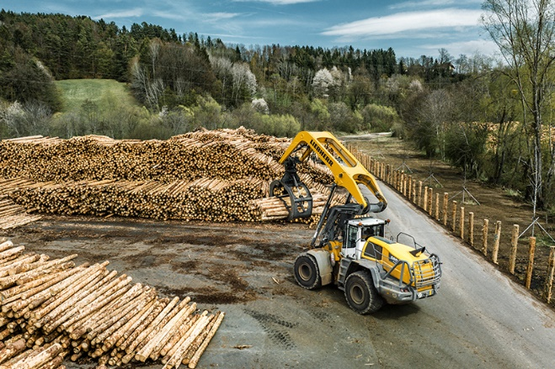
liebherr-l580-loghandler-xpower-rubner-timber-handling.jpg
The powerful L 580 LogHandler XPower wheel loader in operation at Rubner Holzindustrie.

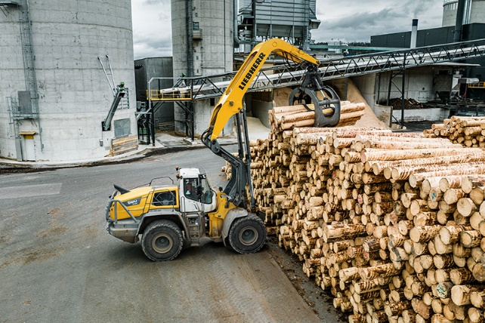
liebherr-l580-loghandler-xpower-rubner-timber-handling-austria.jpg
The special lift arms of the L 580 LogHandler XPower® provide a long reach and are ideal for operating at height.

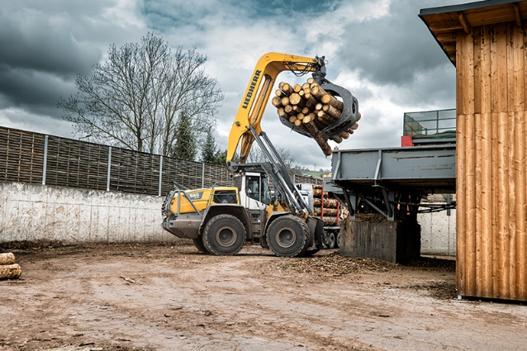
liebherr-l580-loghandler-xpower-rubner-timber-manipulation.jpg
The L 580 LogHandler XPower® loading the sorting train at Rubner Holzindustrie.

Contact
Martin Koller
Marketing and Public Relations
Phone: +43 50809 11475
E-mail: martin.koller.lbh@liebherr.com
Published by
Liebherr-Werk Bischofshofen GmbH
Bischofshofen/Austria
www.liebherr.com

