Press release

Crawler tractors at steinexpo 2023: potential solutions for

boosting efficiency

⸺
Liebherr works ceaselessly on solutions for the crawler tractor sector, also at times of rising pressure on costs, of more stringent requirements on environmental compatibility and of spiralling fuel costs. At the steinexpo 2023 trade fair, the company reveals how its crawler tractor PR 756 achieves compliance with workplace as well as environmental requirements.
Nieder-Ofleiden (Germany), 23 August 2023 – Today, many solutions are available to help boost efficiency on construction sites. The range includes modern assistance systems, alternative drives and even the digital construction site concept. Solutions that can be implemented directly play a role in this, as do medium-term and long-term developments. The PR 756 crawler tractor being exhibited is just one of the ways Liebherr employs to illustrate this point.
Operates efficiently, quietly and with low emissions: the PR 756 crawler tractor
As well as showcasing how remarkably quietly the Liebherr Silent Design can operate, steinexpo also gives Liebherr a platform for demonstrating how its PR 756 crawler tractor is able to achieve even higher fuel efficiency with EcoMode, an upgraded electronically controlled hydrostatic drive. As just one example, this vehicle can already run on HVO (Hydrotreated Vegetable Oil), requiring no modification or conversion to the drive train. Compared to its diesel-powered counterpart, it can then operate straightaway with as much as a 90 % reduction in CO₂ emissions.
Modern assistance systems constitute yet another equipment highlight. These systems extend the site development capability of this highly productive material-moving vehicle and also make it easier to maintain. Sophisticated GPS-based control systems enable these vehicles to perform earthworks and roadbuilding with precise steering and cross slope capability.
High-quality work outcomes achieved with smart assistance systems
These assistance systems also deliver several levels of support to the driver: Free Grade for active shield stabilisation during fine grading and Definition Grade for automatic blade positioning when creating 2D surfaces. This combination of precise drive control and optimised centre of gravity delivers exceptionally high grading speeds as well as extremely precise grading results.
In a direct comparison to modern drive concepts such as the diesel-electric system, many years of experience demonstrate the substantial improvement in efficiency of this generation of hydrostatic drive, in combination with advanced digital technology. Customer feedback indicates that annual cost savings of up to €35,000 can be achieved.
These empirical values are based on data collection using the Liebherr LiDat fleet management portal which can also be accessed on a mobile basis at any time. This portal provides reports of all relevant operational data, updated on a daily basis.
A comprehensive overview featuring a representative range of data is also provided by the Liebherr fuel saving calculator. This facilitates direct comparison with the company’s own fleet.
Enhanced fuel economy and transparent consumption data both help to reduce costs and emission levels. All neatly rounded off by modern assistance systems that enable users to complete challenging tasks to a high standard of quality even faster and more efficiently.
In turn, this significantly reduces the level of stress and associated fatigue of machine operators, enhancing the convenience and efficiency of workplace operations. This is a crucial advantage that really comes into its own with the challenging operations involved in the extractive industry.

About the Liebherr Group

The Liebherr Group is a family-run technology company with a highly diversified product portfolio. The company is one of the largest construction equipment manufacturers in the world. It also provides high-quality and user-oriented products and services in a wide range of other areas. The Liebherr Group includes over 140 companies across all continents. In 2022, it employed more than 50,000 staff and achieved combined revenues of over 12.5 billion euros. Liebherr was founded in Kirchdorf an der Iller in Southern Germany in 1949. Since then, the employees have been pursuing the goal of achieving continuous technological innovation, and bringing industry-leading solutions to its customers.

Pictures
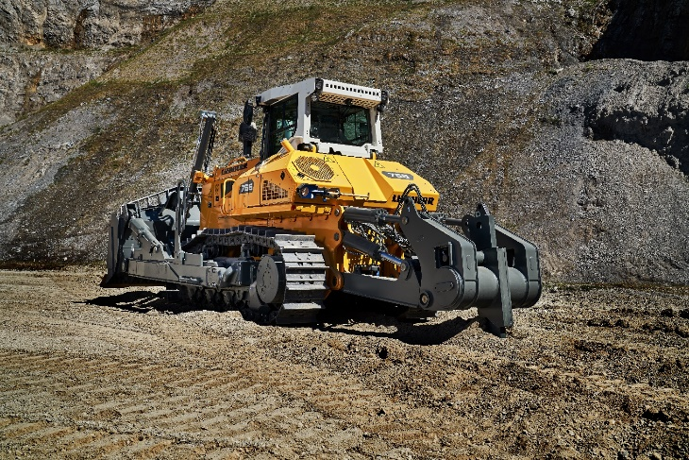
Liebherr-PR-756.jpg
PR 756 crawler tractors really excel in their ability to meet the needs of the extractive industry.

Contact
Lisa Kahlig
Marketing Manager PR & Press
Phone: +43 690 500 644 96
E-Mail: lisa.kahlig@liebherr.com
Published by
Liebherr-Werk Telfs GmbH
Telfs / Austria
www.liebherr.com

