Press release

Treffler strengthens crane fleet with Liebherr LTM 1350-6.1 mobile crane
⸺
Treffler renews fleet and strengthens crane portfolio
Entry into the class of telescopic cranes with boom guying
High lifting capacity of the LTM 1350-6.1 and full equipment offer wide range of applications
Treffler GmbH has taken delivery of a new LTM 1350-6.1 from Liebherr. With the 350-tonner, the Bavarian company strengthens its crane fleet. The new mobile crane replaces an LTM 1300-6.1 and is Treffler's entry into the class of telescopic cranes with boom guying.
Ehingen (Germany), 11 August 2023 – Treffler, a 150-year-old traditional Munich-based company that has been part of the MAXIKraft Group since 2019, is strengthening and renewing its crane fleet with a Liebherr LTM 1350-6.1. Branch manager Matthias Bulisch explains the procurement of the new 6-axle crane: "With the LTM 1350-6.1, we are replacing an LTM 1300-6.1. On the one hand, the investment in the new crane follows our rhythm for fleet renewal, and on the other hand, we are strengthening our portfolio. The new crane has a Y-type telescopic boom guying and is therefore significantly stronger than its predecessor."
LTM 1350-6.1 offers wide range of applications
The LTM 1350-6.1 is Liebherr's entry into the class of telescopic cranes with boom guying system. The spatial Y-guying - both to the rear and to the side - offers significant increases in load capacity, especially when the boom is extended long in a steep position and for jobs with lattice jibs.
"With the new crane, we can take on jobs in the 400-tonne class. We deliberately chose a 6-axle crane because it has advantages in approval processes, compared to 7- to 9-axle cranes," Bulisch said. "We bought the LTM 1350-6.1 fully equipped. This means it can be used for a very wide range of applications, from concrete construction to industrial operations to construction crane assemblies."
Treffler is already more than 150 years old. The company has been in the crane rental business since 1978. In addition to its main office in Munich, Treffler operates a site in Ingolstadt. A majority of the mobile cranes are from Liebherr. Bulisch explains: "Quality, value and service speak for Liebherr. But Liebherr mobile cranes have another important plus point: the same control from the smallest to the largest crane. This allows us to flexibly deploy our operators on different equipment."

About Liebherr-Werk Ehingen GmbH
Liebherr-Werk Ehingen GmbH is a leading manufacturer of mobile and crawler cranes. Its range of mobile cranes extends from 2-axle 35 tonne cranes to heavy duty cranes with a lifting capacity of 1200 tonnes and a 9-axle chassis. Its lattice boom cranes on mobile or crawler crane chassis deliver lifting capacities of up to 3000 tonnes. With universal boom systems and extensive additional equipment, they can be seen in action on construction sites throughout the world. The Ehingen site has a workforce of 4,300. An extensive, global service network guarantees the high availability of Liebherr mobile and crawler cranes. In 2022, the Liebherr plant in Ehingen recorded a turnover of 2.37 billion euros.

About the Liebherr Group

The Liebherr Group is a family-run technology company with a widely diversified product range. The company is one of the largest manufacturers of construction machines in the world. However, it also supplies high quality, user-focused products and services in many other sectors. The group currently comprises more than 140 companies based in every continent of the world. In 2022, it had a workforce of over 50,000 and recorded a consolidated total turnover of more than 12.5 billion euros. The company was founded in 1949 in Kirchdorf an der Iller in southern Germany. Since then, its aim has been to win customers by supplying high quality solutions and to contribute to technological progress.

Image
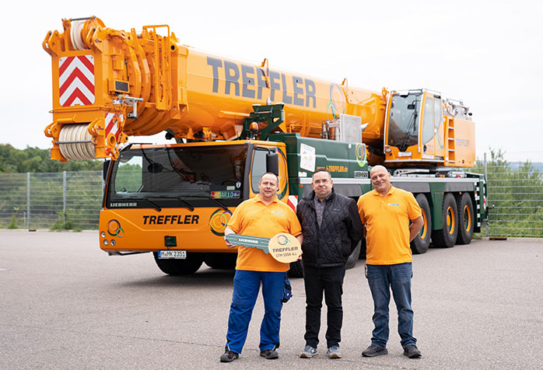
liebherr-ltm1350-6.1-treffler-handover.jpg
Crane handover in Ehingen: Branch manager Matthias Bulisch (center) takes over the new LTM 1350-6.1 with crane operator Mario Fenzel (left) and workshop foreman Darko Kristovic.

Contact
Wolfgang Beringer
Marketing and Communication
Phone: +49 7391/502 - 3663
E-Mail: wolfgang.beringer@liebherr.com
Published by
Liebherr-Werk Ehingen GmbH
Ehingen (Donau) / Germany
www.liebherr.com

