Press release

MyGuide for Earthmoving: new app for Liebherr earthmoving and material handling machines

⸺
Everything at a glance, bundled in one app: all information from the Liebherr earthmoving and material handling machinery product segments – available at any time
Dashboard area: personal watch list and always up to date
Closer to sales: direct contact options and machine configurator
Available now free of charge in the Apple App Store or Google Play Store
Liebherr has launched MyGuide for Earthmoving, a new app specifically aimed at customers and machine operators as well as construction machinery enthusiasts and fans from the earthmoving and material handling industry. The app bundles product information and news from these two segments, allowing users to access the relevant topics quickly, easily and at any time – whether via smartphone or tablet. Among other things, the app offers direct links to sales as well as a personal area that displays the user's favourite products and comparisons as well as Liebherr news.
Kirchdorf an der Iller (Germany), 17 July 2023 – Liebherr developed the new MyGuide for Earthmoving app to make access to the company's earthmoving and material handling product segments even easier and more straightforward for customers, machine operators, people interested in construction machinery and fans. As well as comprehensive information for every target group, the app also offers existing and prospective customers the benefit of being able to make direct contact with Liebherr sales and service partners. Integration of the Liebherr Earthmoving Configurator within the app enables easy operation and means that users can conveniently create, save and manage the configuration of their desired machine via the app.
The MyGuide for Earthmoving app can be downloaded now free of charge from the Apple App Store and Google Play Store for smartphone and tablet mobile devices. It is initially available in Germany, Austria, Switzerland and France.
Always up to date with Liebherr news
A highlight of the MyGuide app is the Liebherr news section, in which press releases and news from both segments are regularly published. From new machines and equipment to application reports and machine handovers as well as topics relating to digitalisation, alternative drives and trade fairs – the range of information available is varied, multi-layered and highly informative. News from Liebherr sales and service partners is also included in the app.
Personal dashboard: individual app area for users
The dashboard is personalised so that the user can view their most recently activity, such as news stories, favourite products and machine comparisons, simply and easily. The dashboard also includes a 'Latest products' section, in which the new machines in the respective product groups are displayed.
Everything at a glance: the entire portfolio of Liebherr earthmoving and material handling machines
In the MyGuide app, users can also obtain comprehensive information about the available product range in their country. In the 'Products' area, all product types are displayed in tile form and with a picture – divided into the earthmoving and material handling categories and sorted by product line. Alternatively, a specific machine model can be searched up.
Each model is presented in the app with pictures of the machine in use, a short description and relevant technical data. In the download area, all brochures and videos related to the machine can be opened, viewed and downloaded to the user's mobile device for later reference.
Product configurator for existing and prospective customers
The MyGuide app is highly beneficial, especially for prospective purchasers and customers, as it offers direct links to sales and thus facilitates access to Liebherr products. For example, the Liebherr Earthmoving Configurator can be used directly via the app to put together a machine tailored to individual requirements. To do this, the user can launch the configurator directly from the 'Products' area for the corresponding machine. Depending on the selected country in the app settings, only the available equipment in that territory is displayed in the corresponding currency. The configurations are then saved locally on the user's device in the 'Configurations' area and can thus be viewed and edited at any time. Configurations with a QR code that have already been created via another medium can be conveniently imported into the MyGuide app by scanning them in via the camera. Once the configuration is complete, a binding offer can be requested from the responsible sales partner.
Closer to sales
The app also enables direct contact to Liebherr sales and service partners. In the 'Partner' area, all contacts are displayed in a list with a map view also available. If the GPS function has been enabled in the settings, the user's own location is also displayed. This is a convenient and quick way to find the nearest sales and service partner. By calling up the corresponding contact, further details appear; the app also allows the user to contact the sales partner directly by phone or email. In addition, the user can save the selected contact directly to their mobile device.
About the Liebherr Group
The Liebherr Group is a family-run technology company with a highly diversified product portfolio. The company is one of the largest construction equipment manufacturers in the world. It also provides high-quality and user-oriented products and services in a wide range of other areas. The Liebherr Group includes over 140 companies across all continents. In 2022, it employed more than 50,000 staff and achieved combined revenues of over 12.5 billion euros. Liebherr was founded in Kirchdorf an der Iller in Southern Germany in 1949. Since then, the employees have been pursuing the goal of achieving continuous technological innovation, and bringing industry-leading solutions to its customers.
Image
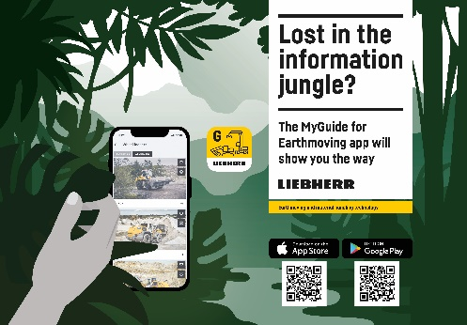
liebherr-myguide-300dpi-en.jpg
The new MyGuide for Earthmoving app bundles all information and news about Liebherr earthmoving and material handling technology in one app.
Contact
Nadine Willburger
Marketing
Phone: +49 7354/80 - 7332
Email: nadine.willburger@liebherr.com
Published by
Liebherr-Hydraulikbagger GmbH
Kirchdorf an der Iller / Germany
www.liebherr.com

