Press release

Over the rooftops of Bratislava: helicopter flies Liebherr crane into city’s old town district

⸺
Liebherr dealer Kranimex assembles a 40 LC tower crane in Slovakia's capital with the help of an MI-8T helicopter
A hard-to-access inner-city construction site with projecting edges and power lines
Smooth assembly thanks to extensive expertise and experienced partners
When a conventional tower crane assembly by mobile crane isn’t possible, Liebherr customers have other options available: in the Slovakian capital of Bratislava, experts from Liebherr dealer Kranimex rose to the challenge by using airlifts. A helicopter transported the 40 LC top-slewing crane into the city centre. The Liebherr machine is set to assist the construction of new apartments there in the coming months.
Bratislava (Slovakia), 6 July 2023 – The 40 LC is at work in the centre of Bratislava. A new build project without direct road access is underway in an up-and-coming area there. To deal with the projecting edges of neighbouring buildings, a normal assembly of the Liebherr crane via mobile crane would have needed a large machine with a minimum lifting capacity of 350 tonnes plus a jib extension.
But the real problem lay in the fact that the 40 LC’s assembly would have necessitated suspension of public transport, with trams running every five minutes, as well as the costly dismantling and subsequent reinstallation of tram power lines. An assembly by helicopter, in collaboration with heavy haulage specialist Tech-Mont, proved to be the right solution for the experts from Liebherr dealer Kranimex. Tech-Mont has more than 25 years of experience in the market.
Helicopter transports heaviest crane part without a problem
The challenging assembly took a total of two days. The MI-8T helicopter used had a maximum lifting capacity of three tonnes. This meant that the helicopter was able to transport even the heaviest crane part, a 2,750-kilogram slewing platform, without a problem. The helicopter picked up the crane components, including tower sections, jib, and counter jib, at a temporary storage location by the Danube and flew them over the city's rooftops to the construction site. Eleven flights were needed to deliver all of the crane parts. Experienced service fitters from Kranimex took delivery of the air-lifted components before assembling the top-slewing crane.
“Strong and reliable teamwork was the key factor for this exceptional assembly,” says Patrik Šeba, service fitter from Liebherr dealer Kranimex. “This was our third assembly with Tech-Mont so we knew we could rely on each other.”
Narrow tower system and foundation anchors
The Liebherr 40 LC crane is working on site with a hook height of 30 metres and a jib measuring just under 25 metres. It offers a maximum lifting capacity of 4,000 kilograms. To save as much space as possible, the crane has been mounted on foundation anchors and the narrow 63 LC tower system, which features external dimensions of just 1.2 x 1.2 metres. The top-slewing crane was built in 2006 and continues to provide reliable service, which is testament to the high quality and durability of Liebherr machines.
It is expected that the crane will continue working on the residential project in the centre of Bratislava until the end of 2023. Its dimensions allow the Liebherr machine to access all parts of the site with ease and to assist with various lifting operations, including the movement of bricks and concrete. Once the crane has finished its work, it will be dismantled by helicopter and flown back over the rooftops of Bratislava.
About Kranimex
Liebherr factory dealer Kranimex has locations in Bratislava and Prague (Czech Republic) and specialises in the sale and rental of Liebherr tower cranes. Through its ongoing acquisition of new equipment, Kranimex guarantees its business partners the highest technical and safety standards, as well as quality and reliability. The company's fleet includes cranes of various sizes and types, including fast-erecting, flat-top and high-top cranes. An extensive range of services completes its portfolio.
About the Liebherr Tower Cranes Division
More than seven decades of experience have made Liebherr a recognised specialist for lifting technology on all types of construction sites. The range of Liebherr Tower Cranes encompasses an extensive selection of high-quality tower cranes that are used worldwide. This includes fast-erecting, top-slewing, luffing jib and special-purpose cranes as well as mobile construction cranes. In addition to these products, Liebherr also offers a wide range of services that complete the company’s portfolio: Tower Crane Solutions, the Tower Crane Center and Tower Crane Customer Service.
About the Liebherr Group
The Liebherr Group is a family-run technology company with a highly diversified product portfolio. The company is one of the world's largest manufacturers of construction machinery. It also offers high-quality, user-oriented products and services in multiple other areas. Today, the group consists of more than 140 companies across all continents. In 2022, it employed more than 50,000 people and achieved combined revenues of over 12.5 billion euros. Liebherr was founded in 1949, in Kirchdorf an der Iller in southern Germany. Ever since then, the company’s employees have been committed to satisfying customers with advanced solutions and to helping drive technological progress.


Images
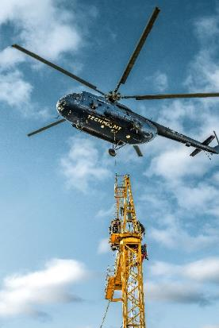
liebherr-assembly-kranimex-bratislava-2023-01.jpg
A helicopter supplied by Tech-Mont was used to erect the Liebherr 40 LC crane in Bratislava's city centre.
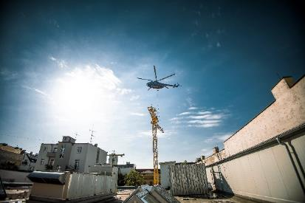
liebherr-assembly-kranimex-bratislava-2023-02.jpg
Service fitters from Liebherr dealer Kranimex took delivery of the individual air-lifted crane components.
liebherr-assembly-kranimex-bratislava-2023-03.jpg
The impressive helicopter assembly took two days in total.

Contact
Daniel Haefele
Global Communication
Phone: +49 7351 / 41 - 2330
Email: daniel.haefele@liebherr.com
Published by
Liebherr-Werk Biberach GmbH
Biberach / Germany
www.liebherr.com

