Press release

170 million euro investment: New Liebherr production site in Alsace

⸺
Liebherr-France SAS, based in Colmar, France, is responsible for the development and production of the Liebherr Group's crawler excavators. As part of its efforts to strengthen local supply chains, Liebherr-France SAS is planning to open a new manufacturing site for welded components as well as pre-assembly and assembly work for driver cabs in the EcoRhena industrial park in Nambsheim (Alsace, France) in 2025. Liebherr is investing 170 million euros on an area of around 47 ha and will create more than 300 jobs.
Colmar (France), June 2023 – On Wednesday, 21 June, Liebherr officialised the investment plans of Liebherr-France SAS for 2025: 170 million euros for the purchase of an industrial site area in Alsace. For several years now, Liebherr-France SAS has been planning to relocate certain activities to the vicinity of its existing manufacturing site in Colmar in order to further strengthen both its competitiveness and its independence in the long term.
Against this background, Liebherr decided to purchase a site in the EcoRhena industrial park in order to establish a new location for its Colmar production company there. The industrial park in Nambsheim, France, is under the responsibility of a French special-purpose association (Syndicat Mixte Ouvert), which also manages the Rhine port of Colmar/Neuf-Brisach. With the support of this Syndicat Mixte Ouvert, Liebherr-France SAS has acquired the land at the EcoRhena business park in Nambsheim (Haut-Rhin). Close to the existing Liebherr-France SAS in Colmar, not far from the Swiss and German borders and in close proximity to a multimodal transport centre, the EcoRhena site offers the ideal location for this project.
Two different production activities: welded components and assembly work on driver's cabs
One production area will be dedicated to the production of important welded parts for Liebherr's construction machinery portfolio, such as crawler and mobile excavators. These include components of the chassis or work equipment. This area will offer a wide range of technical professions in the fields of welding, machining and plant engineering, among others.
In addition, a second production area is planned for pre-assembly and assembly work on driver's cabs for Liebherr construction machinery. Jobs are to be created here in the fields of assembly and logistics, for example.

About Liebherr-France SAS
Liebherr-France SAS, based in Colmar, has been responsible for development and production of Liebherr Group earth-moving crawler excavators since 1961. The current range features about 30 crawler excavator models, from the R 914 Compact to the R 980 SME, which are designed for earth-moving and quarrying applications. The company also produces a host of special attachments for specific tasks such as demolition, material handling, and dredging or tunnelling applications, in addition to electric excavators. Crawler excavators with 14 to 100 tonne operating weights are supplied with Liebherr engines offering 90 to 420 kW power output. With more than 1200 employees, Liebherr-France SAS achieved sales of 534 million euros in 2022.
About the Liebherr Group
The Liebherr Group is a family-run technology company with a highly diversified product portfolio. The company is one of the largest construction equipment manufacturers in the world. It also provides high-quality and user-oriented products and services in a wide range of other areas. The Liebherr Group includes over 140 companies across all continents. In 2022, it employed more than 50,000 staff and achieved combined revenues of over 12.5 billion euros. Liebherr was founded in Kirchdorf an der Iller in Southern Germany in 1949. Since then, the employees have been pursuing the goal of achieving continuous technological innovation, and bringing industry-leading solutions to its customers.
Photos
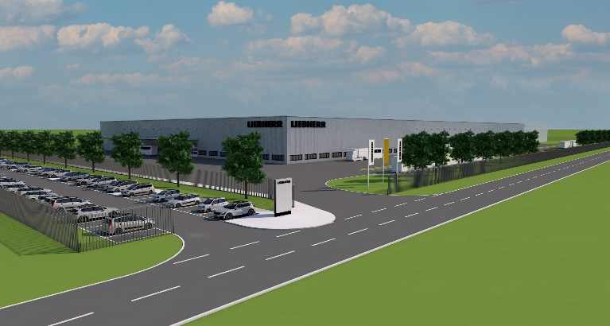
liebherr-nambsheim.jpg .jpg
The planned production site in Nambsheim for welding components and cabins is expected to provide more than 300 new jobs.
Contact
Alban Villaume
Marketing Communication Manager
Telephone: +33 3 89 21 36 09
Email: alban.villaume@liebherr.com
Published by
Liebherr-France SAS
Colmar, France
www.liebherr.com

