Press release

Liebherr and HAECO boost their landing gear service agreement in China
⸺
Liebherr-Aerospace grows its MRO footprint in China by adding a new chapter to its partnership with HAECO Landing Gear Services. This new MRO capability of landing gear services for the COMAC ARJ21 fleet will add local capacity on the Chinese market.
Toulouse (France), June 2023 – Liebherr-Aerospace and HAECO are pleased to announce the expansion of their ARJ21 landing gear service offer in China. As the popularity of the ARJ21-700 Xiangfeng continues to grow in China, with 100 aircraft in operation and its first customer outside of China in Indonesia, Liebherr-Aerospace and HAECO are collaborating to meet the increased demand for landing gear maintenance services.
This unique partnership combines Liebherr-Aerospace's OEM expertise as the design and product responsible company for the COMAC ARJ21 landing gear system with HAECO Landing Gear Services, a well-established and mature MRO partner with vast experience in landing gear maintenance services. Located in Xiamen, HAECO will work with Liebherr-Aerospace's service center in Shanghai to provide support to Chengdu Airlines, Genghis Khan Airlines, China Southern Airlines, One-Two-Three Airlines, Air China, Jiangxi Air, China Express Airlines, and TransNusa.
The success of this teaming approach between Liebherr-Aerospace as the OEM and HAECO as the maintenance partner has already been demonstrated by the high-quality services provided to the Embraer E-Jet E1 family fleet operated in China. With the expansion of Liebherr’s and HAECO’s service offer to ARJ21 operators, both partners aim to support the success of the COMAC ARJ21 program in China and beyond. The landing gear service will also be available for the newly certified ARJ21F cargo version, which will be operated by YTO Cargo Airlines and Longhao Airlines.
To further optimize slot availability for all ARJ21-700 and ARJ21F operators, Liebherr-Aerospace plans to expand its landing gear service capacities with its manufacturing partner in China. This new MRO capability will add local capacity to the Chinese market and ensure that operators of the ARJ21 have access to exceptional as well as reliable landing gear maintenance services.

About Liebherr-Aerospace & Transportation
Liebherr-Aerospace & Transportation SAS, Toulouse (France), is one of eleven divisional control companies within the Liebherr Group and coordinates all activities in the aerospace and transportation systems sectors.
Liebherr-Aerospace is a leading supplier of systems for the aviation industry and has more than six decades of experience in this field. The range of aviation equipment produced by Liebherr for the civil and defense sectors includes flight control and actuation systems, gears and gearboxes, landing gear and air management systems as well as electronics. These systems are deployed in wide-bodied aircraft, single aisle and regional aircraft, business jets, defense aircraft, defense transporters, defense training aircraft and civil and defense helicopters.
Liebherr’s aerospace and transportation systems division employs around 6,000 people. It has three aviation equipment production plants at Lindenberg (Germany), Toulouse (France) and Guaratinguetá (Brazil). These production sites offer a worldwide service with additional customer service centers in Saline (Michigan/USA), Seattle (Washington/USA), Montreal (Canada), Hamburg (Germany), Dubai (UAE), Bangalore (India), Singapore and Shanghai (People’s Republic of China).
About the Liebherr Group
The Liebherr Group is a family-run technology company with a highly diversified product portfolio. The company is one of the largest construction equipment manufacturers in the world. It also provides high-quality and user-oriented products and services in a wide range of other areas. The Liebherr Group includes over 140 companies across all continents. In 2022, it employed around 51,000 staff and achieved combined revenues of over 12.5 billion euros. Liebherr was founded in Kirchdorf an der Iller in Southern Germany in 1949. Since then, the employees have been pursuing the goal of achieving continuous technological innovation, and bringing industry-leading solutions to its customers.
Image
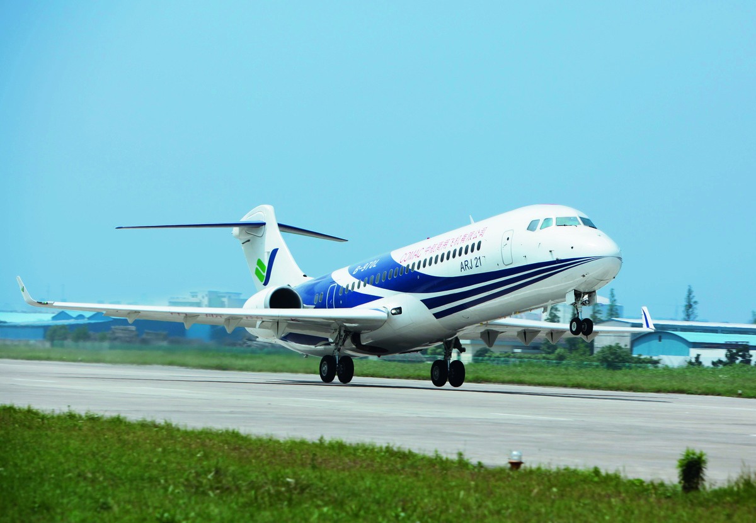
ARJ21-copyright-COMAC.jpg
Liebherr-Aerospace supplies the landing gear system for the ARJ21. - © COMAC
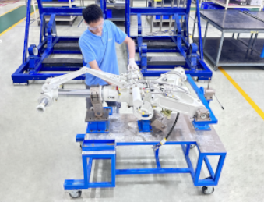
haeco-landing-gear-shopfloor-copyright-haeco.jpg
Landing gear shop floor at HAECO – © HAECO
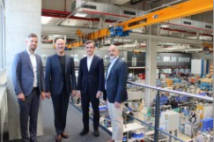
haeco-visit-liebherr-copyright-liebherr.JPG
Christian G. Pinter, Director & GM at HAECO (2nd from left) with Liebherr-Aerospace representatives during his visit at Liebherr-Aerospace in Lindenberg (Germany)
Contact person
Ute Braam
Corporate Communications
Phone: +49 8381 / 46 - 4403
E-mail: ute.braam@liebherr.com
Published by
Liebherr-Aerospace & Transportation SAS
Toulouse / France
www.liebherr.com

