Press information

Liebherr cranes at work on the tallest residential building in New Zealand

⸺
280 HC-L 12/24 and 542 HC-L 18/36 luffing jib cranes provide high lifting capacities for heavy steel and glass components
Liebherr project department Tower Crane Solutions designs cost-effective climbing process
Precision lifting through use of intelligent assistance systems and drives manufactured in-house
Liebherr’s luffing jib cranes have their sights set high: a 280 HC-L 12/24 and a 542 HC-L 18/36 are currently at work on an impressive construction project in Auckland, New Zealand. Measuring 187 metres in height, the “Seascape” skyscraper being built by China Construction New Zealand Limited will be the tallest residential building in New Zealand when completed. As a full service solutions provider, Liebherr is supporting the project with reliable cranes, a special climbing concept and trained service engineers.
Auckland (New Zealand), 7 June 2023 – Cranes from the HC-L series are made for high-rise projects such as this one in the centre of Auckland. Operation in the tightest of spaces, high handling capacities, and impressively high hook heights – the luffing jib cranes from Liebherr offer it all. A 280 HC-L 12/24 with a maximum lifting capacity of 24 tonnes and a radius of 40 metres is in use on site alongside a 542 HC-L 18/36, working with a lifting capacity of up to 36 tonnes and a 50-metre radius. Both machines are from the fleet of China Construction New Zealand Limited.
280 HC-L uses internal climbing system for external climbing
Liebherr’s Tower Crane Solutions project department has developed a custom climbing concept for cost-effective crane operation. It allows the 280 HC-L to rise in height using a 355 IC internal climbing system. The tower sections, measuring just 1.9 x 1.9 metres, are particularly narrow and therefore an ideal fit for spaces such as lift shafts.
The special thing about the “Seascape” project by China Construction New Zealand Limited is that the 280 HC-L is climbing on the outside rather than the inside of the building. This setup allows the 280 HC-L and 542 HC-L to provide optimal service on site. The concept has the advantage that fewer tower sections are needed and that interior work in the lower section of the residential tower can be carried out unhindered. The customer saves both time and money as a result.

542 HC-L climbs on 500 HC tower system
The 542 HC-L is taking a more conventional route, climbing on the outside of the building using a 500 HC tower system. This solution is ideal for large cranes with high lifting capacities and is also extremely compact thanks to external dimensions of just 2.4 x 2.4 metres. The luffing jib crane will be tied to the building a total of nine times until it reaches a maximum tower height of approximately 163 metres.
Once in position, the 542 HC-L will carry out the final lifts on site and also assist in dismantling the 280 HC-L. The 542 HC-L will then climb back down the building and be dismantled with the help of a mobile crane. Liebherr’s service engineers are responsible for maintaining and climbing both cranes and will also take on disassembly.
Skyscraper with striking façade
Construction work on the architecturally impressive skyscraper is scheduled to continue until 2024. A particular feature is its towering glass façade with a diamond-shaped braced steel frame that spans the entire height of the building’s east and west sides. This will allow residents to enjoy unobstructed views of the harbour and Hauraki Gulf.
The building will boast 52 storeys when completed and, with a height of 187 metres, will become a new high point on the Auckland skyline. Alongside retail outlets and office space, the residential tower will also accommodate around 220 apartments.
High-performance drives manufactured in-house
When it comes to moving and placing the building’s numerous glass and steel elements, the two Liebherr luffing jib cranes are the perfect choice. They offer high lifting capacities as well as in-house developed high-performance drives. Plus, intelligent assistance systems such as level luffing, ABB slewing limitation, and Micromove support the crane operator in carrying out safe, precise lifts. With the help of Liebherr’s Micromove fine positioning mode, for example, components can be lowered slowly and with millimetre precision, so that neither the component nor the structure suffer damage in any way.
About the Liebherr Tower Cranes Division
More than seven decades of experience have made Liebherr a recognised specialist for lifting technology on all types of construction sites. The range of Liebherr Tower Cranes encompasses an extensive selection of high-quality tower cranes that are used worldwide. This includes fast-erecting, top-slewing, luffing jib and special-purpose cranes as well as mobile construction cranes. In addition to these products, Liebherr also offers a wide range of services that complete the company’s portfolio: Tower Crane Solutions, the Tower Crane Center and Tower Crane Customer Service.

About the Liebherr Group
The Liebherr Group is a family-run technology company with a highly diversified product portfolio. The company is one of the largest construction equipment manufacturers in the world. It also provides high-quality and user-oriented products and services in a wide range of other areas. The Liebherr Group includes over 140 companies across all continents. In 2022, it employed more than 50,000 staff and achieved combined revenues of over 12.5 billion euros. Liebherr was founded in Kirchdorf an der Iller in Southern Germany in 1949. Since then, the employees have been pursuing the goal of achieving continuous technological innovation, and bringing industry-leading solutions to its customers.
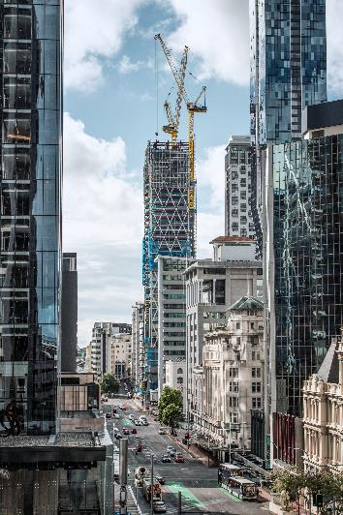
Images
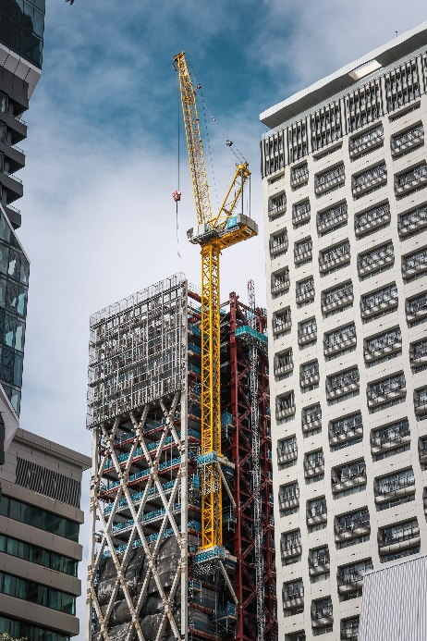
liebherr-hc-l-cranes-seascape-new-zealand-01.jpg
Two Liebherr luffing jib cranes are at work on the construction of New Zealand’s tallest residential building (187 metres).
liebherr-hc-l-cranes-seascape-new-zealand-02.jpg
The 280 HC-L is climbing on the outside of the building with the help of a 355 IC internal climbing system.

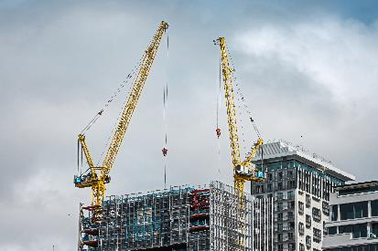
liebherr-hc-l-cranes-seascape-new-zealand-03.jpg
Once the skyscraper is completed, the 542 HC-L will dismantle the 280 HC-L before climbing down again.

Contact
Daniel Haefele
Global Communication
Phone: +49 7351 / 41 - 2330
Email: daniel.haefele@liebherr.com
Published by
Liebherr-Werk Biberach GmbH
Biberach / Germany
www.liebherr.com

