Press release

Liebherr mobile crane LTM 1090-4.2 builds backdrop for the Karl May Festival

⸺
Segeberger Abschleppdienst & Krandienst assembles the stage set every year
The LTM 1090-4.2 offers the manoeuvrability and reach required for this special application
The Liebherr 90-tonner is the company's largest crane

The Wild West comes to Northern Germany: a Liebherr mobile crane is playing a leading role behind the scenes at the Karl May Festival in Bad Segeberg. The new LTM 1090-4.2 operated by local company Segeberger Abschleppdienst & Krandienst is helping to assemble the scenery for this year's performances, which will run from 24 June to 3 September. The demands placed on the crane include excellent manoeuvrability and a long reach.
Ehingen (Donau) (Germany), 31 May 2023 – Every year since 1952, heroes and villains have been enacting exciting adventures based on the novels by German author Karl May in Bad Segeberg. The town is home to one of Europe's most beautiful open-air theatres, which can accommodate up to 7,700 spectators. Segeberger Abschleppdienst & Krandienst has been involved in set construction for these productions for many years – in 2023, for “Winnetou I – Blood Brothers“.
This year, the company deployed its new LTM 1090-4.2, which was added to its fleet in February. Owner René Sellmer explains: “The Liebherr 90-tonner is perfect for this job. On the one hand, it's sufficiently compact and manoeuvrable for the narrow access road. On the other, with its 60-metre telescopic boom, it can reach all the required assembly areas from one crane location, where the soil is sufficiently load-bearing. However, since we can't fully extend all the sliding beams, the VarioBase® variable support base is worth its weight in gold since it enables us to work safely.”
A taxi crane on the prairie
The LTM 1090-4.2 carries 8.8 tonnes of ballast with a 12-tonne axle load on public roads. As a taxi crane, it can thus perform a large number of jobs without a counterweight transport vehicle. This crane configuration is also sufficient when it comes to lifting the individual parts of the theatre set (which weigh up to 3.5 tonnes) for this year's Karl May Festival. “A set designer creates unique scenery for each festival season,” reports Sellmer, whose company started life as a towing firm. In addition to recovery and towing vehicles, the company's fleet includes telescopic loaders, low-loaders, trailers and mobile cranes. The LTM 1090/4.2 is now the largest crane in the company’s fleet.

About Liebherr-Werk Ehingen GmbH
Liebherr-Werk Ehingen GmbH is a leading manufacturer of mobile and crawler cranes. Its range of mobile cranes extends from 2-axle 35 tonne cranes to heavy duty cranes with a lifting capacity of 1200 tonnes and a 9-axle chassis. Its lattice boom cranes on mobile or crawler crane chassis deliver lifting capacities of up to 3000 tonnes. With universal boom systems and extensive additional equipment, they can be seen in action on construction sites throughout the world. The Ehingen site has a workforce of 4,300. Extensive, global service guarantees the high availability of Liebherr mobile and crawler cranes. In 2022, the Liebherr plant in Ehingen recorded a turnover of 2.37 billion euros.

About the Liebherr Group

The Liebherr Group is a family-run technology company with a highly diversified product portfolio. The company is one of the largest construction equipment manufacturers in the world. It also provides high-quality and user-oriented products and services in a wide range of other areas. The Liebherr Group includes over 140 companies across all continents. In 2022, it employed more than 50,000 staff and achieved combined revenues of over 12.5 billion euros. Liebherr was founded in Kirchdorf an der Iller in Southern Germany in 1949. Since then, the employees have been pursuing the goal of achieving continuous technological innovation, and bringing industry-leading solutions to its customers.

Photos:

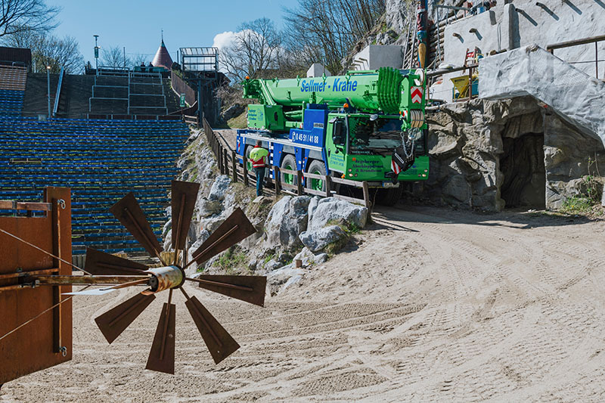
liebherr-ltm1090-4-2-segeberger-01.jpg
The LTM 1090-4.2 safely navigates the narrow access road to the Bad Segeberger open-air theatre.
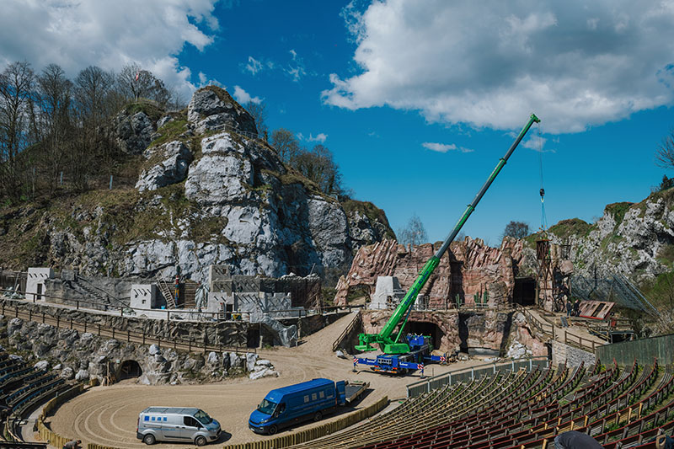
liebherr-ltm1090-4-2-segeberger-02.jpg
With its 60-metre telescopic boom, the LTM 1090-4.2 can reach all working areas of the set from one location.

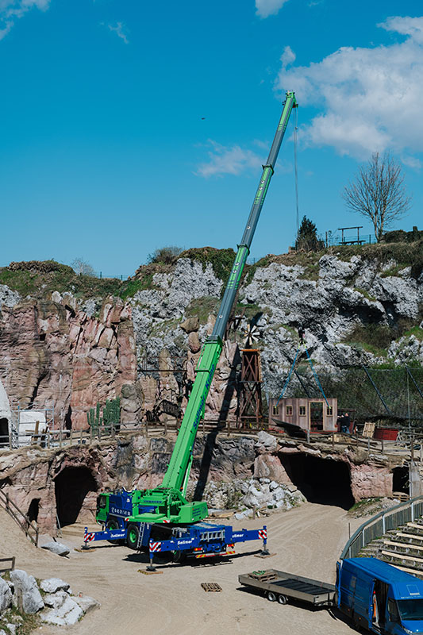
liebherr-ltm1090-4-2-segeberger-03.jpg
8.8 tonnes of ballast were sufficient for the scenery components, which weighed up to 3.5 tonnes

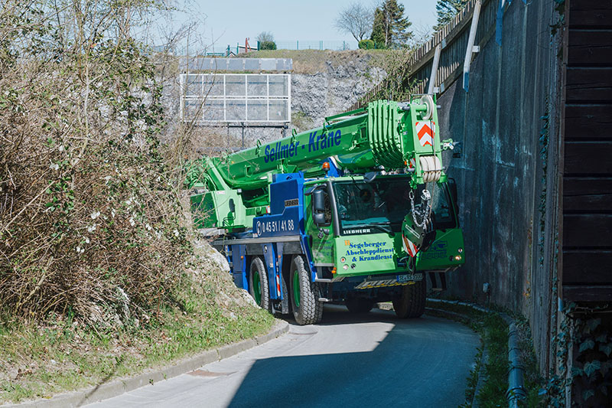
liebherr-ltm1090-4-2-segeberger-04.jpg
Job done – see you at the dismantling in September!

Contact
Wolfgang Beringer
Marketing and Communication
Phone: +49 7391/502 - 3663
Email: wolfgang.beringer@liebherr.com
Published by
Liebherr-Werk Ehingen GmbH
Ehingen (Donau) / Germany
www.liebherr.com

