Press release

Fuchs starts operating a Liebherr mixing tower

⸺
Hans Fuchs Betonwerk Ellwangen GmbH + Co. KG starts operating a Liebherr Betomat 5 with two high performance mixers
Flexible concrete discharge and a particularly high storage volume
Hans Fuchs Betonwerk Ellwangen GmbH und Co. KG has started to operate an ultra-modern Liebherr concrete mixing tower. The new mixing tower with two high performance mixers combines concrete discharge flexibility with expanded storage volume. It supplies the prefabrication facility, paving stone factory (production of composite stone / concrete goods) and the truck mixer fleet of the renowned building company.
Bad Schussenried (Germany), 25 May 2023 – The new mixing plant that Fuchs has chosen is a Betomat 5 - 875. Fuchs is a large building company in Germany and employs around 300 people in various locations. Fuchs is well established both in manufacturing pre-cast concrete parts and concrete goods, as well as in nationwide ready-mixed concrete industry. The customer chose Liebherr specifically: “Thanks to the competent advice and support in planning and implementation right from the beginning, we were immediately impressed by the quality and would build with Liebherr again”, said Johannes Veit, managing partner at Fuchs.
The tower is around 32 metres high and has a storage volume of 875 m³ for aggregates in twelve star-shaped chambers. The plant is fed by a galvanised bucket elevator. The material is supplied by a recessed hopper with a volume of 20 m³. This supports the mixing tower's flexibility in use, as the aggregates can be filled using both wheel loaders and HGVs as required.
Six cement silos each with a capacity of 120 tonnes form the cement section. One silo is designed with two chambers. Therefore, seven types with a total of 720 tonnes can be stored. The cement screws are controlled by frequency converters to enable precise metering and therefore significant cement and cost savings.
Two Liebherr mixing systems for the highest concrete quality
The plant is equipped with two mixer systems to enable concrete production that is adapted to the customer’s requirements. The two Liebherr ring-pan mixers (RIM 2.5-D RIM and RIM 1.5-D) work with double agitator systems. The Liebherr agitator systems enable high concrete quality in short mixing times, as well as an optimised mixture of paint directly in the concrete. The four concrete discharge units also enable maximum flexibility (1 x truck mixer, 2 x handover slides, 1 x belt). Under normal circumstances, the small mixer supplies the prefabrication facility but both mixers can discharge the ready-mixed concrete in the truck mixer if required.
Longevity and equipment
The particular longevity of the plant is ensured by high-quality components and an almost completely galvanised steel structure. To ensure smooth operation during the cold winter months, the entire plant is insulated with plastic-coated facade sheets and equipped with heating. Therefore, the Liebherr mixing tower can meet any of the varying requirements in modern concrete production throughout the year even in tough weather conditions.
The mixing plant was equipped with the additional options of a color dosing system, a slewing funnel for HGV discharge or for collecting cleaning water, a high pressure mixer cleaning system and a camera monitoring system.
As part of responsible resource handling, Fuchs is also using a Liebherr LRS 908 residual concrete recycling plant in addition to the new concrete mixing tower. With a throughput of 12 m³ per hour, it processes this material from the mixing plant and truck mixer cleaning system, as well as unused concrete residue. The parts of the prepared material are washed out in a closed material cycle and can therefore be partially reused subsequently.
About Liebherr-Mischtechnik GmbH
Liebherr-Mischtechnik GmbH is a global manufacturer and supplier of high-quality concrete mixing plants, concrete pumps and ready-mixed concrete truck mixers. The company is part of the Liebherr group and is headquartered in Bad Schussenried, Germany.
About the Liebherr Group
The Liebherr Group is a family-run technology company with a highly diversified product portfolio. The company is one of the largest construction equipment manufacturers in the world. It also provides high-quality and user-oriented products and services in a wide range of other areas. The Liebherr Group includes over 140 companies across all continents. In 2022, it employed more than 50,000 staff and achieved combined revenues of over 12.5 billion euros. Liebherr was founded in Kirchdorf an der Iller in Southern Germany in 1949. Since then, the employees have been pursuing the goal of achieving continuous technological innovation, and bringing industry-leading solutions to its customers.

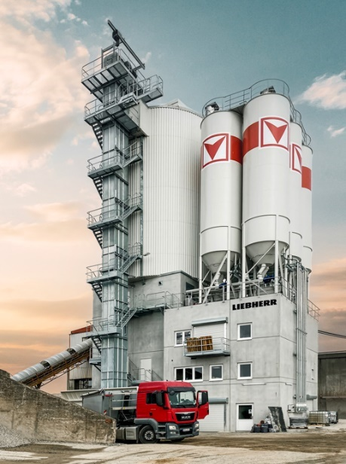
Image
liebherr-betomat-fuchs.jpg
Liebherr Betomat 5 mixing plant with two ring-pan mixers, twelve aggregate chambers and six cement silos.
Contact
Klaus Eckert
Telephone: +49 7583 949 328
E-mail: klaus.eckert@liebherr.com
Published by
Liebherr-Mischtechnik GmbH
Bad Schussenried / Germany
www.liebherr.com

