Press release

BKM builds faster with a Liebherr LTR 1220

⸺
BKM's new Liebherr LTR 1220 increases the speed of prefab assembly
The LTR 1220 is by far the most powerful crawler crane with a telescopic boom on the market
Difficult hall construction cleverly mastered close under high-voltage power lines
In the summer of 2022, BKM Bau Beteiligungs-GmbH (BKM), a company specialising in precast concrete construction and assembly, upgraded its crane fleet with a telescopic boom crawler crane for the first time. It chose to buy the most powerful crane type that the market currently has to offer in this segment: the LTR 1220 from Liebherr. With its maximum load moment of 672 tonnes per metre, it leaves the competition far behind. The same goes for the achievable lifting height of 101 metres with the use of lattice jibs on the 60-metre boom. After one year in permanent service and five completed projects with the newcomer, BKM's assembly manager Boris Cordes is thoroughly impressed.
Ehingen (Donau) (Germany), 24 May 2023 – As a supplier of precast concrete buildings, the company BKM produces reinforced concrete elements at several locations. Until now, the company, based in Nienburg between Hanover and Bremen, has erected warehouses or office buildings for its customers using mobile cranes. For the last year, however, an additional telescopic boom crawler crane from Liebherr has been handling its orders – with considerable success. "With our new LTR 1220, we are significantly faster than before. By at least 20 per cent," explains Boris Cordes. As the assembly manager at BKM (alongside his other responsibilities), he supervised the company's most recent large project involving the crawler crane in Norderstedt near Hamburg.
Just a few metres between pulley head and power line
A warehouse building with 11,000 square metres of floor space had to be constructed in the north of Germany. The special thing – or rather, the particularly difficult thing – about this project was that parts of the concrete hall had to be built directly underneath and at a short distance from two large high-voltage power lines. At certain times the crane and fitters only had a few metres of usable height above the structure, because a minimum safety distance from the sagging cables had to be maintained. As with all crane types produced at the Liebherr factory in Ehingen, the LICCON control system of the LTR 1220 makes it possible to define the limits for the work area as standard. This prevents the telescopic section from accidentally extending too far or the boom from luffing up.
The LTR 1220, by far the most powerful machine on the market for crawler cranes with telescopic booms, was able to demonstrate not only its considerable power but also its other capabilities in Norderstedt. The assembly of 36-metre-long roof trusses under the power lines proved to be the main sticking point on the construction site. Since all the pillars for the hall had already been sunk at the start of the project, the girders could not be delivered parallel to the installation direction. The crawler crane, which remained mobile under load, had the task of grabbing the far end of the 40-tonne elements and moving the load under the overhead line. On the other side, a Liebherr mobile crane had attached and then swung the heavy reinforced-concrete beams into the 90-degree-offset assembly position. "We wouldn't have been able to do that with a mobile crane under the power lines," says Cordes.
990 operating hours without problems
Matthias Bachmann, who drives the LTR 1220 – now painted in the corporate blue of BKM – is full of praise for his new machine: "Control, camera system, mobility, precision... everything is really top notch," he enthuses. And in terms of lifting power, the state-of-the-art crane leaves nothing to be desired for its satisfied operator. "A 60-tonne girder was the heaviest thing I have moved with the LTR so far. And in the 990 operating hours we didn't have a single standstill – I think that's excellent." This is music to the ears of assembly manager Boris Cordes, who adds: "Buying the LTR 1220 was the best decision we could have made. The crane is simply outstanding."

About Liebherr-Werk Ehingen GmbH
Liebherr-Werk Ehingen GmbH is a leading manufacturer of mobile and crawler cranes. Its range of mobile cranes extends from 2-axle 35 tonne cranes to heavy duty cranes with a lifting capacity of 1200 tonnes and a 9-axle chassis. Its lattice boom cranes on mobile or crawler crane chassis deliver lifting capacities of up to 3000 tonnes. With universal boom systems and extensive additional equipment, they can be seen in action on construction sites throughout the world. The Ehingen site has a workforce of 4,300. Extensive, global service guarantees the high availability of Liebherr mobile and crawler cranes. In 2022, the Liebherr plant in Ehingen recorded a turnover of 2.37 billion euros.
About the Liebherr Group
The Liebherr Group is a family-run technology company with a widely diversified product range. The company is one of the largest manufacturers of construction machines in the world. However, it also supplies high quality, user-focused products and services in many other sectors. The group currently comprises more than 140 companies based in every continent of the world. In 2022, it had a workforce of over 50,000 and recorded a consolidated total turnover of more than 12.5 billion euros. The company was founded in 1949 in Kirchdorf an der Iller in southern Germany. Since then, its,aim has been to win customers by supplying high quality solutions and to contribute to technological progress.
Images:
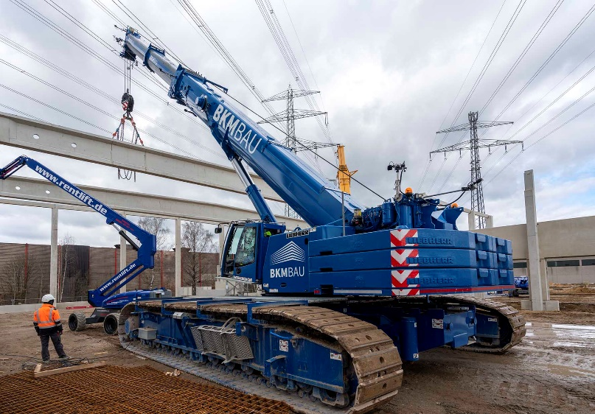
liebherr-ltr220-bkm-building-norderstedt-01.jpg
The mightiest beast: the Liebherr LTR 1220 offers the highest performance in the telescopic crawler crane segment worldwide.
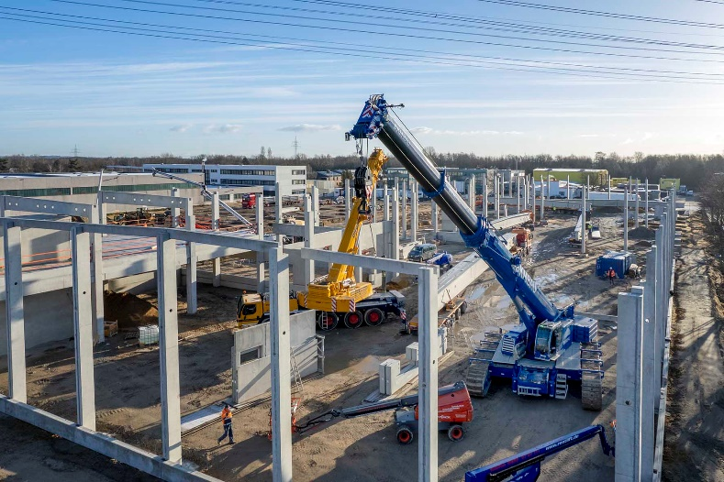
liebherr-ltr220-bkm-construction-norderstedt-02.jpg
Powerful performance: the LTR 1220 installed 900 precast concrete elements on the construction site in Norderstedt, some of which had to be manoeuvred only a short distance below two overhead power lines.
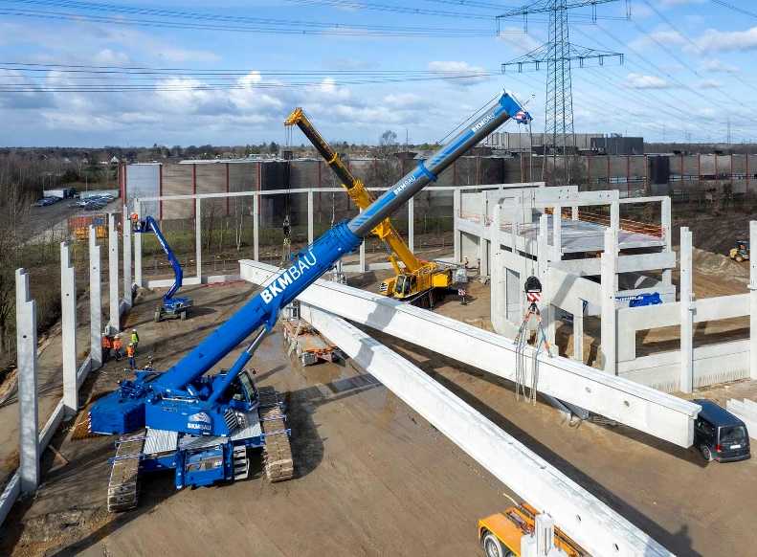
liebherr-ltr220-bkm-construction-norderstedt-03.jpg
Clever solution: together with a LTM 1130-5.1 mobile crane operated by the heavy-duty and crane logistics company Ulferts & Wittrock, a 40-tonne ceiling truss is installed. The crawler crane was tasked with moving the load.
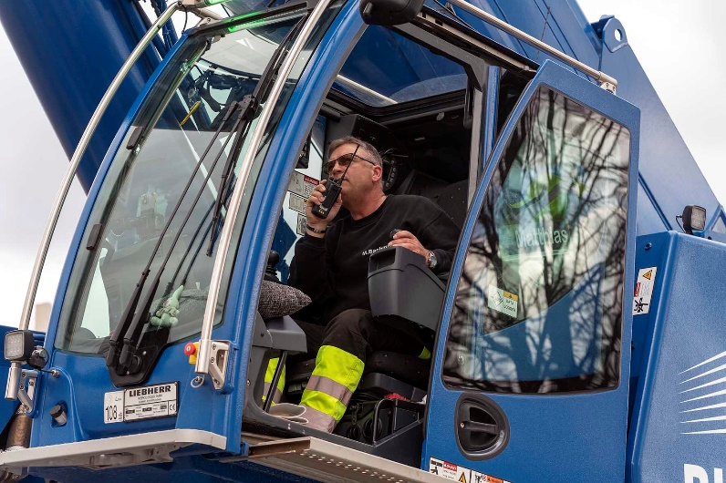
liebherr-ltr220-bkm-construction-norderstedt-04.jpg
"There is nothing better for handling concrete components," says crane driver Matthias Bachmann.

Contact
Wolfgang Beringer
Marketing and Communication
Phone: +49 7391/502 - 3663
Email: wolfgang.beringer@liebherr.com
Published by
Liebherr-Werk Ehingen GmbH
Ehingen (Donau), Germany
www.liebherr.com

