Press release

First Liebherr mobile cranes for Sankyu Saudi Arabia Co.

⸺
High safety standards of Liebherr cranes and reliable service were key purchasing criteria
LTM 1050-3.1 and LTM 1160-5.2 mainly scheduled for maintenance work in industries
Liebherr operates three locations in Saudi Arabia

Liebherr is delighted to have a new customer: Sankyu Saudi Arabia Co. has taken delivery of its first mobile cranes from the market leader. The specialist in plant construction, operational support and logistics services will mainly use the LTM 1050-3.1 and LTM 1160-5.2 for maintenance work in refineries and other industries. The high safety standards of the Liebherr cranes and the reliable service were important purchasing criteria for Sankyu.
Ehingen (Donau) (Germany), 17 May 2023 – Machines that are used in refineries and other industries must meet the highest demands with regard to quality, safety and fast, reliable service. Mahdi Al Salem, deputy Branch Manager of Sankyu Saudi Arabia says: "To grow our business in Saudi Arabia and live up to our vision and mission of being number one in mechanical industry maintenance, we need to rely on strong customer service and products with a high level of safety. The new cranes from Liebherr are a perfect fit for our support team. With Liebherr, we can rely on competent and fast service should the cranes ever break down. Crane operations in refineries and other sensitive industries are very challenging." Liebherr provides this highly qualified service through Saudi Liebherr Company Ltd. with headquarters in Jeddah and branches in Dammam and Riyadh.
Sankyu also cites the price-performance ratio and reliability as key factors in its decision to use Liebherr cranes. The 50-tonne LTM 1050-3.1 mobile crane and the LTM 1160-5.2 with a maximum lifting capacity of 180 tonnes, combined with special equipment for working in different industries, precisely meet the requirements of major Saudi clients such as the oil production company Saudi Aramco. With their long telescopic booms and high lifting capacities in their respective crane classes, the Liebherr mobile cranes are the perfect choice for the jobs planned by Sankyu.
The Sankyu Group of Companies
The Sankyu Group of Companies, headquartered in Japan, can look back on a century of entrepreneurial activities under the guiding principle of "valuing people" since its founding in 1918, while maintaining a sense of appreciation for its employees and customers. The company name Sankyu comes from the English expression "thank you". The company is active in two business areas. The Logistics segment is involved in the loading and unloading of ships, the operation of container terminals as well as the packaging, storage and management of warehouses and transport services. The Machine Factory segment is engaged in the construction, installation, piping and maintenance of general industrial machinery and environmental equipment, the transportation of large and heavy goods, the design, assembly and construction of bridges, and the construction of factory facilities. Other business areas include services in the areas of information systems, personnel placement, insurance services, social and civil engineering, plant construction as well as leasing, maintenance and management of machinery.
About Liebherr-Werk Ehingen GmbH
Liebherr-Werk Ehingen GmbH is a leading manufacturer of mobile and crawler cranes. Its range of mobile cranes extends from 2-axle 35 tonne cranes to heavy duty cranes with a lifting capacity of 1200 tonnes and a 9-axle chassis. Its lattice boom cranes on mobile or crawler crane chassis deliver lifting capacities of up to 3000 tonnes. With universal boom systems and extensive additional equipment, they can be seen in action on construction sites throughout the world. The Ehingen site has a workforce of 4,300. Extensive, global service guarantees the high availability of Liebherr mobile and crawler cranes. In 2022, the Liebherr plant in Ehingen recorded a turnover of 2.37 billion euros.
About the Liebherr Group
The Liebherr Group is a family-run technology company with a highly diversified product portfolio. The company is one of the largest construction equipment manufacturers in the world. It also provides high-quality and user-oriented products and services in a wide range of other areas. The Liebherr Group includes over 140 companies across all continents. In 2022, it employed more than 50,000 staff and achieved combined revenues of over 12.5 billion euros. Liebherr was founded in Kirchdorf an der Iller in Southern Germany in 1949. Since then, the employees have been pursuing the goal of achieving continuous technological innovation, and bringing industry-leading solutions to its customers.

Photograph:
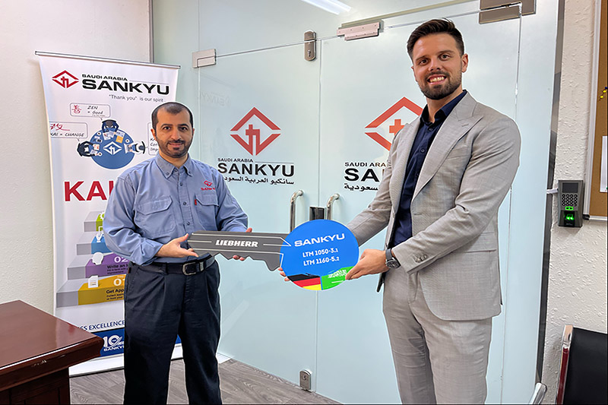
liebherr-sankyu-handover.jpg
From left to right: Mahdi Al Salem (Sankyu Saudi Arabia Co.), Daniel Tuerkis (Saudi Liebherr Co. Ltd)

Contact
Wolfgang Beringer
Marketing and Communication
Phone: +49 7391/502 - 3663
Email: wolfgang.beringer@liebherr.com
Published by
Liebherr-Werk Ehingen GmbH
Ehingen (Donau) / Germany
www.liebherr.com

