Press release

MAXIKraft takes delivery of third Liebherr LR 11000 crawler crane

⸺
Flexible set-up configurations of Liebherr crawler cranes important criterion for MAXIKraft
First deployment during assembly of a wind turbine
LR 11000 travels with full load

MAXIKraft has taken delivery of another Liebherr LR 11000. The new crawler crane is now the third of this type to join the group of companies' crane fleet. MAXIKraft appreciates the highly flexible nature of the 1,000-tonne machine from the Liebherr factory in Ehingen. At Dünfus wind farm, a few kilometres north of Cochem, it assembled a Vestas 5.6 MW wind turbine during its first deployment. It had to lift components weighing up to 100 tonnes to a height of 170 metres.
Ehingen (Donau) (Germany), 16 May 2023 – "With its special configurations, the LR 11000 offers enormous lifting capacities for wind power assemblies. But it also offers flexible deployment options for other applications," says company owner Maik Kanitzky, justifying the investment in what is now the third Liebherr 1,000-tonne machine. MAXIKraft uses several large lattice boom cranes made in Ehingen. Among them are LG 1750, LR 1700-1.0, LR 1800-1.0 and LR 11000 type cranes. Steffen Lehmann manages the deployment of the large cranes at MAXIKraft. He elaborates: "For us, the highly flexible set-up versions and boom combinations of the Liebherr lattice boom cranes are the decisive factor. Having permanent control of all parameters of a lift is important. Our drivers rate the LICCON2 control system positively. On three large screens, it provides real-time information about load, winch pull, boom position, ground pressure, centre of gravity, and many other parameters – plus the extreme sensitivity of the equipment when driving, luffing, and turning."
The first deployment of the brand new LR 11000 took the 1,000-tonne machine to Dünfus wind farm, where MAXIKraft had been commissioned to assemble a Vestas 5.6 MW wind turbine. The V150-5.6 MW has a rotor diameter of 150 metres, a hub height of 169 metres, and a total height of 244 metres. This makes it one of the most powerful wind turbines in Germany. The heaviest part is the gondola, which weighs around 100 tonnes.
On 19 April, crane driver Marco G. was able to lift the gondola onto the tower with a special yoke after it had been approved by the site manager. It was estimated to take around two hours. Important argument for the deployment of crawler cranes: After picking up the gondola, the crane had to travel about 20 metres on excavator mats to reach the assembly position. For the Dünfus deployment, MAXIKraft configured the LR 11000, powered by a Liebherr 8-cylinder 500 kW engine, in the SL10DF2BV set-up version with a 162-metre main boom, 21-metre lattice type fixed jib and 42-metre derrick boom. The crane is equipped with six winches as standard. These move two hook blocks, the luffing gear for the main boom and luffing jib as well as the V-frame for ballast positioning.
Immediately after assembly of the last rotor blade, the 1,000-tonne machine was dismantled and will travel with more than 50 trucks to the next site. The compact dimensions of the components are particularly advantageous here. These have a maximum width of 3.5 metres and a height of 3.2 metres. The massive expansion of wind power will "gift" the large blue/silver MAXIKraft crawler cranes many more spectacular deployments.
Last year, MAXIKraft celebrated its 30th anniversary. The group of companies has many years of experience in the field of crane services and heavy transport. Telescopic, lattice and crawler cranes offering 25 to 1,000 tonnes lifting capacity and road transport technology up to 300 tonnes payload are available for every application. The MAXIKraft group of companies includes five companies serving Saxony, Saxony-Anhalt, Thuringia, Brandenburg, Berlin, Lower Saxony and Bavaria with a total of 23 branches.

Images
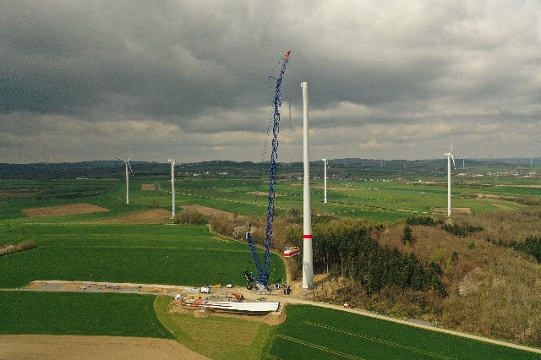l
liebherr-lr11000-MAXIKraft-01.jpg
In April 2023, MAXIKraft's third LR11000 crawler crane assembled a 5.6 MW wind turbine near Treis-Karden on the Moselle River. The gondola was mounted at a height of 170 metres.
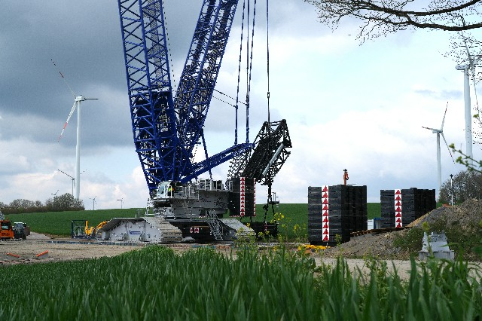
liebherr-lr11000-MAXIKraft-02.jpg
Basic machine LR 11000 – clearly visible V-frame, which allows flexible positioning of the derrick ballast. To the right of the crane, 450 t of ballast are set up, which are only needed to luff the boom up/down.
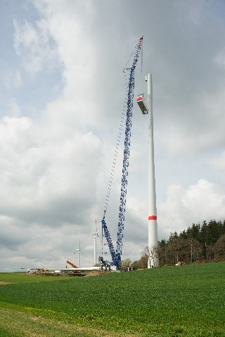
liebherr-lr11000-MAXIKraft-03.jpg
The gondola, which weighs over 100 tonnes with a cross beam, is lifted to its assembly position at a height of 170 metres.

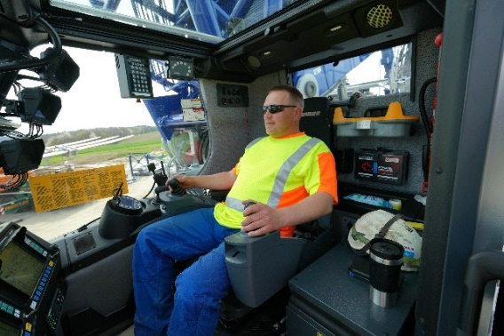
liebherr-lr11000-MAXIKraft-04.jpg
Marco G. has been operating cranes for over 30 years and, together with his colleague Mattias K., is responsible for the brand new LR 11000. The crane is primarily used within Germany for the assembly of wind turbines.

Contact
Wolfgang Beringer
Marketing and Communication
Phone: +49 7391/502 - 3663
Email: wolfgang.beringer@liebherr.com
Published by
Liebherr-Werk Ehingen GmbH
Ehingen (Donau) / Germany
www.liebherr.com

