Press release

Liebherr presents the new LH 26 M Timber Litronic at LIGNA 2023 in Hanover

⸺
Powerful machine for efficient timber handling
Thanks to its compact design, it is ideal for use in sawmills and lumber yards with limited space
The new addition is the smallest machine in Liebherr's existing portfolio of material handlers in the 25-tonne range
Liebherr will unveil the new LH 26 M Timber Litronic for efficient timber handling at the world's leading trade fair LIGNA in Hanover. Thanks to its extremely compact design and exceptional manoeuvrability, this specialist machine is ideal for use in sawmills and lumber yards where space is at a premium. The new handling machine also boasts impressively low fuel consumption when operating at maximum capacity. Liebherr will also demonstrate its new integrated tyre pressure monitoring system on the material handler for the first time.
Hanover (Germany), 15 May 2023 – With the LH 26 M Timber Litronic, Liebherr will present a new timber truck to the public at LIGNA that extends its existing portfolio to include a lighter machine with an operating mass of between 23,500 and 26,000 kg. Liebherr will also showcase its new, integrated tyre pressure monitoring system as part of its trade fair exhibit. This system allows the desired target tyre pressure to be set and monitored on the display in the operator's cab. The system will be optionally available for Liebherr material handlers from October.
Liebherr's trade fair exhibit also includes a straight 6.6 m long boom and a 5 m long stick with an angled stick end as well as a Liebherr type GM 10B wood grapple with a capacity of up to 1.30 m². The machine configuration also includes the 1.2 m high, rigid cab elevation LFC 120 for optimum visibility and a 3 m wide support blade at the rear. Maximum splash protection is provided thanks to the hot-dip galvanised mudguards, which also serve as a platform for easy and safe access to the operator's cab.
The new machine combines high driving performance with compact dimensions
The engine power of 125 kW / 170 hp provides the system with a large amount of torque, which allows the machine to accelerate quickly. In combination with the high pump flow, this guarantees fast, dynamic work movements and therefore maximum handling capacity.
Thanks to its compact design, the new machine is ideal for use in confined spaces. It’s extremely small front and tail swing radius enables the machine to turn around completely even in very narrow operating locations. The minimal contours of the right front side enable the machine to work very close to sorting lines or timber stacks as it is always within the width of the undercarriage. This ensures an excellent view of the working area, ensures additional safety and prevents collisions.
Four-wheel steering for greater manoeuvrability and integrated tyre pressure monitoring system
To ensure excellent manoeuvrability and agility, the LH 26 M Timber is equipped with four-wheel steering as standard. The four-wheel steering increases driving stability and thus improves the machine's directional stability. The automatic steering reversal, which is also standard, guarantees the correct steering direction at all times, when travelling both forwards and in reverse.
To allow the operator to keep an eye on the tyre pressures, the machine features Liebherr's new integrated tyre pressure monitoring system. The desired target tyre pressure can be set on the display in the operator's cab. If the current tyre pressure deviates from the set target pressure, a warning is shown on the display. The integrated monitoring system not only increases safety, but also results in increased driving comfort as well as reduced tyre wear.
Optimised undercarriage concept with efficient travel mode for trailer operation
The electric pivoting angle adjustment in the travel motor provides additional torque, maximum acceleration and a higher drawbar pull. This ensures a consistently good driving performance even on inclines. Optimal adjustment of both the engine speed and flow rate ensures impressive fuel efficiency even at top speed.
For longer distances, the combination of a material handler and trailer is the optimal choice. The powerful travel drive and robust axles enable the machine to tow trailers with a weight of up to 60 tonnes.
The 3 m wide undercarriage and rear support blade give the machine a high degree of stability during handling operations, which also means the load capacity can be further increased; for example, when loading and unloading the trailer. This enables more timber to be handled during each cycle to increase productivity. The support blade can also be used for clearing work and thus increases safety in the timber yard.

About the Liebherr Group
The Liebherr Group is a family-run technology company with a highly diversified product portfolio. The company is one of the largest construction equipment manufacturers in the world. It also provides high-quality and user-oriented products and services in a wide range of other areas. The Liebherr Group includes over 140 companies across all continents. In 2022, it employed more than 50,000 staff and achieved combined revenues of over 12.5 billion euros. Liebherr was founded in Kirchdorf an der Iller in Southern Germany in 1949. Since then, the employees have been pursuing the goal of achieving continuous technological innovation, and bringing industry-leading solutions to its customers.
Images
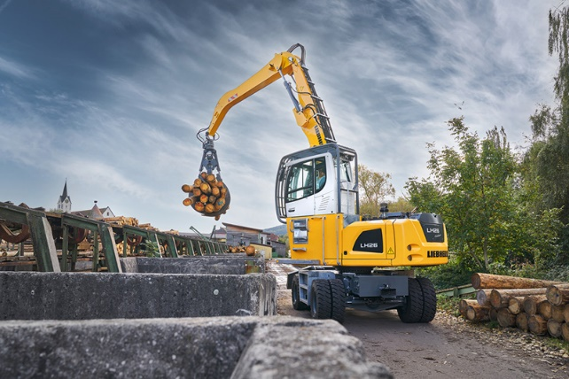
liebherr-lh-26-m-timber-litronic-1.jpg
Liebherr will unveil the new LH 26 M Timber Litronic timber truck at LIGNA in Hanover.

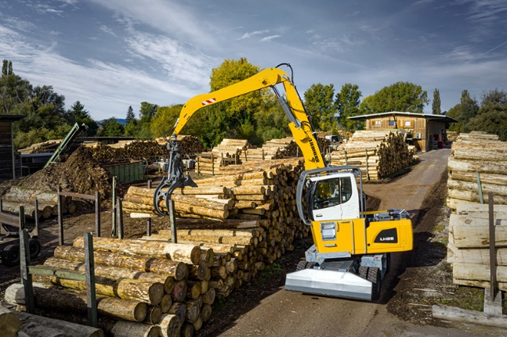
liebherr-lh-26-m-timber-litronic-2.jpg
Thanks to its compact design and exceptional manoeuvrability, this specialist machine is ideal for work in sawmills and lumber yards where space is at a premium.

Contact
Nadine Willburger
Marketing
Phone: +49 7354 / 80 - 7332
Email: nadine.willburger@liebherr.com
Published by
Liebherr-Hydraulikbagger GmbH
Kirchdorf an der Iller / Germany
www.liebherr.com

