Press release

New Liebherr L 580 LogHandler XPower® makes its début at Ligna 2023

⸺
Liebherr L 580 LogHandler XPower® as special wheel loader for handling logs
Power-split travel drive increases productivity, new lift arms and optimised grapple
Innovative equipment and assistance systems for convenient and safe timber handling
The L 580 LogHandler XPower® will make its trade fair début in May 2023 at the world-leading Ligna trade fair
Liebherr will exhibit a new version of the L 580 LogHandler XPower®, the special wheel loader for the timber industry. The overhauled model has been optimised in multiple ways, including the lift arms which have been developed for handling logs and for operating with the relevant grapples. The modified lift arms are capable of manipulation heights of up to seven metres and have a reach of nearly four metres, enabling versatile work in the timber yard. Structural adjustments, particularly on the swivel arm, improve visibility. These innovations help operators move more cubic metres of wood per hour and so increase their productivity. As of now, the new L 580 LogHandler XPower® can be purchased from Liebherr sales partners and will be showcased for the first time at a trade fair at Ligna 2023 in May.
Hanover (Germany), 15th May 2023 – The L 580 LogHandler XPower® is based on the standard version of the Liebherr L 580 XPower® wheel loader. It has many of the advantages for which the XPower® wheel loaders are renowned, in particular, the XPower® power-split travel drive, which Liebherr installs on all XPower® models as standard. With its high performance, low fuel consumption and a final speed of 40 km/h, the L 580 LogHandler XPower® excels during short loading cycles as well as over long distances. Responding to customer requests, Liebherr has adopted multiple equipment options from its standard wheel loaders for the new L 580 LogHandler XPower®. For example, the active personnel detection, an innovative assistance system to increase safety and the steering wheel-free operator's cab with convenient joystick steering.
Productivity in timber work with new lift arms and optimised grapple
The special wheel loader's lift arms consist of a newly designed swivel arm and an optimised boom. The new swivel arm has no components which could impair visibility. It is designed so the view of the grapple, the logs being transported, the woodpiles and the vehicles to be loaded remains unobstructed. Liebherr has reworked the geometry of the boom so the machine operator can move the grapple laden with logs optimally and with more power in all directions, even at great heights. The stroke limit damping thereby ensures a gentle movement to the end positions of the working hydraulics, which reduces jolting and extends the components' service life.
The new lift arms on the L 580 LogHandler XPower® are notable for other intelligent solutions. For example, the machine operator can program individual lift arm positions on the touch display in the cab. Recurring work procedures can therefore be repeated automatically and safely, increasing convenience when handling logs. The electrohydraulic pilot control and angle sensors are the technical foundation for this. Together with other pressure sensors, they ensure that the optional weighing system can weigh the load in the grapple at any time. An indicator in the display, which provides information on the machine's stability enhances this weighing system.
The new, optional grapple monitoring system, including a camera fitted on the boom, also increases safety. It provides a direct view of the working attachment and transmits a live image on an additional display in the operator's cab, improving visibility for the machine operator. In the rework process, Liebherr has also adapted the grapples, which have a capacity of up to 4.0 m². These are greater than on previous models and are optimised for easy loading. Their claws are wider than before to make log transportation more stable and safer. The grapple, which can be rotated 360° and allows logs to be manipulated in all directions, ensures maximum versatility.
Convenience and safety in the timber yard with XPower® operator's cab and assistance systems
The spacious cab on the L 580 LogHandler XPower® is a safe and convenient workspace for the machine operator. The interior is logically designed and storage options and control elements form an ergonomic unit. The multiple hydraulic functions of the lift arms and grapple, and the travel direction can all be precisely controlled with one hand using the Liebherr control lever, which moves with the operator's seat. Other functions can be easily operated using the state-of-the-art, height-adjustable touch display or the buttons positioned near the control lever.
In the design without the steering wheel, the operator's cab is generously proportioned and the steering column is also omitted. In this case, customers must have their L 580 LogHandler XPower® fitted with the optional joystick steering when ordering. Joystick steering allows the operator to steer easily with just one hand. This makes working more pleasant because intensive turning of a steering wheel is replaced by short movements on an ergonomically designed joystick. The position of the joystick always corresponds to the machine's respective articulation angle. With force feedback on the joystick this ensures intuitive and safe operation, even at high speeds and on challenging terrain.
Other innovative equipment is also available on the new L 580 LogHandler XPower®, like active personnel detection. This optional assistance system, which is installed at the rear, warns of dangers to the rear of the machine both visually on the display and with acoustic signals in the cabin. In order to provide a specific warning of imminent injury to people, the assistance system independently distinguishes between people and objects using smart sensors. As soon as active personnel detection emits a warning signal, the brake assistant automatically reduces the machine's speed. This eliminates the human reaction time required for conventional braking. This shortens the stopping distance by crucial metres, further reducing the frequency and severity of accidents and making the timber yard safer.
About Liebherr-Werk Bischofshofen GmbH
Liebherr-Werk Bischofshofen GmbH develops, produces and sells wheel loaders from the Liebherr Group. The plant in Salzburger Land (Austria) has grown steadily over the decades thanks to sustainable innovations, creative solutions and high quality standards. The wheel loader range is constantly being expanded and includes models in different product groups: compact loaders, stereo loaders, and mid-sized and large wheel loaders with impressive, innovative drive designs.
About the Liebherr Group
The Liebherr Group is a family-run technology company with a highly diverse product portfolio. The company is not only one of the largest construction equipment manufacturers in the world, but also provides high-quality and user-oriented products and services in a wide range of other areas. The Liebherr Group now includes over 140 companies across all continents. In 2021, the group employed more than 49,000 staff and achieved combined revenues of over € 11.6 billion. Liebherr was founded in 1949 in Kirchdorf an der Iller. Since then, staff have pursued the goal of contributing to technological advancement and bringing industry-leading solutions to its customers.
Images
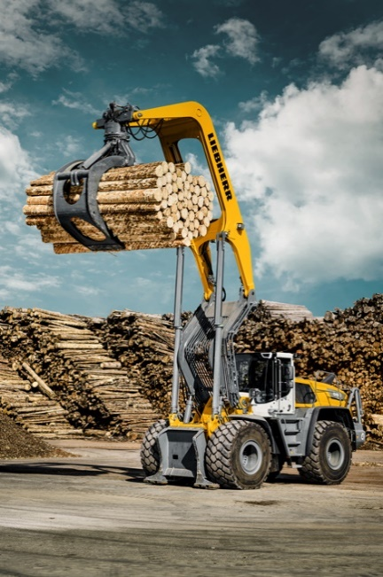
liebherr-l580-loghandler-xpower-new-version-2023-1.jpg
A high-performance specialist machine for handling logs: The Liebherr L 580 LogHandler XPower®.

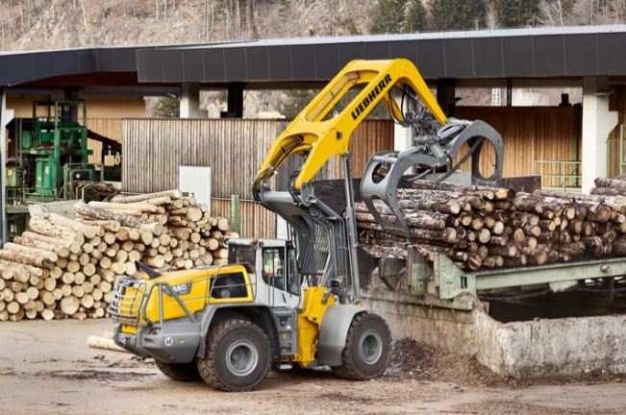
liebherr-l580-loghandler-xpower-new-version-2023-2.jpg
The Liebherr L 580 LogHandler XPower® has special lift arms for long reaches and large manipulation heights.

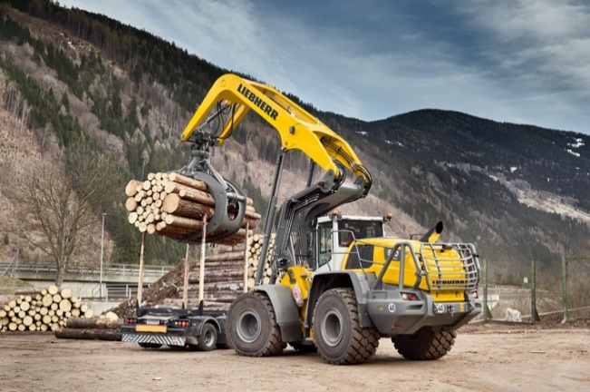
liebherr-l580-loghandler-xpower-new-version-2023-3.jpg
The Liebherr L 580 LogHandler XPower® loads a lorry with logs.

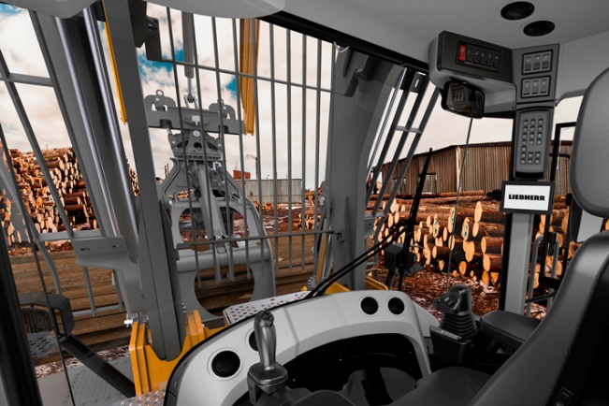
liebherr-l580-loghandler-xpower-new-version-2023-cabin.jpg
Optimal view and plenty of space: the operator's cab in the L 580 LogHandler XPower® without steering wheel.

Contact
Martin Koller
Marketing and Public Relations
Phone: +43 50809 11475
E-mail: martin.koller.lbh@liebherr.com
Published by
Liebherr-Werk Bischofshofen GmbH
Bischofshofen/Austria
www.liebherr.com

