Press release

Liebherr at LIGNA 2023: Special machines and solutions for the timber and forestry industry

⸺
Making its trade fair debut: the Liebherr L 580 LogHandler XPower® is a specialized wheel loader for handling logs
The new LH 26 M Timber Litronic material handler is ideal for use in confined spaces
The Liebherr T 60-9s telescopic handler will demonstrate its abilities as a powerful multifunction machine for diverse industrial applications
The Liebherr stand in the outdoor area will also host impressive demonstrations by STIHL TIMBERSPORTS®
Liebherr will showcase its special machines and solutions for the wood processing industry at the LIGNA 2023 international trade fair for the timber and forestry sector in Hanover. From 15 to 19 May, visitors will be able to explore Liebherr's approximately 475 m² exhibition stand in the fair's outdoor area (Corner 7, Stand L44). The Liebherr LH 26 M Timber Litronic material handler and the Liebherr T 60-9s telescopic handler will be among the machines on display. The Liebherr L 580 LogHandler XPower® is a specialized wheel loader for handling logs that will make its trade fair debut at LIGNA. In addition, an athlete from the STIHLTIMBERSPORTS® series will be a guest on the Liebherr stand and will put on an impressive sawing show. The various product demonstrations will take place several times each day.
Kirchdorf an der Iller (Germany), 03 May 2023 – Liebherr offers a broad range of powerful special machines and solutions for efficient timber handling. These machines are optimally designed for jobs such as loading and unloading trucks and trailers, log sorting and transport. For these tasks, good driving performance, high payloads and fast working cycles are the order of the day. Whether working as a material handler, wheel loader or telescopic handler, these machines are equipped to drive quickly and manoeuvre nimbly while handling raw materials precisely and delicately; for example, during gripping and sorting work. Liebherr will exhibit four of its special-purpose machines at LIGNA.
Wheel loader for increased productivity in timber handling
Liebherr will present a new version of its L 580 LogHandler XPower®, a specialized wheel loader for the timber industry, at LIGNA 2023. This machine is based on the standard version of the Liebherr L 580 XPower® wheel loader and provides many of the now familiar advantages of the XPower line-up; chief among them, the power-split XPower travel drive. The upgraded model features numerous optimisations; for example, on the lift mast and the associated grapples, which were specially developed for log handling.
For flexible work in the timber yard, the modified mast allows manipulation heights of up to seven metres and a reach of almost four metres. Some design-related adjustments, especially to the basic boom, have also resulted in improved visibility. These innovations will enable operating companies to move more cubic metres of wood per hour and thus increase their productivity. The new L 580 LogHandler XPower® is available now from Liebherr sales partners.
Liebherr will also showcase the L 538 as a representative of its new series of medium-sized wheel loaders, which it has recently redeveloped and fundamentally revised. The redesigned mast, which ensures the highest possible breakout, holding and retrieval forces, features optimised Z-kinematics and improved working hydraulics. With their increased engine power and tip loads, these wheel loaders are ready for a wide range of demanding operations in various industries. The latest innovations enable faster cycle times and dynamic and powerful working movements – even with heavy attachments such as high-tip buckets or wood grapples.
New Liebherr LH 26 M Timber Litronic material handler
The new LH 26 M Timber Litronic will also be on show at LIGNA. Thanks to its extremely compact design and exceptional manoeuvrability, this specialist handling machine is ideal for use in sawmills and lumber yards where space is at a premium. It also boasts impressively low fuel consumption when operating at maximum capacity.
With the LH 26 M Timber Litronic, Liebherr has expanded its existing portfolio to include a lighter machine with an operating mass of between 23,500 and 26,000 kg. This model is also equipped with a new integrated tyre pressure monitoring system, which allows the desired target tyre pressure to be set and monitored on the display in the operator's cab. The system will be optionally available for Liebherr timber handlers from October.
Liebherr T 60-9s telescopic handler – a multifunctional machine for industrial applications
Another vehicle that will be presented by Liebherr is the T 60-9s telescopic handler, the largest of the three industrial machines, which have proven themselves as efficient multifunctional workhorses in a myriad of applications.
With payloads of up to six tonnes and powerful working hydraulics, they allow goods to be lifted quickly and positioned with pinpoint accuracy. Being equipped with all-wheel drive, these machines can move heavy loads at great heights and are also ideal for work on unpaved ground. When manoeuvring in tight spaces, machines with excellent agility excel. Thanks to a particularly large steering angle combined with a long wheelbase, Liebherr telescopic handlers offer precisely this kind of manoeuvrability without sacrificing load capacity. In addition, these machines feature a continuous front windscreen that provides excellent visibility upwards – the best prerequisite for safe working. With the optionally available fine control, the working hydraulics can be adapted to the required application scenario – including the use of all power reserves and a fine-control range for precise operation.
Relaxed and comfortable driving is another basic requirement for the safe operation of telescopic handlers. Liebherr machines stand out here thanks to numerous intelligent and detailed solutions. The programmable constant flow rate, for example, allows the speed of road sweepers to be precisely controlled. With the optionally available manual control package, the travel speed can be adjusted as required. All in all, the eight models in the Liebherr telescopic handler series cover an extremely wide range of applications. These machines are available both as an s-variant for demanding applications and as a value variant. This means that customers can find the perfect machine for every requirement.
Impressive STIHLTIMBERSPORTS® shows
At the Liebherr stand, athlete Christoph Lang from STIHL TIMBERSPORTS® will demonstrate his skills on a high-horsepower chainsaw and a two-metre-long hand-pulled saw. On site, Lang will demonstrate the action-packed Stock Saw and Single Buck saw disciplines from the STIHLTIMBERSPORTS® series. Visitors can look forward to four exciting shows on each day of the fair.
As a special highlight between the demonstrations, anyone interested will also get the chance to test their own woodworking talent under Lang's professional guidance. Using the so-called Single Buck, a two-metre hand-pulled saw, visitors will be able to slice off their own "cookie" as a trophy.
About the Liebherr Group
The Liebherr Group is a family-run technology company with a highly diversified product portfolio. The company is one of the largest construction equipment manufacturers in the world. It also provides high-quality and user-oriented products and services in a wide range of other areas. The Liebherr Group includes over 140 companies across all continents. In 2022, it employed more than 50,000 staff and achieved combined revenues of over 12.5 billion euros. Liebherr was founded in Kirchdorf an der Iller in Southern Germany in 1949. Since then, the employees have been pursuing the goal of achieving continuous technological innovation, and bringing industry-leading solutions to its customers.

Images
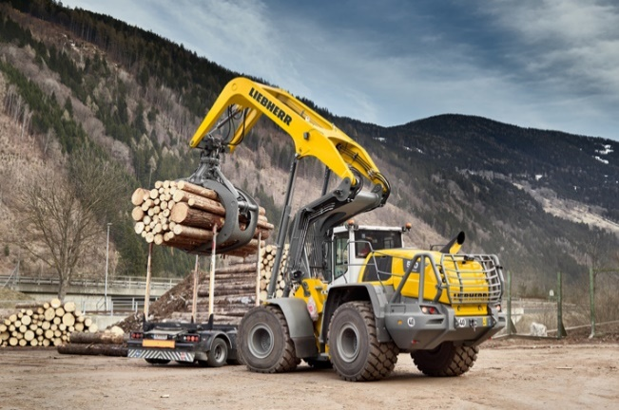
liebherr-l580-loghandler-xpower-version-2023.jpg
The Liebherr L 580 LogHandler XPower® loads logs onto a truck.

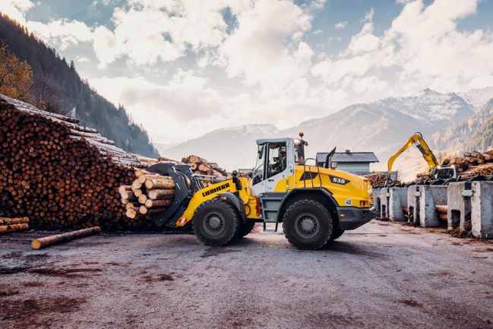
liebherr-mid-sized-wheel-loader-l538-timber.jpg
New high-performance mast: the Liebherr L 538 wheel loader transports logs with a wood grapple.

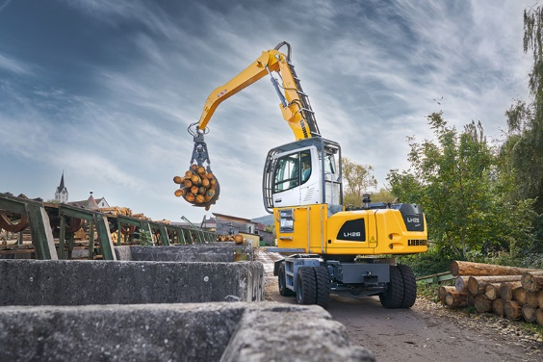
liebherr-lh-26-m-timber-litronic.jpg
Liebherr will unveil the new LH 26 M Timber Litronic material handler at LIGNA in Hanover.
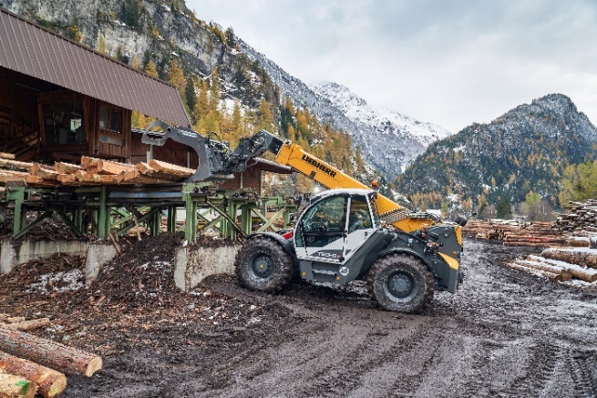
liebherr-t-60-9s.jpg
The Liebherr T 60-9s is used for timber handling in the sawmill.

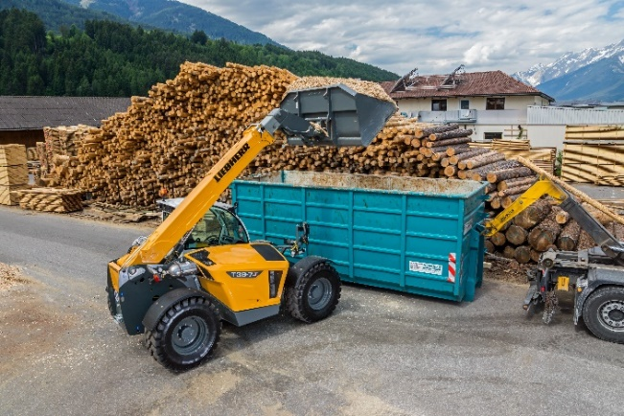
liebherr-t-36-7s.jpg
The Liebherr T-36-7s loads wood chips into a container.

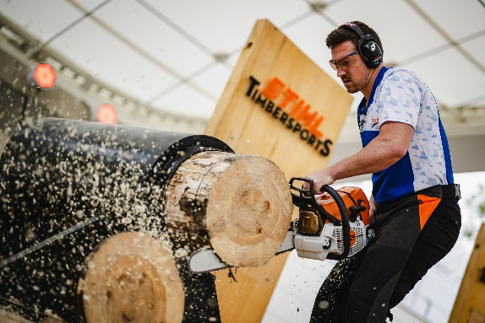
liebherr-stihl.jpg
Also at the Liebherr stand in the fair's outdoor area: impressive shows by STIHL TIMBERSPORTS®.

Contact
Nadine Willburger
Marketing
Phone: +49 7354 / 80 - 7332
Email: nadine.willburger@liebherr.com
Martin Koller
Marketing and Public Relations
Phone: +43 50809 / 11475
Email: martin.koller.lbh@liebherr.com
Lisa Kahlig
Marketing PR & Press
Phone: +43 50809 61413
Email: lisa.kahlig@liebherr.com
Published by
Liebherr-Hydraulikbagger GmbH
Kirchdorf an der Iller / Germany
www.liebherr.com

