Press release

First LR 1400 SX in the Middle East for “The King of Barges”

⸺
Al Jazeera Shipping Co. W.L.L. is considered to be one of the largest marine operators in the Gulf region with a fleet of over 150 units consisting of various sizes and types of tugs, barges and other equipment. The company recently extended its fleet with Liebherr’s brand new LR 1400 SX crawler crane.
Nenzing (Austria), 28 April 2023 - Al Jazeera Shipping Co. W.L.L. has been active in both the maritime and the offshore and oil industries for over 45 years. The main activities of the company include chartering tugboats, supply boats, accommodation and work barges, as well as leasing offshore construction equipment. The company also has its own marine fabricating yard to carry out the associated repair and maintenance jobs. It covers an area of over 80,000 square metres with 300 metres water frontage and is adjacent to the Mina Salman Port area.
Back in early 2022, Mr. Ali Hasan Mahmood, Managing Director of Al Jazeera Shipping, commonly known under his alias “The King of Barges”, expressed his desire to renew one of his used older generation crawler cranes. This led him to various suppliers and his attention was caught by the latest addition to the Liebherr crawler crane range, namely the 400-tonne LR 1400 SX. Apart from the crane’s superior load curve and safety ratings, Mr. Ali Hasan’s decision to go with Liebherr was mainly driven by the model’s short assembly time, its preselection feature of individually customized load charts and, in particular, its capability to preselect barge inclinations, which automatically applies the permitted load curve. The LR 1400 SX has just recently been commissioned and will be working on several projects with Bapco and its refinery in Bahrain beginning in May 2023.
“We are proud to be the first company in the Gulf to receive the Liebherr 400-tonne crawler crane model LR 1400 SX. Hopefully more Liebherr crawler crane purchases are to come with the assistance and full cooperation from Liebherr. A great association,” says Ali Hasan Mahmood.

Further details about the LR 1400 SX:
Animation: Liebherr - Crawler Crane LR 1400 SX - YouTube
Gradient Travel Aid: Liebherr - Gradient Travel Aid - YouTube
Boom Up-and-Down Assistant: Liebherr – Boom Up-and-Down Assistant - YouTube
Ground pressure visualization: Liebherr - Ground Pressure Visualization - YouTube
Images
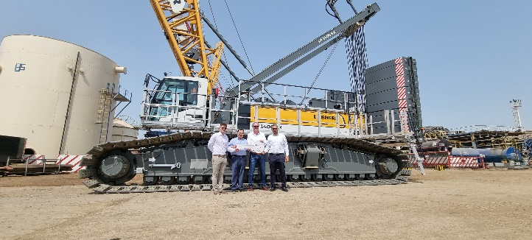

liebherr_lr1400sx_handover.jpg
The handover of Liebherr’s first LR 1400 SX in the Middle East (from left to right):
Jasmin Music (Liebherr), Ali Hasan Mahmood (Al Jazeera Shipping), Knut Brandenburg and Samir Hussein (Liebherr)
Contact
Gregor Griesser
Strategic Marketing and Communications
Email: gregor.griesser@liebherr.com
Wolfgang Pfister
Head of Strategic Marketing & Communications
Tel.: +43 50809 41444
Email: wolfgang.pfister@liebherr.com
Published by:
Liebherr-Werk Nenzing GmbH
Nenzing/Austria
www.liebherr.com

