Press release

Three LR 1700-1.0 cranes for Canada – GUAY reinforces crawler crane fleet with Liebherr 700 tonne models

⸺
GUAY plans to use the LR 1700-1.0 cranes specially for erecting wind turbines
The LR 1700-1.0 cranes will be the largest crawlers in GUAY fleet
Narrow track concept is a winner

Canadian crane contractor GUAY has ordered three LR 1700-1.0 crawler cranes from Liebherr. One of them has been ordered with a narrow track chassis. The company plans to use this crane in particular in wind farms. With the new cranes, GUAY is meeting the growing demands for lifting capacity and hoisting height for erecting wind turbines. The 700 tonne cranes will be the most powerful Liebherr crawlers models in the company's fleet. The economical transport concept of the LR 1700-1.0 was an important feature behind GUAY’s decision to buy the new cranes.
Ehingen (Donau) (Germany), 27 April 2023 - "We are seeing a strong increase in demand for new wind farms in our market. The government is investing large sums in green energy to meet the growing demand. We need to invest in larger crawler cranes as wind turbines get heavier and taller", said Executive Vice President Guillaume Gagnon, explaining the company’s purchase of the three LR 1700-1.0 cranes.
The new Liebherr cranes will reinforce the Canadian crane specialist's fleet and deliver the highest hoisting heights in the fleet. GUAY mainly plans to use the 700 tonne models in wind farms, but they will also be used in industry and for construction work. "We will now be able to erect wind turbines up to 165 metres in height and the maximum hook height of 196 metres will enable us to work on tall buildings," Gagnon added. "We chose the LR 1700-1.0 to be able to provide our customers with a state-of-the-art crane for their future wind projects. After completing our research, the high lifting capacity and small footprint proved to be the perfect combination for us. Compared to larger crawler cranes, the transport costs for the LR 1700-1.0 are lower due to the perfect weight and size of its components."
Economical transport and innovative crane technology
The LR 1700-1.0 from Liebherr combines the benefits of economical transport from crawler cranes in the 600 tonne class with the performance of lattice boom cranes in the 750 tonne class and all the innovations featured in Liebherr’s crawler crane developments from the last few years, such as VarioTray and V-Frame. VarioTray is a small counterweight frame that can be unbolted quickly and easily as required. This eliminates the need for tiresome stacking and unstacking of counterweight plates. The V-frame ballast system is a hydraulically adjustable folding frame which enables the ballast radius of the LR 1700-1.0 to be infinitely adjusted between 13 and 21 metres. A rigid ballast guide system is thus no longer required for large radii.
Gagnon continued: "The V-Frame increases the crane’s capacity and flexibility to do all the work we have planned. VarioTray saves us time when working on wind power projects because we only need a lot of counterweight to erect long boom configurations. We have been working with Liebherr for a long time. We like the fact that Liebherr continually creates innovations that drive the industry forward. The LR 1700-1.0 is the latest model in this crawler crane class and it will also meet the requirements of the future thanks to its state-of-the-art crane technology."
GUAY is one of the largest privately owned crane companies in Canada and North America, with more than 20 outlets in the province of Quebec and will see it celebrate its 60th anniversary next year. Jean-Marc Baronet founded the company in 1964 and is still its owner and president at the age of 92. His goal has always been to continue to deliver new solutions to his customers by investing in new technologies and larger equipments. Today, the company employs around 625 people and operates over 500 cranes of various types.

About Liebherr-Werk Ehingen GmbH
Liebherr-Werk Ehingen GmbH is a leading manufacturer of mobile and crawler cranes. Its range of mobile cranes extends from 2-axle 35 tonne cranes to heavy duty cranes with a lifting capacity of 1200 tonnes and a 9-axle chassis. Its lattice boom cranes on mobile or crawler crane chassis deliver lifting capacities of up to 3000 tonnes. With universal boom systems and extensive additional equipment, they can be seen in action on construction sites throughout the world. The Ehingen site has a workforce of 4,300. Extensive, global service guarantees the high availability of Liebherr mobile and crawler cranes.
About the Liebherr Group
The Liebherr Group is a family-run technology company with a highly diversified product portfolio. The company is one of the largest construction equipment manufacturers in the world. It also provides high-quality and user-oriented products and services in a wide range of other areas. The Liebherr Group includes over 140 companies across all continents. Liebherr was founded in Kirchdorf an der Iller in Southern Germany in 1949. Since then, the employees have been pursuing the goal of achieving continuous technological innovation, and bringing industry-leading solutions to its customers.

Image:
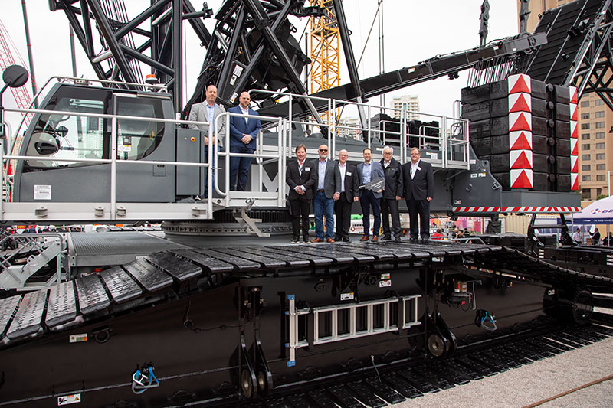

liebherr-lr1700-1.0-guay.jpg
From left to right: Eric Beauvais, Jean-Francois Houde (both from GUAY.), Lee Spalding (Liebherr Canada Ltd.), Michel Riverin (GUAY), Kyle Jardine (Liebherr Canada Ltd.), Guillaume Gagnon (GUAY) Dr. h. c. Willi Liebherr (Liebherr International AG) and Tim Petersen (Liebherr Canada Ltd.).

Contact
Wolfgang Beringer
Marketing and Communication
Phone: +49 7391/502 - 3663
Email: wolfgang.beringer@liebherr.com
Published by
Liebherr-Werk Ehingen GmbH
Ehingen (Donau) / Germany
www.liebherr.com

