Press information

Liebherr cranes at work on Europe's first CO₂-neutral thermal spa in Milan

⸺
Transport and assembly-optimised 125 EC-B 6 and 240 EC-B 12 Fibre flat-top cranes
Fibre technology delivers strong performance and easy handling of hoist rope
Tailored support and comprehensive service for successful crane operation
Thermal waters will soon be bubbling where horses were once kept: Europe’s first CO₂-neutral thermal spa is under construction in Milan’s San Siro district. For years, the historic De Montel stables were left to fall into disrepair. A new lease of life is now being given to the 1.6-hectare site. Two transport and assembly-optimised Liebherr cranes, a 125 EC-B 6 and a 240 EC-B 12 Fibre, are instrumental in this project.
Milan (Italy), 27 April 2023 – Moving concrete buckets, placing formwork, and lifting steel parts: the top-slewing cranes are involved in various tasks for the spa’s shell construction and renovation of the historic stables in the north-west of Milan. Built between 1915 and 1918 in Art Nouveau style, the De Montel stables quickly became one of Italy's most prestigious equestrian centres. Decline set in following the Second World War and the facility increasingly fell into disrepair.
Flexible jib lengths
A 125 EC-B 6 flat-top crane with a six-tonne maximum lifting capacity is now helping shape a new beginning. The crane features a 50 metre-long jib and has a freestanding hook height of 30 metres. A 240 EC-B 12 Fibre with a freestanding hook height of 44 metres and a 65-metre long jib is also in use, delivering a maximum lifting capacity of twelve tonnes.
Thanks to their reach, the two flat-top cranes, which also have intelligent assistance systems for efficient and safe lifting installed, can comfortably reach all corners of the construction site. Jibs from the EC-B series can be accurately adjusted to site requirements using two-and-a-half-metre sections.
Fibre rope advantages
The “Fibre” part of the 240 EC-B’s name stands for Liebherr’s pioneering fibre rope technology. Fibre cranes achieve significantly higher performance values compared to their steel rope counterparts. Fibre rope is also more durable, easier to handle when reeving due to its lighter weight, and maintenance is less complicated as lubrication isn’t required. And a further advantage: crane operators are able to see at a glance when the fibre rope needs changing. The components of the rope’s cover wear out at different rates – a red layer indicates that the rope has reached the end of its service life. This increases safety during operation.
Italy’s largest city spa
There are thermal water springs running underneath the construction site, some 300 metres below the ground. So, the area is ideal for a thermal spa. Italy’s largest city spa primarily stands out because of its sustainability focus. The spa is designed to produce no CO₂ emissions during operation. Its owners have opted for a whole package of measures, such as photovoltaic systems, solar thermal panels, connection to a district heating network, the reuse of rainwater, and the recovery of energy from waste.
Optimal overall package
The construction company Techbau S.p.A, based in Castelletto Sopra Ticino (NO), purchased the cranes for this project through Liebherr dealer Niederstätter. “We chose Liebherr cranes based on the professional advice we received from Niederstätter. The 125 EC-B 6 and 240 EC-B 12 Fibre flat-top cranes are perfect for this project on account of their design, lifting capacity and reach,” says Techbau project manager Mario Corrias. Niederstätter is also providing support in terms of crane maintenance and servicing. The cranes are scheduled to be dismantled towards the end of 2023, subject to progress on site.
About the Liebherr Tower Cranes Division
More than seven decades of experience have made Liebherr a recognised specialist for lifting technology on all types of construction sites. The range of Liebherr Tower Cranes encompasses an extensive selection of high-quality tower cranes that are used worldwide. This includes fast-erecting, top-slewing, luffing jib and special-purpose cranes as well as mobile construction cranes. In addition to these products, Liebherr also offers a wide range of services that complete the company’s portfolio: Tower Crane Solutions, the Tower Crane Center and Tower Crane Customer Service.
About the Liebherr Group
The Liebherr Group is a family-run technology company with a highly diversified product portfolio. The company is one of the largest construction equipment manufacturers in the world. It also provides high-quality and user-oriented products and services in a wide range of other areas. The Liebherr Group includes over 140 companies across all continents. In 2022, it employed more than 50,000 staff and achieved combined revenues of over 12.5 billion euros. Liebherr was founded in Kirchdorf an der Iller in Southern Germany in 1949. Since then, the employees have been pursuing the goal of achieving continuous technological innovation, and bringing industry-leading solutions to its customers.

Images
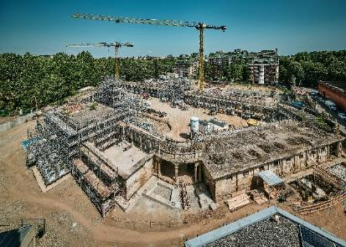
liebherr-ec-b-san-siro-italy-01.jpg
A 125 EC-B 6 and 240 EC-B 12 Fibre from Liebherr are involved in the construction of a sustainable thermal spa in Milan, Italy.
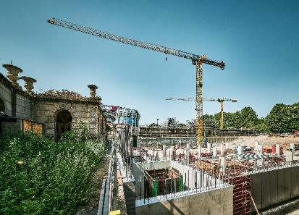
liebherr-ec-b-san-siro-italy-02.jpg
The historic De Montel stables are being integrated into the new facility.
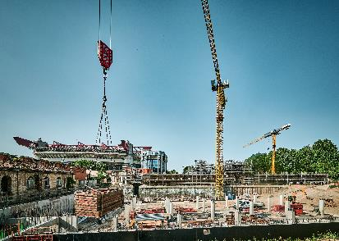
liebherr-ec-b-san-siro-italy-03.jpg
The flat-top cranes will continue supporting renovation and structural work until the end of 2023.

Contact
Daniel Haefele
Global Communication
Phone: +49 7351 / 41 - 2330
Email: daniel.haefele@liebherr.com
Published by
Liebherr-Werk Biberach GmbH
Biberach / Germany
www.liebherr.com

