Press release

Rothmund strengthens crane fleet with Liebherr LTM 1450-8.1

⸺⸺
- LTM 1450-8.1 is Rothmund's strongest mobile crane
- 85-metre telescopic boom and short set-up time were important decision criteria
- First-class customer service and uniform crane control speak in favour of Liebherr
Rothmund GmbH Kran und Montage has significantly strengthened the performance spectrum of its mobile crane fleet: the Liebherr LTM 1450-8.1 is now the Pforzheim-based company's most powerful crane. For managing director Heiko Brückner, the 85-metre telescopic boom and the short set-up time on the construction site were important decision criteria for the Liebherr 450-tonner.
Ehingen (Donau) (Germany), 25 April 2023 – Rothmund has increased the maximum lifting capacity of its crane fleet from 350 to 450 tonnes with the LTM 1450-8.1. Heiko Brückner explains: "Everything is getting bigger and heavier. That's why we decided to purchase an additional crane with a higher lifting capacity. The order volume was there."
At 85 metres, the LTM 1450-8.1 has the world's longest telescopic boom in the 8-axle class, which can be carried on public roads with a twelve-tonne axle load. This means it is quickly ready for use on the construction site. "We are thrilled with the concept of the crane. It is quickly set up and with its 85-metre jib it is optimal for construction crane assemblies," says Brückner.
Rothmund has procured six new Liebherr cranes since 2020. Two more are on order. Brückner reports, "At Bauma we ordered an LTM 1150-5.3 and the brand new LTM 1100-5.3. Around 95 per cent of our mobile cranes now come from Liebherr. The customer service is unbeatable. We also take advantage of the Liebherr training offer for our crane operators. Liebherr offers another big advantage: because the control system is the same from small to large cranes, we can flexibly deploy our drivers on different equipment."
Rothmund GmbH was founded in 1982 as a crane company in the Pforzheim area. The customers' demands grew so rapidly that after one and a half years there were already three cranes in operation and after five years there were five. Over the years, the company has developed into a service provider for heavy and machinery transport as well as plant relocation. In the meantime, a number of special vehicles such as safe crawlers, air cushion systems and loading cranes are part of the equipment.
About Liebherr-Werk Ehingen GmbH
Liebherr-Werk Ehingen GmbH is a leading manufacturer of mobile and crawler cranes. Its range of mobile cranes extends from 2-axle 35 tonne cranes to heavy duty cranes with a lifting capacity of 1200 tonnes and a 9-axle chassis. Its lattice boom cranes on mobile or crawler crane chassis deliver lifting capacities of up to 3000 tonnes. With universal boom systems and extensive additional equipment, they can be seen in action on construction sites throughout the world. The Ehingen site has a workforce of 4,300. Extensive, global service guarantees the high availability of Liebherr mobile and crawler cranes. In 2022, the Liebherr plant in Ehingen recorded a turnover of 2.37 billion euros.
About the Liebherr Group
The Liebherr Group is a family-run technology company with a highly diversified product portfolio. The company is one of the largest construction equipment manufacturers in the world. It also provides high-quality and user-oriented products and services in a wide range of other areas. The Liebherr Group includes over 140 companies across all continents. In 2022, it employed more than 50,000 staff and achieved combined revenues of over 12.5 billion euros. Liebherr was founded in Kirchdorf an der Iller in Southern Germany in 1949. Since then, the employees have been pursuing the goal of achieving continuous technological innovation, and bringing industry-leading solutions to its customers.
.
Images:
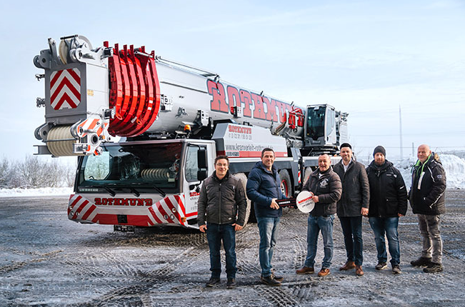
liebherr-ltm1450-8.1-rothmund.jpg
Crane handover in Ehingen: (f.l.t.r.) Oliver Rösch (Rothmund GmbH), Joachim Sommer (Liebherr-Werk Ehingen GmbH), Heiko Brückner (Rothmund GmbH), Alexander Schwald (Liebherr-Werk Ehingen GmbH), Lilo Puma, Tilo Schäfer (beide Rothmund GmbH).
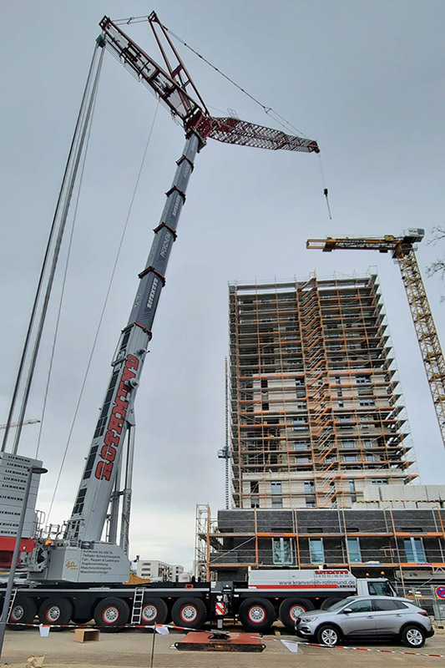
liebherr-ltm1450-8.1-rothmund-einsatz.jpg
The assembly of tower cranes is an important field of application for the LTM 1450-8.1.

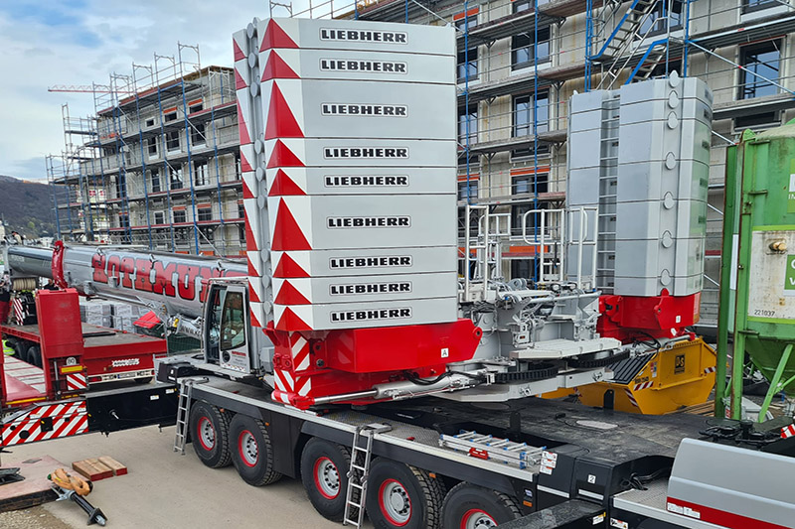
liebherr-ltm1450-8.1-rothmund-varioballast.jpg
The VarioBallast® is a great advantage in confined operating conditions: The ballast radius can be infinitely reduced from 7 metres to 5 metres with a simple hydraulic swivel mechanism.

Contact
Wolfgang Beringer
Marketing and Communication
Phone: +49 7391/502 - 3663
Email: wolfgang.beringer@liebherr.com
Published by
Liebherr-Werk Ehingen GmbH
Ehingen (Donau) / Germany
www.liebherr.com

