Press release

Liebherr power for the energy transition

⸺
Liebherr mobile cranes build on important route for wind power
LTM 1230-5.1 erects overhead line pylons in daily cycles with LTM 1070-4.2
Albert Regel GmbH has already erected over 100 electricity pylons
The transport of wind power from the coastal regions to the south of Germany is an essential point for the success of the energy transition and the transformation towards renewable energies. In order to expand these capacities, new, high-performance power lines are indispensable. The largest project currently underway, an extra-high voltage line through Lower Saxony and Hesse, is being realised with Liebherr mobile cranes from Albert Regel GmbH, among others.
Ehingen (Donau) (Deutschland), 21. April 2023 – The energy transition project with the somewhat unadorned title "Wahle-Mecklar" has it all: 555 mighty electricity pylons have to be erected over a length of 230 kilometres. Only a very small part of the route will be bridged with underground cables. The new power line, which runs through the federal states of Lower Saxony and Hesse, is scheduled for completion in 2024 after a total of four years of construction. Several Liebherr mobile cranes are being used to erect the pylons, which are up to 90 metres high. Albert Regel GmbH, headquartered in Baunatal near Kassel in Hesse, regularly sends equipment from its modern fleet to the pipeline construction site.
Extremely long telescopic boom - usually no jib required
"When it comes to mast construction, the crane of choice here is clearly our LTM 1230-5.1," reports Daniel Stawizki, dispatcher at Regel. "With its 75-metre telescopic boom, the mobile crane can manage almost all of these jobs without the aid of a jib. We only use a 32-metre fixed jib on the crane for the largest of the up to 90-metre high overhead line pylons. A few times we have also sent out our 300-tonne LTM for this."
Most of the time, Regel's LTM 1070-4.2 flanks the crane work on the future power line. It handles the individual lattice tower elements on the ground and lends a hand when the components have to be brought into a vertical position for assembly together with the large mobile crane. This compact, modern 70-tonne mobile crane can carry most of its ballast on the road. Moreover, due to its active and speed-dependent rear-axle steering, it is virtually predestined to easily reach the work sites in the terrain and to be ready to pull within a very short time.
For three years now, Regel's cranes have been moving out to the construction sites of the grid operator Tennet in phases. "We have definitely already erected well over a hundred of the electricity pylons," reports Stawizki. "If everything works out, the completed lattice tower will be up within a day in the evening." The company has also already had an LTM 1200-5.1 in action together with an LTM 1090-4.2 as a team on the construction sites along the route.
At the company's headquarters in Baunatal, Regel operates around 40 mobile cranes together with a depot near Fulda. With the exception of five machines, they all come from the Liebherr factory in Ehingen. In addition to crane work, Albert Regel GmbH also offers heavy transport as well as machine and industrial relocations.
About Liebherr-Werk Ehingen GmbH
Liebherr-Werk Ehingen GmbH is a leading manufacturer of mobile and crawler cranes. Its range of mobile cranes extends from 2-axle 35 tonne cranes to heavy duty cranes with a lifting capacity of 1200 tonnes and a 9-axle chassis. Its lattice boom cranes on mobile or crawler crane chassis deliver lifting capacities of up to 3000 tonnes. With universal boom systems and extensive additional equipment, they can be seen in action on construction sites throughout the world. The Ehingen site has a workforce of 4,300. Extensive, global service guarantees the high availability of Liebherr mobile and crawler cranes. In 2022, the Liebherr plant in Ehingen recorded a turnover of 2.37 billion euros.
About the Liebherr Group
The Liebherr Group is a family-run technology company with a highly diversified product portfolio. The company is one of the largest construction equipment manufacturers in the world. It also provides high-quality and user-oriented products and services in a wide range of other areas. The Liebherr Group includes over 140 companies across all continents. In 2021, it employed more than 50,000 staff and achieved combined revenues of over 12.5 billion euros. Liebherr was founded in Kirchdorf an der Iller in Southern Germany in 1949. Since then, the employees have been pursuing the goal of achieving continuous technological innovation, and bringing industry-leading solutions to its customers.
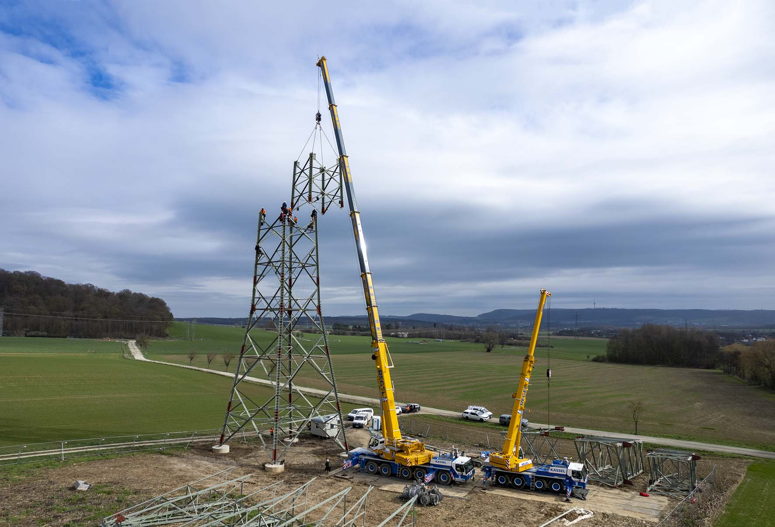
Images:

liebherr-ltm1230-ltm1070-regel-01.jpg
Energy transition: Regel has erected well over 100 electricity pylons with Liebherr mobile cranes.
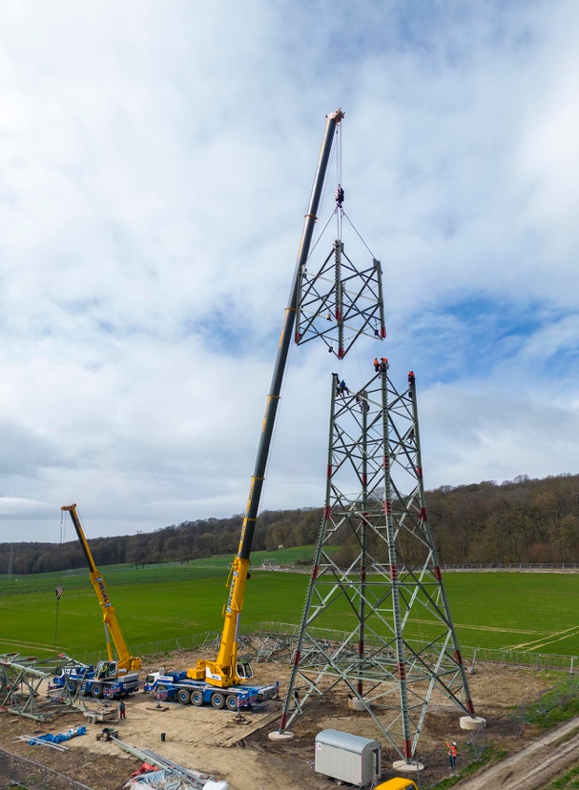
liebherr-ltm1230-ltm1070-regel-02.jpg
Long telescopic boom: Thanks to the impressively long telescopic boom of 75 metres, the LTM 1230-5.1 does not require the time-consuming attachment of jibs for most assembly work.

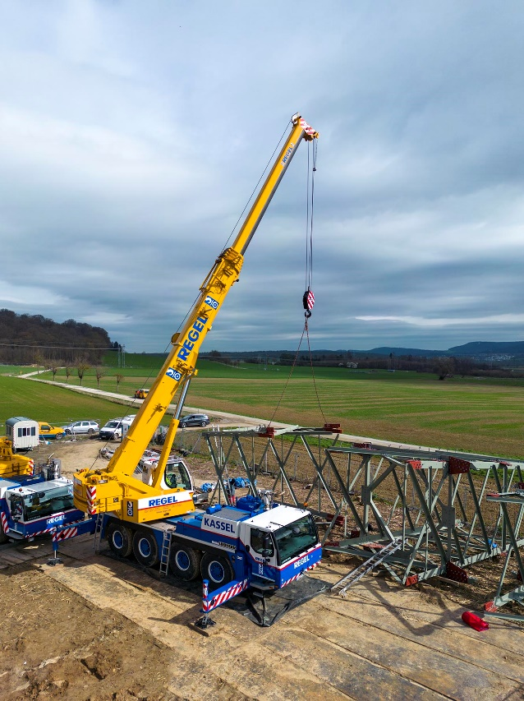
liebherr-ltm1230-ltm1070-regel-03.jpg
All-terrain assistant: While the large Liebherr mobile crane lifts the lattice mast construction of the overhead line, here the LTM 1070-4.2 prepares the next component for assembly.
Contact
Wolfgang Beringer
Marketing and Communication
Phone: +49 7391/502 - 3663
Email: wolfgang.beringer@liebherr.com
Published by
Liebherr-Werk Ehingen GmbH
Ehingen (Donau) / Germany
www.liebherr.com

