Press release

Premiere in the Port of Rostock: Sarens takes delivery of the first Liebherr LR 12500-1.0 crawler crane

⸺
Sarens convinced by performance and concept of new crawler crane
Focus on operations in the renewable energy sector
LR 12500-1.0 will handle in tandem strokes with LR 1800-1.0 monopiles weighing over 1,400 tonnes.
The crane and heavy lifting company Sarens took delivery of the first unit of the new Liebherr LR 12500-1.0 crawler crane at the Port of Rostock on 1 April. Sophie Albrecht, Member of the Board of Liebherr International AG, handed over the symbolic key to Marc Sarens, Director & Member of the Board at Sarens. The globally active Belgian company will use the new Liebherr 2,500-tonne crawler crane primarily in the renewable energy sector, for example for handling offshore wind turbines.
Ehingen (Donau) (Germany), 20 April 2023 – For Sarens, the high capacity of the new Liebherr LR 12500-1.0 was the decisive criterion in purchasing the 2,500-tonne crane. Carl Sarens, Director Technical Solutions, Projects & Engineering says: "The capacity of the LR 12500-1.0 is enormous. Operations in the renewable energy sector, such as here in Rostock, are a particular focus for the crawler crane. The handling of offshore wind turbines in ports is becoming more and more important and the individual weights of the components are constantly increasing. The initial assembly of the new crane worked very well."
During the symbolic handover of the keys to the LR 12500-1.0, Sophie Albrecht, who is responsible for the mobile and crawler crane division within the Liebherr Group, among other things, mentioned an interesting detail: "Today would have been the 108th birthday of my grandfather and company founder Hans Liebherr."
Sarens has given the new crawler crane its own name and dedicated it to a long-time employee: "Straffen Hendrik". The Flemish word "straffen", meaning strength, goodness, robustness, characterises the experienced employee Hendrik Sanders. He has been working for the Belgian company for more than 30 years and is responsible for large cranes as a project planner.
In the port of Rostock, the LR 12500-1.0 will lift 50 monopiles with a diameter of up to nine metres, a length of up to 90 metres and a weight of more than 1,400 tonnes into the water in tandem lifts with a Liebherr LR 1800-1.0 over a period of about eight weeks. Including load handling attachments, the two cranes have gross loads of up to 1,750 tonnes to move. The monopiles, huge foundations for offshore wind turbines, will then be pulled afloat to a special ship, which will then take them to the Baltic Eagle offshore wind farm, which is currently under construction. It is located about 30 kilometres north of the island of Rügen.
About Liebherr-Werk Ehingen GmbH
Liebherr-Werk Ehingen GmbH is a leading manufacturer of mobile and crawler cranes. Its range of mobile cranes extends from 2-axle 35 tonne cranes to heavy duty cranes with a lifting capacity of 1200 tonnes and a 9-axle chassis. Its lattice boom cranes on mobile or crawler crane chassis deliver lifting capacities of up to 3000 tonnes. With universal boom systems and extensive additional equipment, they can be seen in action on construction sites throughout the world. The Ehingen site has a workforce of 4,300. Extensive, global service guarantees the high availability of Liebherr mobile and crawler cranes. In 2022, the Liebherr plant in Ehingen recorded a turnover of 2.37 billion euros.
About the Liebherr Group
The Liebherr Group is a family-run technology company with a highly diversified product portfolio. The company is one of the largest construction equipment manufacturers in the world. It also provides high-quality and user-oriented products and services in a wide range of other areas. The Liebherr Group includes over 140 companies across all continents. In 2022, it employed more than 50,000 staff and achieved combined revenues of over 12.5 billion euros. Liebherr was founded in Kirchdorf an der Iller in Southern Germany in 1949. Since then, the employees have been pursuing the goal of achieving continuous technological innovation, and bringing industry-leading solutions to its customers.

Images:

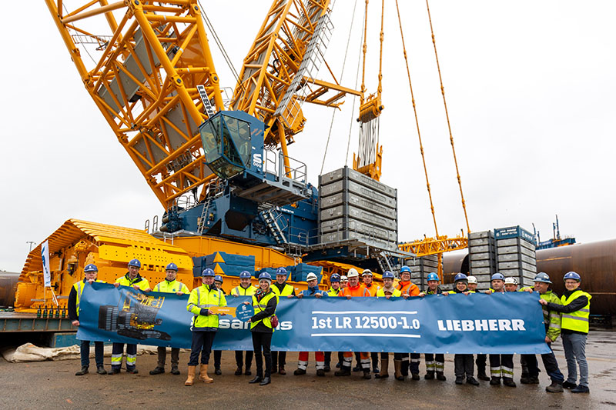
liebherr-lr12500-1.0-sarens-handover.jpg
Sophie Albrecht (Member of the Board of Liebherr International AG) hands over the symbolic key of the LR 12500-1.0 to Marc Sarens.

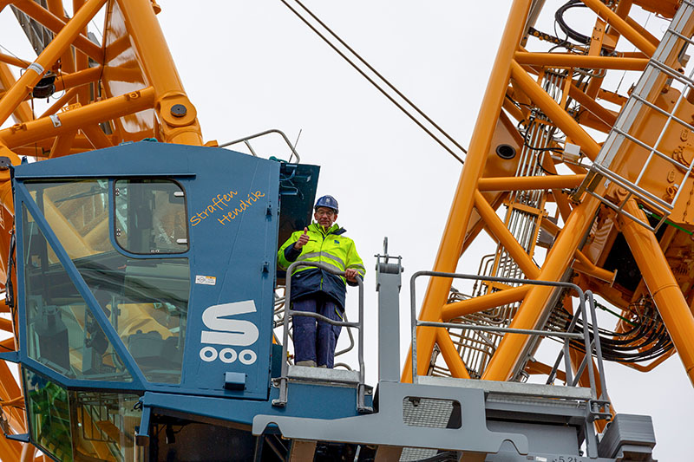
liebherr-lr12500-1.0-hendrik-sanders.jpg
Hendrik Sanders, project planner for large cranes, is pleased about the naming "Straffen Hendrik" in his honour.

Contact
Wolfgang Beringer
Marketing and Communication
Phone: +49 7391/502 - 3663
Email: wolfgang.beringer@liebherr.com
Published by
Liebherr-Werk Ehingen GmbH
Ehingen (Donau) / Germany
www.liebherr.com

