Press information

Liebherr cranes build sustainable office building at Luxembourg Airport

⸺
Seven EC-B series cranes in reliable operation on new building project with tight schedule
Smart assistance systems ensure maximum safety and efficient handling performance
“Skypark Business Center” offers space for offices, lifestyle amenities and childcare
The “Skypark Business Center” currently under construction at Luxembourg Airport is a lighthouse project in terms of office real estate. The new building brings together architecture, functionality and sustainability – and seven flat-top cranes from Liebherr are an integral part of making this happen. Just a few metres from the airport’s apron, the cranes from Skyliners S.à R.L. rental fleet are moving building materials for one of the largest timber buildings in Europe.
Luxembourg (Luxembourg), 12 April 2023 – “The Skypark project is as prestigious as it is challenging,” says Dany Hanus, responsible for the crane fleet at Skyliners. “Direct service, quick response times and our ability to offer reliable machines are crucial criteria for meeting the strict deadlines on site.”
The machines in use are a 172 EC-B 8, two 202 EC-B 10, one 285 EC-B 12 and three 250 EC-B 12 with jib lengths of 40, 45, 50 and 55 metres. All have aircraft warning paintwork. Depending on the model, the top slewing cranes have a maximum lifting capacity of up to twelve tonnes. The highest tower cranes on the construction site are a 250 EC-B 12 and a 285 EC-B 12, each with a hook height of 69 metres. The lowest one, another 250 EC-B 12, has a hook height of 50.4 metres.
Few transport units
The jib and tower elements in the EC-B series can be flexibly adapted to the conditions on site. This means that several cranes can work together in the tightest of spaces without any problems and that slewing above the runway isn’t an issue. Plus, assistance systems support the crane operators in their work and increase handling performance, reliability and safety. The cranes are equipped, for example, with the fine positioning mode Micromove, the short-term load increase function Load-Plus and the ABB operating range limitation system. Thanks to their optimised transport and assembly concept, it was possible to deliver the flat-top cranes to the building site with just a few transport units and to then assemble them quickly. The first crane was erected in December 2020.
Since then, the Liebherr machines have been providing efficient support for structural work. 41,000 cubic metres of concrete, 55,000 cubic metres of wall formwork, 63,000 square metres of slab formwork and 6,000 tonnes of reinforcement were used for the four basement levels. While the area below ground is predominantly concrete, the upper floors are being built with European timber.
Milestone for Airport City
Upon its completion at the end of 2023/early 2024, the “Skypark Business Center” will offer approximately 100,000 square metres of space for restaurants, retail, fitness facilities, hotels, offices and a kindergarten. There will also be a multi-storey car park. The building is the first milestone for Airport City, a large-scale development project around Luxembourg Airport.
The new building is what is known as a Nearly Zero Energy Building. Wooden construction, photovoltaic systems, rainwater collection, double façades, green roofs and terraces, as well as plenty of natural light throughout, help to keep its carbon footprint, energy consumption and operating costs as low as possible. Sustainability is already factored into the construction phase. Gravel from excavation is being used for the concrete walls and slabs of the parking spaces, which reduces the number of trucks that need to be driven onto site, thereby cutting down emissions.
Everything from one source
The flat-top cranes will continue to work on the site until the end of 2023. All the cranes are from the rental fleet belonging to Skyliners. The Luxembourg-based company has specialised in the rental and sale of tower cranes for over 25 years and offers its customers a fleet of close to 100 tower and fast erecting cranes, ranging from 26 to 630 metre-tonnes. Experienced service technicians are on hand to assist with the assembly, dismantling and maintenance of the Liebherr machines.
About the Liebherr Tower Cranes Division
More than seven decades of experience have made Liebherr a recognised specialist for lifting technology on all types of construction sites. The range of Liebherr Tower Cranes encompasses an extensive selection of high-quality tower cranes that are used worldwide. This includes fast-erecting, top-slewing, luffing jib and special-purpose cranes as well as mobile construction cranes. In addition to these products, Liebherr also offers a wide range of services that complete the company’s portfolio: Tower Crane Solutions, the Tower Crane Center and Tower Crane Customer Service.
About the Liebherr Group
The Liebherr Group is a family-run technology company with a highly diversified product portfolio. The company is one of the world's largest manufacturers of construction machinery. It also offers high-quality, user-oriented products and services in multiple other areas. Today, the group consists of more than 140 companies across all continents. In 2021, it employed more than 49,000 people and achieved combined revenues of over 11.6 billion euros. Liebherr was founded in 1949, in Kirchdorf an der Iller in southern Germany. Ever since then, the company’s employees have been committed to satisfying customers with advanced solutions and to helping drive technological progress.

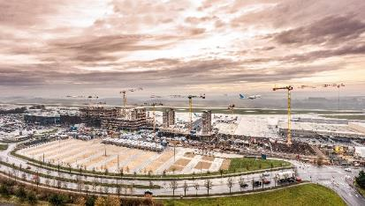
Images
liebherr-ec-b-skyliners-luxembourg-airport-01.jpg
Seven Liebherr flat-top cranes are assisting with the construction of an office building at the apron of Luxembourg Airport.
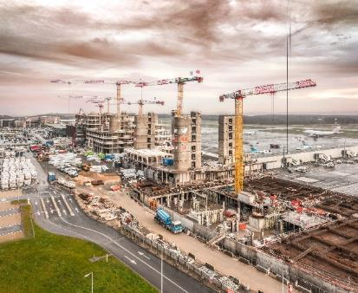
liebherr-ec-b-skyliners-luxembourg-airport-02.jpg
The top-slewing cranes from Liebherr have jibs with aircraft warning paintwork and smart assistance systems for maximum safety.

Contact
Daniel Haefele
Global Communication
Phone: +49 7351 / 41 - 2330
Email: daniel.haefele@liebherr.com
Published by
Liebherr-Werk Biberach GmbH
Biberach / Germany
www.liebherr.com

