Press information

Four aces for BKL:
MK 88-4.1 and MK 140 cranes from Liebherr boost fleet

⸺
Simple operation and flexible use impress long-standing Liebherr partner
Cost-effective operation, even with short downtimes
New mobile construction cranes expand crane fleet at BKL’s locations in Bavaria and Hesse
Liebherr has delivered four new mobile construction cranes to BKL Baukran Logistik GmbH. Two MK 88-4.1 and two MK 140 have joined the company’s fleet at its Munich, Rosenheim, and Frankfurt am Main locations. BKL now has four more aces up its sleeve for customers when it comes to short jobs involving projecting edges and space restrictions.
Biberach/Riß (Germany), 29 March 2023 – “With more than 600 tower and mobile cranes available, BKL offers its customers a huge selection of different machines. It’s important that our team is trained and has experience in handling this range so that we can get the best use out of each crane,” says CEO Jörg Hegestweiler. “So, one of the decisive factors for buying the mobile construction cranes from Liebherr was their easy handling, which is similar to that of the LTM series cranes we provide for mobile work.”
Experienced MK customer
Crane specialists at BKL have been successfully working with machines from Liebherr’s MK series and its time-tested taxi crane concept for over 20 years. Only one person is needed for travel, assembly and operation. Additional transport vehicles aren't required. These features even make jobs with short downtimes cost-effective and are a particular advantage given the current shortage of skilled workers. Mobile construction cranes offer long reaches, have a compact footprint, and can be positioned close to buildings.
Typical tasks for the MKs, which BKL deploys across Germany, include green roof installations, steel construction work, flat roof renovations, and roof replacements. The crane rental company’s mobile construction cranes often play unusual roles when customers need crane solutions for special lifting projects. An MK 140, for example, suspended a grand piano complete with pianist as part of an open-air concert. Another MK 140 played a leading role behind the scenes of a new BKL video by moving the lighting and handling HSE-Equipment.
Electric operation without emissions
The four-axle MK 88-4.1 offers a hook height of up to approx. 59 metres (45-degree luffed position) and a maximum radius of 45 metres. It has an eight-tonne load capacity and can still lift as much as 2,200 kilograms at its jib head. Powered by site electricity or another power source, the MK 88-4.1 works without CO₂ emissions and is exceptionally quiet on site. This can prove a particular advantage on night-time construction sites. And its hybrid power concept means that operation isn’t limited to one source of power: if an external supply isn’t available, an efficient diesel generator ensures self-sufficient operation.
Long reach
The five-axle MK 140 has a maximum lifting capacity of eight tonnes and a jib head lifting capacity of 1,900 kilograms at a 58.5-metre radius. So it offers the perfect solution for when heavy lifting and long reaches are required. The MK 140 is the only machine in the MK series with a three-section telescopic tower of solid wall construction. It also features an infinitely height-adjustable lift cabin, as do the other cranes in the series. The crane operator is able to work efficiently inside thanks to large glass panels, an ergonomic and comfortable control stand, and modern display systems.
About BKL Baukran Logistik GmbH
BKL Baukran Logistik GmbH specialises in the sale and rental of cranes along with related services. With over 50 years of experience and more than 300 employees in Munich, Ingolstadt, Rosenheim, Frankfurt am Main, Aschaffenburg, Hanover and Hildesheim, the company is one of the largest manufacturer-independent full-service providers of crane solutions in Europe. The BKL crane fleet includes over 500 construction cranes ranging from 22 to 90 metres in radius, more than 100 mobile cranes from 30 to 700 tonnes, and 20 mobile construction cranes with a radius of up to 65 metres. BKL customers also benefit from the company's comprehensive range of services, which are certified in accordance with DIN EN ISO 9001 and SCCP, and cover everything from planning, logistics, and transport to 24-hour emergency response.
About the Liebherr Tower Cranes Division
More than seven decades of experience have made Liebherr a recognised specialist for lifting technology on all types of construction sites. The range of Liebherr Tower Cranes encompasses an extensive selection of high-quality tower cranes that are used worldwide. This includes fast-erecting, top-slewing, luffing jib and special-purpose cranes as well as mobile construction cranes. In addition to these products, Liebherr also offers a wide range of services that complete the company’s portfolio: Tower Crane Solutions, the Tower Crane Center and Tower Crane Customer Service.

About the Liebherr Group
The Liebherr Group is a family-run technology company with a highly diversified product portfolio. The company is one of the world's largest manufacturers of construction machinery. It also offers high-quality, user-oriented products and services in multiple other areas. Today, the group consists of more than 140 companies across all continents. In 2021, it employed more than 49,000 people and achieved combined revenues of over 11.6 billion euros. Liebherr was founded in 1949, in Kirchdorf an der Iller in southern Germany. Ever since then, the company’s employees have been committed to satisfying customers with advanced solutions and to helping drive technological progress.

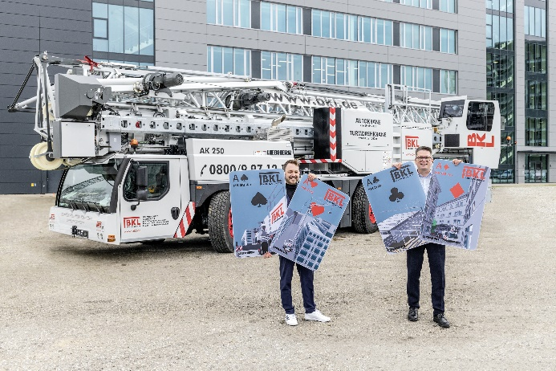
Image
liebherr-handover-mk-bkl-2023.jpg
An ace ready for every challenge: Peter Hofmann (Liebherr-Werk Biberach GmbH; left) and Jörg Hegestweiler (BKL Baukran Logistik GmbH) during the crane’s official handover at Liebherr’s site in Biberach an der Riß.

Contact
Daniel Haefele
Global Communication
Phone: +49 7351 / 41 - 2330
Email: daniel.haefele@liebherr.com
Published by
Liebherr-Werk Biberach GmbH
Biberach / Germany
www.liebherr.com

