Press release

Liebherr and China Airlines sign agreement on A321neo component support

⸺
Liebherr and China Airlines have entered into a long term agreement, under which the OEM Liebherr-Aerospace will provide repair support services for a wide range of air conditioning and bleed system components installed on China Airlines’ fleet of 25 Airbus A321neo. All material support and component maintenance services will be provided by Liebherr-Singapore, Liebherr-Aerospace’s dedicated service center for the Asia-Pacific region.
Singapore, March 2023 – Liebherr-Aerospace and China Airlines signed a contract that underlines the close relationship that China Airlines has built up with Liebherr-Aerospace since many years. “We really appreciate Liebherr’s service and place our trust and confidence in the company. We want to continue our long term partnership and thus decided to choose Liebherr as our service provider for the component support on our new Airbus A321neo fleet”, commented Jason Tsai, Vice President Engineering at China Airlines.
“This is a great success for Liebherr-Aerospace in the Asia-Pacific region. We are honored and proud to further extend our partnership with China Airlines and continue supporting their success. China Airlines has been our customer for many years and this selection re-affirms their continuous confidence in the quality and efficiency of our team and services provided,” said Ekkehard Pracht, General Manager Aerospace, at Liebherr Singapore.
China Airlines is the largest airline in Taiwan, headquartered in Taoyuan International Airport. It operates short, medium, and long haul services to international and intercontinental destinations across Asia, Europe, North America, and Oceania. Further subsidiaries of the China Airlines group of airlines include Tigerair Taiwan as well as Mandarin Airlines.

About Liebherr-Aerospace & Transportation
Liebherr-Aerospace & Transportation SAS, Toulouse (France), is one of eleven divisional control companies within the Liebherr Group and coordinates all activities in the aerospace and transportation systems sectors.
Liebherr-Aerospace is a leading supplier of systems for the aviation industry and has more than six decades of experience in this field. The range of aviation equipment produced by Liebherr for the civil and defense sectors includes flight control and actuation systems, gears and gearboxes, landing gear and air management systems as well as electronics. These systems are deployed in wide-bodied aircraft, single aisle and regional aircraft, business jets, fighter aircraft, defense transporters, defense training aircraft as well as civil and defense helicopters.

Liebherr’s aerospace and transportation systems division employs around 6,000 people. It has three aviation equipment production plants at Lindenberg (Germany), Toulouse (France) and Guaratinguetá (Brazil). These production sites offer a worldwide service with additional customer service centers in Saline (Michigan/USA), Seattle (Washington/USA), Montreal (Canada), Hamburg (Germany), Dubai (UAE), Bangalore (India), Singapore and Shanghai (People’s Republic of China).
About the Liebherr Group
The Liebherr Group is a family-run technology company with a highly diversified product portfolio. The company is one of the largest construction equipment manufacturers in the world. It also provides high-quality and user-oriented products and services in a wide range of other areas. The Liebherr Group includes over 140 companies across all continents. In 2021, it employed around 49,000 staff and achieved combined revenues of over 11.6 billion euros. Liebherr was founded in Kirchdorf an der Iller in Southern Germany in 1949. Since then, the employees have been pursuing the goal of achieving continuous technological innovation, and bringing industry-leading solutions to its customers.

Image
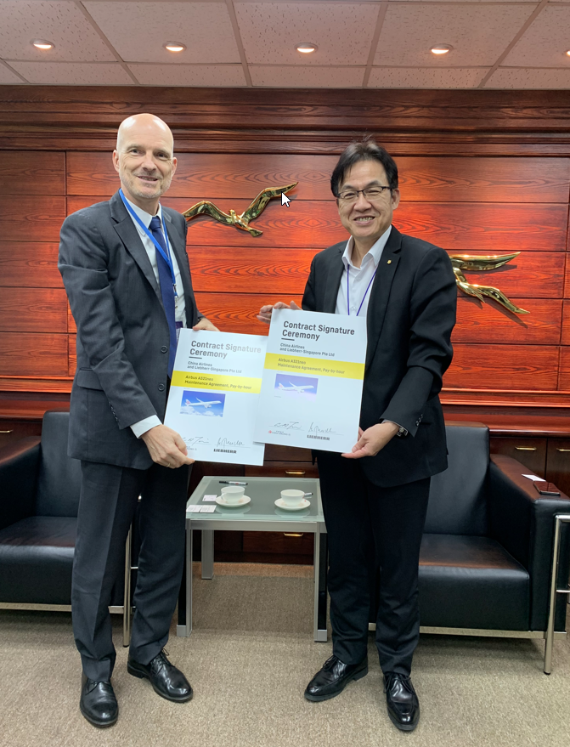
liebherr-china-airlines-contract-signature-ceremony-march2023.jpg
Jason Tsai, Vice President Engineering at China Airlines (right) and Ekkehard Pracht, General Manager Aerospace, at Liebherr Singapore at the contract signature ceremony. – © Liebherr
Contact person
Ute Braam
Corporate Communications
Phone: +49 8381 / 46 - 4403
E-Mail: ute.braam@liebherr.com
Published by
Liebherr-Aerospace & Transportation SAS
Toulouse / France
www.liebherr.com

