Press release

“The sky’s the limit”

First LR 1400 SX in operation

⸺
Liebherr’s largest multi-purpose crawler crane found its first assignment in Atlanta, Georgia - on a construction site almost fit for a film. Full Tilt Crane Services is using the LR 1400 SX to lift concrete tilt-up panels, which are being manufactured on site by their parent company Martin Concrete Construction, Inc. Together, they are a one-stop shop for tilt-up projects. Full Tilt Crane Services selected the new crane from Nenzing in order to respond to the changing market.
Nenzing (Austria), 21 March 2023 - “To lift our biggest parts!” That was just one of the reasons why Full Tilt Crane Services added the LR 1400 SX to its fleet. “We bought the machine to meet the needs of our customers: to lift larger and heavier pieces at one time,” explains Managing Director Jason Richardson.
Liebherr-Werk Nenzing GmbH developed the LR 1400 SX because of this market requirement, to provide a versatile crawler crane for ever heavier and bigger loads. With the new model, the factory has successfully expanded its portfolio to include loads up to 400 tonnes.
The tilt-up panels, which the LR 1400 SX is lifting on the construction site in Atlanta, are produced on-site. No precast elements and no truck deliveries. The largest tilt-up panel has a height of approximately 34 metres. “You’re not going to be able to do that in the precast market.” The tilt-up panels produced by Martin Concrete Concrete on-site have the advantage that it makes them considerably more flexible than precast. This is where the size of the LR 1400 SX plays a significant role. “The sky’s the limit,” jokes Jason Richardson. It will probably be boundless when the construction of the Electric Owl Studios is complete and ready for “Action”.
Quick set-up. Safe operation.
During the development stage, it was important for Liebherr that set-up and transportation are easy, despite the size of the crawler crane. With the compact transport weight of 46 tonnes, it can be easily moved between the jobsites. “The self-assembly system of the crane is very important to us. We don’t need an assist crane. Right now, we can fully assembly our LR 1400 SX in under 12 hours.” Full Tilt Crane Services frequently moves from jobsite to jobsite, often completing their projects within one to two weeks.The fact that the LR 1400 SX can be moved quickly is a great advantage for the company.
Platform and railings remain attached to the uppercarriage during transportation and only need to be folded down. Thanks to the self-assembly system, the boom sections, the carbody counterweight, crawlers and hoist winches can be easily assembled and disassembled without the need for an auxiliary crane. The crane can even hydraulically lift, lower, and secure the 150-tonne rear counterweight without assistance. The rear counterweight itself is modular and can be equipped with 5 or 10-tonne counterweight slabs, depending on requirements.
With the assistance systems ground pressure visualization, Gradient Travel Aid or Boom Up-and-Down Assistant, Liebherr has paid special attention to the safety concept of the new weightlifter. In the meantime, Full Tilt Crane Services has ordered a second LR 1400 SX. “Our expectations from the first one met everything we were looking for. It’s a great machine,” enthuses Jason Richardson.

The whole story can be watched here:
Liebherr – First LR 1400 SX in lifting operation - YouTube

Further details about the LR 1400 SX:
Animation: Liebherr - Crawler Crane LR 1400 SX - YouTube
Gradient Travel Aid: Liebherr - Gradient Travel Aid - YouTube
Boom Up-and-Down Assistant: Liebherr – Boom Up-and-Down Assistant - YouTube
Ground pressure visualization: Liebherr - Ground Pressure Visualization - YouTube

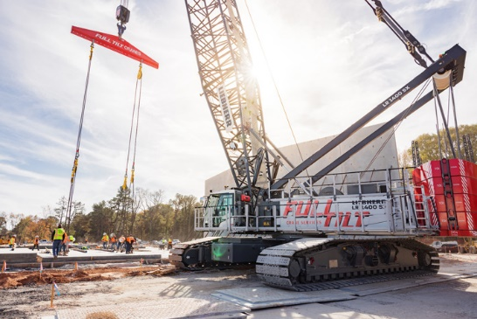
Images

liebherr-lr1400sx-1.jpg
The new weightlifter has a name: LR 1400 SX.
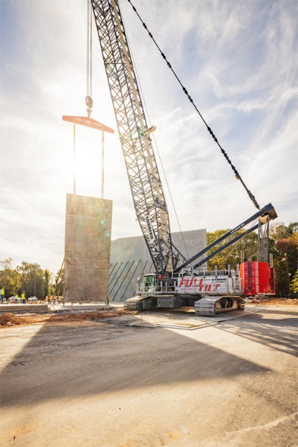
liebherr-lr1400sx-2.jpg
The LR 1400 SX lifts the concrete tilt-up panels to the right position.

Contact
Gregor Griesser
Strategic Marketing and Communications
Email: gregor.griesser@liebherr.com
Wolfgang Pfister
Head of Strategic Marketing & Communications
Tel.: +43 50809 41444
Email: wolfgang.pfister@liebherr.com
Published by:
Liebherr-Werk Nenzing GmbH
Nenzing/Austria
www.liebherr.com

