Press release

Bay Crane expands fleet of 500+ cranes at Conexpo 2023

⸺
Bay Crane takes delivery of a Liebherr LTM 1300-6.3
Fleet includes over 270 Liebherr cranes
Continues to purchase from Liebherr due to superior service and reliability of machines
Bay Cranes takes delivery of Liebherr’s LTM 1300-6.3 at Conexpo 2023. This purchase will allow Bay Crane to utilitze a record breaking boom to further support crane rental and rigging intiatives.
Las Vegas, NV (USA), Liebherr USA, Co., Mobile and Crawler Cranes, March 16, 2023 – Bay
Crane, a leader in crane rental and heavy specialized transportation solutions in the Northeast, expands their massive fleet with the purchase of a Liebherr LTM 1300-6.3. Bay Crane takes delivery of this mobile crane at Conexpo 2023, the largest construction tradeshow in North America. The company currently has over 270 Liebherr cranes in their fleet including eight LTM 1300-6.2’s.
Bay Crane chose the LTM 1300-6.3 due to its reliability and versatility paired with a world record telescopic boom. At 295 ft, it is the longest main boom available in this size class aiding Bay Crane in additional rigging and changing of mechanical equipment on various job sites. The LTM 1300-6.3 also features all of Liebherr’s latest innovations to ensure safe, powerful operation including: ECOmode, ECOdrive, VarioBase®Plus, VarioBallast®, Auto-Ballast, single-engine concept, and windspeed load charts. This 360 USt model rounds out the Liebherr 6-axel cranes.
With 80 years of experience and 15 locations throughout the Northeast, Bay Crane is committed to providing unparalleled service to the construction, lifting, and hauling industries with their fleet of Liebherr cranes. Kenneth Bernardo, President of Bay Crane notes, “Liebherr offers superior service and their machines hold excellent resale value.”
About Liebherr USA, Co.
Liebherr USA, Co. based in Newport News, VA provides sales and service on behalf of ten different Liebherr product segments: earthmoving, material handling, mining, mobile and crawler cranes, tower cranes, concrete technology, deep foundation machines, maritime cranes; components, and refrigeration and freezing.
About the Liebherr Group
The Liebherr Group is a family-run technology company with a highly diversified product portfolio. The company is one of the largest construction equipment manufacturers in the world. It also provides high-quality and user-oriented products and services in a wide range of other areas. The Liebherr Group includes over 140 companies across all continents. In 2021, it employed more than 49,000 staff and achieved combined revenues of over 11.6 billion euros. Liebherr was founded in Kirchdorf an der Iller in Southern Germany in 1949. Since then, the employees have been pursuing the goal of achieving continuous technological innovation, and bringing industry-leading solutions to its customers.
Images

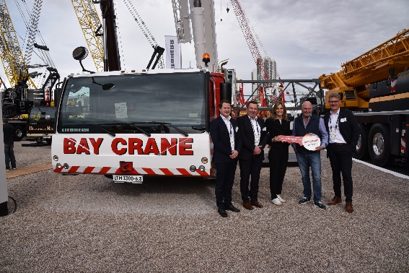
liebherr-Bay Crane1.jpg
info

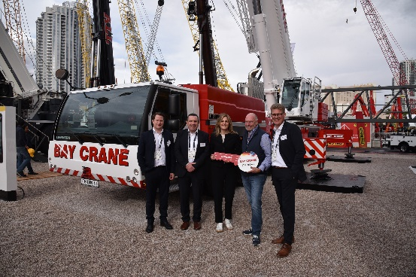
liebherr-Bay Crane2 .jpg

Contact
Ana Cabiedes
Head of Marketing
Liebherr USA, Co.
E-Mail: ana.cabiedes@liebherr.com
Published by
Liebherr USA, Co.
Newport News / USA
www.liebherr.com

