Press release

Modernisation with innovative technology: Grúas Aguilar procures eleven new Liebherr mobile cranes

⸺⸺
- Grúas Aguilar acquires eleven new Liebherr mobile cranes from 60 to 700 tonnes capacity
- The Liebherr LTM 1650-8.1 mobile crane is one of the flagships of Grúas Aguilar
- The new additions will be used at Grúas Aguilar's sites in Madrid and Palma de Mallorca
The Spanish crane and heavy lift company Grúas Aguilar has purchased eleven new mobile cranes from Liebherr. The company, headquartered in Madrid, is modernizing its fleet with the units, which range from 60 to 700 tonnes lifting capacity. In order to meet customer needs with the highest possible quality, Grúas Aguilar pursues a strategy of continuously renewing its equipment fleet with innovative models equipped with the latest technology.
Ehingen (Donau) (Germany), 16 March 2023 - Grúas Aguilar is active in a wide range of projects throughout the Iberian Peninsula, France and Morocco. When modernising its crane fleet, the crane specialist consistently relies on Liebherr's product range. This is reflected in the latest investment: eleven mobile cranes of various sizes and load capacities were procured.
The current investment package, which was delivered successively from June 2022, also includes the Liebherr LTM 1650-8.1 all-terrain crane, which has now become one of the flagships of Grúas Aguilar's machinery fleet. "We chose this 8-axle mobile crane with a lifting capacity of 700 tonnes to replace a 500-tonne unit. As a result, this new model perfectly complements our fleet in the heavy-duty sector," says company owner Luis Aguilar. "With its high performance and telescopic boom up to 80 metres long, the LTM 1650-8.1 is a very versatile model designed for a wide range of applications. This flexibility also means high profitability for us." Grúas Aguilar's applications for the LTM 1650-8.1 include civil engineering, industrial, wind power and port development.
Continuous modernisation of the machinery fleet
With the Liebherr LTM 1650-8.1 mobile crane, Grúas Aguilar has completed an order for a total of 11 Liebherr mobile cranes, including the following models: LTM 1060-3.1, LTM 1070-4.2, LTM 1090-4.2, LTM 1150-5.3 and LTM 1230-5.1. All these all-terrain cranes, including the LTM 1650-8.1, are destined for the fleets that Grúas Aguilar operates in Madrid and Palma de Mallorca.

Grúas Aguilar has always had a policy of constantly renewing its fleet of machines in order to be able to offer its customers the best possible service at all times thanks to a modern and high-quality fleet. Luis Aguilar says: "Liebherr's product range is synonymous with success and guarantee. Therefore, when we have to replace a model, we choose the same brand that we have trusted for years and that will continue to represent a secure value in the future."
Grúas Aguilar has relied on Liebherr quality and service since 1986. Since then, Liebherr has always been an important and reliable technology partner. One of the company's strengths is undoubtedly Liebherr Ibérica's excellent after-sales service, which gives us great security in the development of our lifting projects," Luis Aguilar concludes.
About Grúas Aguilar
Grúas Aguilar was founded in 1968 and has since been involved in thousands of projects in the Iberian Peninsula, France and Morocco. The company has a large fleet of mobile cranes, of which more than 70 per cent are Liebherr. Grúas Aguilar provides services in a wide range of sectors, including public works, civil engineering, energy, cement, iron and steel, chemicals and the environment.
About Liebherr Ibérica, S.L.
Liebherr Ibérica is the Spanish sales and service company of the Liebherr Group and was founded in 1988. Today, Liebherr Ibérica is responsible for sales and service in the product areas of mobile cranes, earthmoving and mining machinery, maritime cranes and concrete technology.
About Liebherr-Werk Ehingen GmbH
Liebherr-Werk Ehingen GmbH is a leading manufacturer of mobile and crawler cranes. Its range of mobile cranes extends from 2-axle 35 tonne cranes to heavy duty cranes with a lifting capacity of 1200 tonnes and a 9-axle chassis. Its lattice boom cranes on mobile or crawler crane chassis deliver lifting capacities of up to 3000 tonnes. With universal boom systems and extensive additional equipment, they can be seen in action on construction sites throughout the world. The Ehingen site has a workforce of 3,800. Extensive, global service guarantees the high availability of Liebherr mobile and crawler cranes. In 2021, the Liebherr plant in Ehingen recorded a turnover of 2.33 billion euros.
About the Liebherr Group
The Liebherr Group is a family-run technology company with a highly diversified product portfolio. The company is one of the largest construction equipment manufacturers in the world. It also provides high-quality and user-oriented products and services in a wide range of other areas. The Liebherr Group includes over 140 companies across all continents. In 2021, it employed more than 49,000 staff and achieved combined revenues of over 11.6 billion euros. Liebherr was founded in Kirchdorf an der Iller in Southern Germany in 1949. Since then, the employees have been pursuing the goal of achieving continuous technological innovation, and bringing industry-leading solutions to its customers.

Images
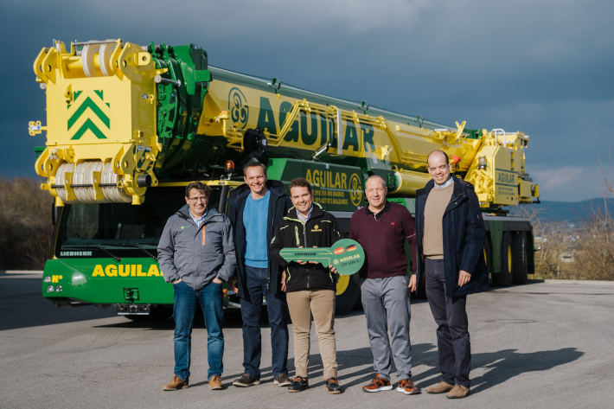
liebherr-ltm1650-8.1-gruas-aguilar-handover.jpg
Official handover of the Liebherr LTM 1650-8.1 mobile crane to Grúas Aguilar. From left to right: José Manuel Martín (Grúas Aguilar), Georg Reinbold (Liebherr-Werk Ehingen GmbH), Luis Aguilar Cerezo (Grúas Aguilar), Tobias Böhler (Liebherr Ibérica) and Álvaro Hueso (Liebherr Ibérica).

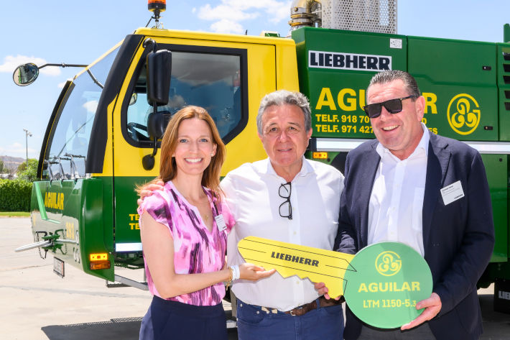
liebherr-ltm1150-5-3-gruas-aguilar-handover.jpg
Official handover of the first of eleven Liebherr mobile cranes to Grúas Aguilar at Liebherr Ibérica's open day. From left to right: Sophie Albrecht (Member of the Board of Liebherr-International AG), Luis Aguilar Pérez (Grúas Aguilar) and Christoph Kleiner (Liebherr-Werk Ehingen GmbH).
Contact
Wolfgang Beringer
Marketing and Communication
Phone: +49 7391/502 - 3663
Email: wolfgang.beringer@liebherr.com
Published by
Liebherr-Werk Ehingen GmbH
Ehingen (Donau), Germany
www.liebherr.com

