Press release

US premiere of the Liebherr PR 766 G8 at Conexpo 2023

⸺
Equipped with High Drive, the PR 766 G8 is fully optimized for heavy-duty mining operations
Advanced efficiency: the only hydrostatic drive dozer in its class
Increased productivity built around safety and operator comfort
The PR 766 G8 further expands the Liebherr fleet of Generation 8 dozers, with an operating weight of up to 119,784 lbs (54,333 kg). The application range for this machine has also been extended into the mining sector. Similar to the largest Liebherr PR 776 dozer, the Liebherr PR 766 G8 now has High Drive, the proven and tested running gear for heavy-duty mining applications.
Las Vegas (USA), March 14, 2023 – A multifunctional dozer for material handling and mining operation, the Liebherr PR 766 G8 is the latest generation specifically developed to let customers take full advantage of its enormous potential in key applications. The newly designed running gear works in combination with all the advantages of the cab and operating comfort, maximizing the operator’s and the machine’s performance and productivity – even on rough terrain over long operating periods. The diesel-hydraulic drive design sets the Liebherr dozer ahead of the competition with conventional torque converters. Particularly in diesel consumption, this provides advantages in efficiency shown by previous generations as well as larger and smaller sister machines.
Performance and economy: advanced, infinitely variable drive design
The new PR 766 G8 is powered by a Liebherr 8-cylinder diesel engine with a maximum output of 490 HP (360 kW) and meets Tier 4f emission standards. The operating weight of the hydrostatic dozer is up to 119,784 lbs, with available blade capacities of 17.8 yd³ (13.6 m³) (Semi-U blade) or 22.2 yd³ (17 m³) (U-blade).
The variable hydrostatic Liebherr drive design allows customers to operate the PR 766 G8 to maximize utilization and save time and resources. The drive components and the intelligent Liebherr engine management system are perfectly synchronized, so that the diesel engine is kept at constant speed, within the optimum fuel-efficiency range (~ 1,600 rpm), by the hydrostatic drive. This really sets the Liebherr propulsion drive apart from similar D9 class drive designs available on the market, where the engine speed fluctuates significantly during use.
All Generation 8 Liebherr dozers have the ECO function fitted as standard. The operator can select between high performance (including automatic Power Boost) and maximum economy, to ensure further fuel savings in light to medium-duty applications.
The complete Liebherr drive train, therefore, contributes to high efficiency and significantly lower fuel consumption compared to the industry standard for the same pushing performance.
In-house manufactured components ensure reliability
For decades, Liebherr engines have been proving themselves in the construction industry all over the world. Developed for the harshest operating conditions, the advanced technology of these engines ensures optimum operational safety and length of service life. The proven and tested hydrostatic Liebherr drive also operates with high-quality hydraulic pumps and motors that are virtually wear-free and highly reliable in service.
For highly demanding special applications such as in the desert, at low temperatures or in special industry operation (mining, wood, paper, etc.), Liebherr offers a wide range of tried and tested modifications.
High Drive for heavy mining operations
To match the heavy operating demands of rocky terrain more closely, the drive design of the larger dozer (PR 776) has been specifically adapted for the PR 766 G8.
Swivel bearing guide wheels and track rollers absorb shocks and maintain very good track chain traction. This allows the running gear to adapt more closely to the ground surface when driving over rocky terrain, but a more critical factor is the raised position of the final drive. High Drive reduces wear on sprockets and bearing bushes, protects the final drive and seals it from damage and dirt.
Operator comfort: advanced cab design with intuitive controls
The operator’s cab has been specifically developed for this class of equipment so that the operator can readily find his way around. Using the Liebherr proven joystick function, the operator is able to control all driving and steering movements with just one electronic input device.
The cab is packed with special features including the centralized controls, a 9'' touch display, generous storage space and a ventilated storage compartment. The driver can use the display to access all the key machine parameters and simply set operating modes such as the ECO function, automatic engine speed reduction or the drive and the steering response, as well as operate the convenience and safety functions such as the standard reversing camera.
The PR 766 G8 has a spacious cab and ergonomic joystick offering the best conditions for fatigue free operation. All the controls for traction drive, blade and ripper can be set by the operator from the most ergonomic position. The seat has an integrated contact switch to automatically detect the operator’s presence, without having to operate a safety lever.

Maximum safety with an excellent view
The modern design of the new Liebherr PR 766 G8 gives the operator a clear view in all directions, enabling highly effective work and progress and increasing safety in daily operation.
The design includes rounded body edges and sloping sides, panoramic glass and a minimal profile for the cab-integrated ROPS/FOPS protection, to ensure optimum visibility of the terrain, blade and rear ripper. This leaves a clear view of the front and side areas of the dozer. It is not impeded by the exhaust system or the continuous work platform. The platform provides easy access to the cab, as well as to the service points and the filler nozzles for hydraulic and operating fluids.
Modern LEDs (1,200 lm) are used for optimum illumination of the work area. Modular lighting (including additional headlights or high-performance LEDs with 4,200 lm) is an integral part of the machine design and allows the best match of lighting to the corresponding application.
Optimum service accessibility
The new Liebherr dozer is designed for quick maintenance access and easy servicing, with centralized maintenance points, wide-opening access hatches and engine compartment doors, a standard tilting operator's cab and an optional cooling fan that can be swung out for cleaning.
Furthermore, all Liebherr dozers for mining (PR 766 and 776) have Ground Level Service Stations at the rear of the machines. Daily maintenance and service work can be conducted quickly and safely at ground level. The electrical systems include switches for access lighting, an emergency stop and Ground Level Lockout (electrical system deactivation for maintenance). For operating fluids and fuels, there is a quick-change connection for engine and hydraulic oil as well as a quick refuelling device.
Liebherr's standard fleet management system, LiDAT, offers effective data management for servicing the machine including warning messages, machine position, current consumption data and fluid fill levels. Depending on the subscription agreement, data is updated several times a day and can be pulled at any time via the Internet. An automatic alarm can be set up for high priority notifications/info, for example, when the device leaves a predefined zone or in the event of critical operating states.
About Liebherr USA, Co.
Liebherr USA, Co. based in Newport News, VA provides sales and service on behalf of ten different Liebherr product segments: earthmoving, material handling, mining, mobile and crawler cranes, tower cranes, concrete technology, deep foundation machines, maritime cranes; components, and refrigeration and freezing.
About Liebherr-Werk Telfs GmbH
Liebherr-Werk Telfs GmbH has been producing and developing an ever-growing range of construction machines with hydrostatic drives since 1976. The company is able to draw on the many years of experience of the Liebherr Group with this type of drive. Whether dozers or crawler loaders, telescopic handlers or pipe layers - construction machines from Telfs are consistently designed for highest efficiency and effectiveness. Increasing efficiency and reducing fuel consumption and CO₂ emissions are a central focus. The latest computer-aided technologies are used both in development and production: from design engineering to welding robot processes, right through to computerised quality management.
About the Liebherr Group
The Liebherr Group is a high technology company, in family ownership, with a diversified portfolio of products. The company is one of the largest construction machinery manufacturers in the world. But it also offers a range of high quality, high customer benefit products and services in many other areas. The Group currently consists of more than 140 companies across all continents. In 2021, it employed more than 49,000 people and generated a consolidated sales turnover of over €11.6 bn. Liebherr was founded in 1949, in Kirchdorf an der Iller in southern Germany. From inception, the goal of the employees has been to delight their customers through novel contribution to technological progress and advanced technology solutions.

Images
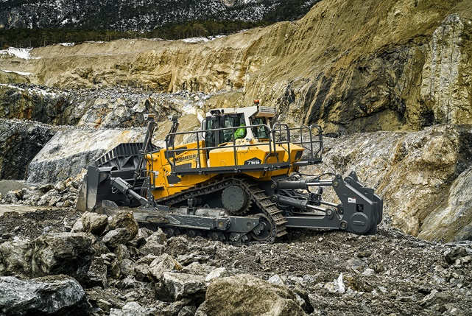
liebherr-pr766-g8.jpg
With the benefit of hydrostatic drive, the PR 766 G8 automatically delivers the highest possible tractive force when ripping.

Contact
Alexander Katrycz
Head of Marketing
Liebherr-Werk Telfs GmbH
Phone: +43 (50809) 6 1416
E-Mail: alexander.katrycz@liebherr.com
Ana Cabiedes
Head of Marketing
Liebherr USA, Co.
Phone: +1 757 240 4250
E-mail: ana.cabiedes@liebherr.com
Published by
Liebherr-Werk Telfs GmbH
Telfs / Austria
www.liebherr.com

