Press release

Hybrid RTG retrofit for Baltic Hub

⸺
Liebherr Transform project will retrofit a Liduro energy storage system along with a reduced sized generator
Cost neutral solution provides over 30 % reduction in emissions and fuel consumption.

Killarney (Ireland), March 2023 – The Baltic Hub, formerly DCT Gdansk have commissioned Liebherr Container Cranes Ltd. to retrofit a hybrid green energy storage solution on one of its Liebherr RTGs. The terminal has 18 Liebherr RTGs at the port and the initial purchase will allow the Baltic Hub to assess the technology with a view to further retrofitting its fleet of Liebherr RTG with the system. The retrofit sees the addition of a Liduro energy storage system along with exchanging the existing 13 L genset with a smaller 8 L genset. This will allow the RTG to operate at the same speed and productivity, whilst reducing operating costs, and delivering substantial environmental benefits, including a reduction in emissions and carbon footprint.
According to Oran Kane, Liebherr’s Container Cranes Head of Department for Upgrades and Modifications, the retrofitting of the Liduro energy storage system is a natural choice.
“Baltic Hub, like many ports and terminals worldwide are working to minimise their impact on the environment, through reducing their carbon footprint. The green energy solution that they have chosen, not only makes a significant reduction in the amount of energy consumed and the amount of emissions released, but the return on investment is clear to see, with the retrofit paying for itself in the short term. With such benefits on offer, the green energy retrofit is an easy win for our customers. The technology represents the future of energy storage in container handling, and we are proud to be at the forefront of this innovation.”
Regenerated power
At the heart of the system is the Liduro LES 200, a capacitor system designed and developed by Liebherr-Electronics and Drives GmbH. The system is designed to capture and store energy generated during hoist lowering and braking that would otherwise be wasted. The stored energy is then deployed during the hoisting cycle to reduce the overall demand on the genset, allowing for a reduction in fuel consumed and a reduction in emissions. Dual layer capacitors are capable of rapidly charging and discharging many times, without a drop in performance, making them an ideal solution for applications requiring high power and short-duration energy storage, such as that found in container handling.
By utilising this innovative technology, the RTG crane will have access to reliable, high-power energy during peak demand periods. The system is modular and depending on the operational requirements of the port, single or multiple units may be installed to a single RTG.
The Liduro energy storage system is available on new Liebherr RTGs or can be retrofitted to existing Liebherr RTGs through Liebherr specialist retrofit and upgrade teams, Liebherr Transform.

About Liebherr Container Cranes
Liebherr Container Cranes Ltd. Is one of the world’s leading manufacturers of ship to shore container cranes, rail mounted gantry cranes and rubber tyre gantry cranes. From a base in Killarney, Ireland, Liebherr Container Cranes Ltd designs, builds and exports container cranes worldwide. Founded in 1958 as the first Liebherr factory outside of Germany, today, container cranes manufactured by Liebherr in Ireland are renowned for their quality, longevity and productivity.
About the Liebherr Group
The Liebherr Group is a family-run technology company with a highly diversified product portfolio. The company is one of the largest construction equipment manufacturers in the world. It also provides high-quality and user-oriented products and services in a wide range of other areas. The Liebherr Group includes over 140 companies across all continents. In 2021, it employed more than 49,000 staff and achieved combined revenues of over 11.6 billion euros. Liebherr was founded in Kirchdorf an der Iller in Southern Germany in 1949. Since then, the employees have been pursuing the goal of achieving continuous technological innovation, and bringing industry-leading solutions to its customers.
Images
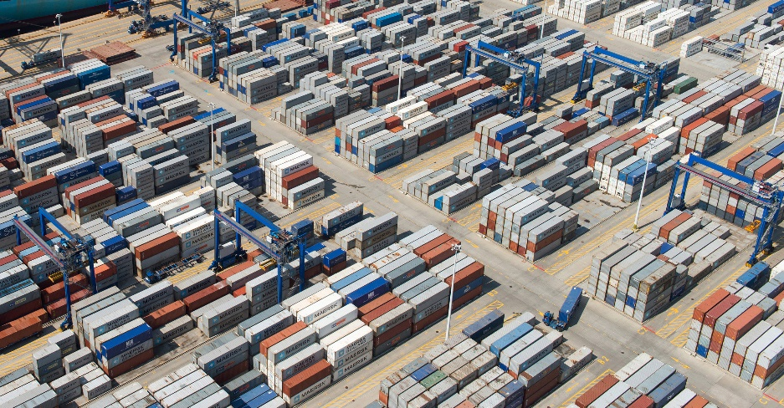
Liebherr_Baltic_hub_rtg.jpg
Liebherr RTG at the Baltic Hub, Poland.
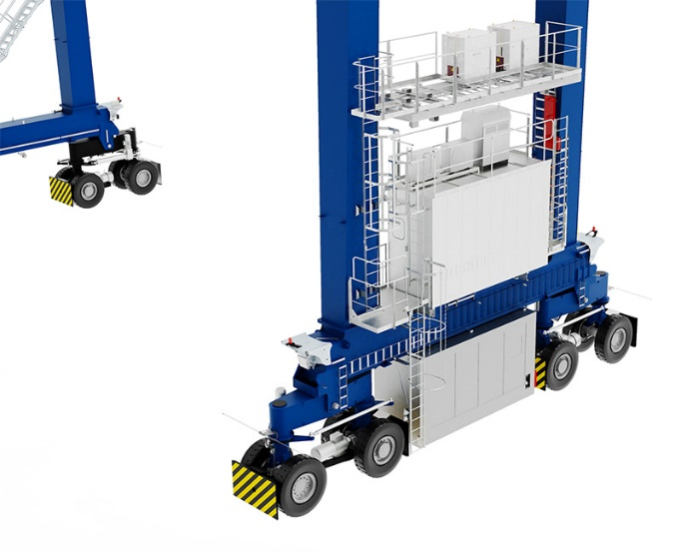
Liebherr_liduro.jpg
The Liduro energy storage system is easy to retrofit and can be seen above the e-house.

Contact
Trevor O’Donoghue
Marketing Manager
Telephone: ++353 0 64 668 0459
E-Mail: trevor.odonoghue@liebherr.com
Published by
Liebherr Container Cranes Ltd.
Killarney/Ireland
www.liebherr.com

