Press release

Denmark's leading recycling company relies on XPower® wheel loader from Liebherr

⸺
- RGS Nordic, market leader in construction waste management in Denmark, uses 40 XPower® wheel loaders in its recycling operations
- Efficient wheel loaders with power-split drive reduce CO2 emissions
- Economy and reliability of Liebherr wheel loaders as a purchase criterion
RGS Nordic specialises in recycling construction and demolition waste materials and is the market leader in Denmark. It operates a fleet of around 130 construction machines, about two-thirds of which have been supplied by the Liebherr Group. Among them are 40 XPower® wheel loaders of various sizes featuring wheel power-split travel drive as standard and returning notably low fuel consumption.
Copenhagen (Denmark), 10th March 2023 - Every day, more than 1,000 truckloads of construction waste and other material arrive at RGS Nordic's facilities to be converted into reusable and circular products and reintegrated into the product cycle. The 40 Liebherr XPower® wheel loaders are used for material handling as part of the process.
Michael Jørgensen, strategic purchasing manager, commented: "The Liebherr wheel loaders need less fuel, are powerful and have hardly any downtime. We are particularly impressed that we achieve 30% more productivity with the same fuel consumption than with comparable wheel loaders in this size class." Those enormous advantages in fuel consumption also ensure lower CO2 emissions, meaning the machines align perfectly with RGS Nordic's core values.
Clear statement: Recycling is the future
At Denmark's largest waste management site, recycling the delivered material is top priority. "We aim to make circular economy a sustainable business", added Jørgensen. The Liebherr wheel loaders play a key role in helping the company achieve that aim. On one hand, they transport the bulky waste pre-sorted by Liebherr excavators to the sorting plants, and on the other, feed the numerous crushing and screening plants with various construction wastes. At the end of the treatment process, the recycled material is reused on construction sites around Copenhagen.
RGS Nordic also returns the supplied, partly contaminated material to the product cycle through specialised processing operations, for example by adding substances such as calcium and by constantly shifting the piles of earth using the Liebherr wheel loaders. That function is important to ensure a reliable oxygen supply during composting. Once that operation is complete, the XPower® machines load the recycled material on to trucks for RGS Nordic's customers to use as a natural raw material on a wide variety of construction sites rather than rely on new products.
RGS Nordic at a glance
RGS Nordic employs over 200 people and operates 22 reception and treatment facilities in Denmark, including the country's largest waste treatment site and the Nordic region's biggest commercial biological site for treating industrial wastewater. The recycling specialist has set itself a goal of converting even more waste into quality building materials and implementing sustainable processes in the circular economy. The large Liebherr fleet plays a vital role supporting the company in its daily work.
About Liebherr-Werk Bischofshofen GmbH
Liebherr-Werk Bischofshofen GmbH develops, produces and sells wheel loaders from the Liebherr Group. The plant in the state of Salzburger Land (Austria) has grown steadily over the decades thanks to sustainable innovations, creative solutions and high quality standards. The wheel loader range is constantly being expanded and includes different models in four different product groups: compact, stereo, mid-sized, and large wheel loaders, which have impressive, innovative drive designs.
About the Liebherr Group
The Liebherr Group is a family-run technology company with a highly diversified product portfolio. The company is one of the largest construction equipment manufacturers in the world. It also provides high-quality and user-oriented products and services in a wide range of other areas. The Liebherr Group includes over 140 companies across all continents. In 2021, it employed more than 49,000 staff and achieved combined revenues of over 11.6 billion euros. Liebherr was founded in Kirchdorf an der Iller in Southern Germany in 1949. Since then, the employees have been pursuing the goal of achieving continuous technological innovation, and bringing industry-leading solutions to its customers.
Images
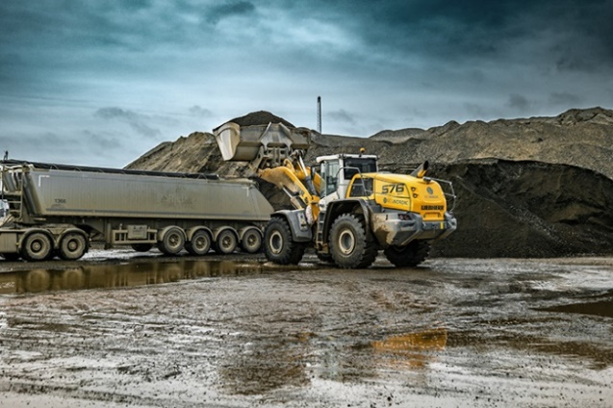
liebherr-L576-xpower-rgs-denmark-recycling-lorry-loading.jpg
40 Liebherr XPower® wheel loaders are in use at RGS Nordic for material handling.

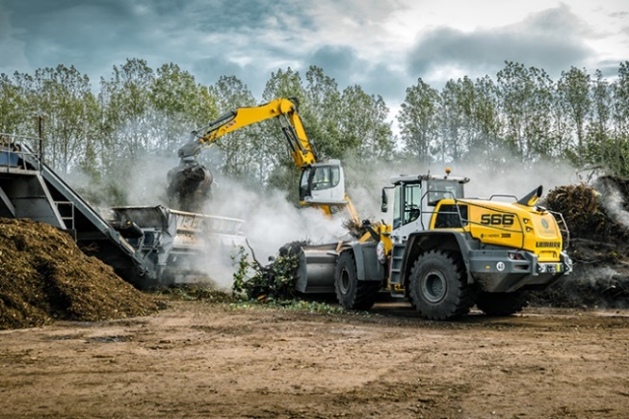
liebherr-L566-xpower-rgs-denmark-recycling.jpg
CO2-saving and more fuel efficient: The Liebherr XPower® wheel loaders impress with their power-split travel drive.

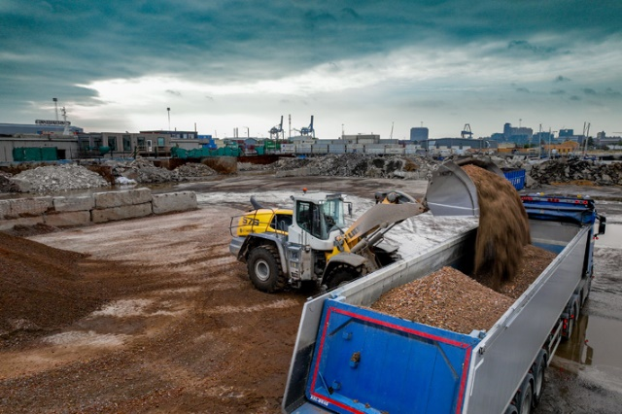
liebherr-L576-xpower-rgs-denmark-recycling-company.jpg
The L 576 XPower® wheel loader is in use at Denmark's leading recycling company RGS Nordic.

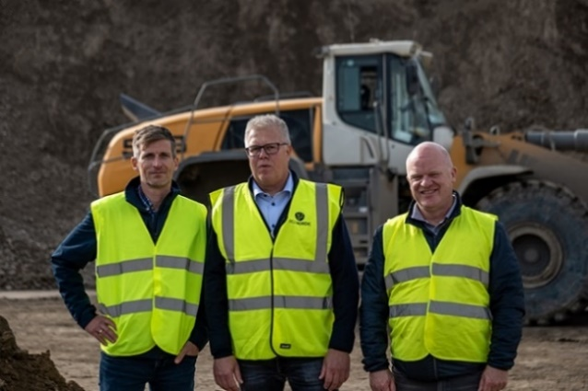
liebherr-group-picture-rgs-denmark-from-right-hubert-feneberger-michael-jørgensen-birger-hjelm.jpg
Sights set on the future: Hubert Feneberger (Liebherr-Werk Bischofshofen), Michael Jørgensen (Strategic Purchasing Manager - RGS Nordic) and Birger Hjelm (Sales Manager - Liebherr Sales Partner).

Contact
Martin Koller
Marketing and Public Relations
Phone: +43 50809 11475
E-mail: martin.koller.lbh@liebherr.com
Published by
Liebherr-Werk Bischofshofen GmbH
Bischofshofen/Austria
www.liebherr.com

