Press information

Hüffermann Krandienst:
flat-top cranes from Liebherr prove their flexibility in use

⸺
Modern EC-B cranes impress with their high lifting capacity, minimal number of transport units and efficient assembly
Top-slewing cranes supplied for rental by Hüffermann Krandienst
Service with short response times contributes to successful crane operations
Hüffermann Krandienst GmbH has built up a comprehensive rental fleet with new Liebherr tower cranes and further expanded its selection at Bauma 2022. The machines are put to work on variety of construction projects, as three examples from Germany show. Cranes from the EC-B series have been used for a tropical zoo enclosure, a residential and commercial building in a central location, and an office building complete with children's daycare centre. All machines impressed with their transport and assembly-optimised concept.
Biberach/Riß (Germany), 9 March 2023 – A fascinating building project has been under way at the Allwetterzoo in Münster, namely a tropical zoo environment housing plants, water sources and animals under a large foiled dome structure. The elliptical building covers 4,000 square metres and reaches a height of 16 metres at its highest point. A Liebherr 172 EC-B 8 flat-top crane with a freestanding hook height of 39 metres, a 60-metre radius, and a maximum lifting capacity of eight tonnes has played a key part in construction.
“The crane supported smooth operations on site in the best possible way with its precise slewing and easy operation,” said Tjark Bethke, site manager and managing director at Windhorst Stahl- und Metallbau GmbH. His company designed and manufactured the dome. “All components were placed in exactly the right position with millimetre precision and without any problems.” He considers the crane an important success factor in the dome’s time-consuming and challenging assembly.
Precise lifting with smart assistance systems
The crane had to move heavy steel components for the dome and insert them with millimetre precision. The heaviest part weighed in at 4.2 tonnes and was around 49 metres long. This lift was mastered with ease by the Liebherr crane thanks to its responsive drives. When a load needs to be placed with extreme precision, the crane operator is able to activate Micromove, the crane’s fine-positioning mode. Micromove is one of several assistance systems designed for the safe and efficient handling of loads.
It was essential for the crane to be mounted on a cruciform base. Foundation anchors embedded in concrete were not an option as special ground probes in the tropical enclosure made this impossible. The probes are part of the new building's regenerative energy concept. Heating is provided by geothermal energy and, thanks to concrete core activation, heat can be stored as well. The electricity required for the ground pumps and water treatment is generated by means of a photovoltaic system.
Delivery via standard trucks
Sustainability also influenced the construction of a residential and commercial building in the centre of Oldenburg. More than 120 apartments as well as retail space and restaurant premises have been built to KfW Efficiency House 55 specifications on a plot of land measuring around 2,700 square metres. A 172 EC-B 8 with a freestanding hook height of 39 metres and a 45-metre radius was in operation there for structural work from April 2022 to January 2023. A 125 EC-B 6 with a freestanding hook height of 24 metres and a 30-metre radius was also involved. Both cranes were mounted on foundation anchors due to the tight conditions on site.
Logistics posed a particular challenge as the construction site was located in a pedestrian zone with narrow access roads. The cranes therefore needed to be transported with as few trucks as possible. This is where the EC-B series with its transport-optimised concept came into its own. All crane parts can be transported on regular trucks. Plus, the jib sections have compact external dimensions and can be cleverly stacked together to save on transport units.
Compact head and quick assembly connections
Another 172 EC-B 8 from Liebherr is helping to build an office building complete with day-care centre and underground car park in the Überseestadt district of Bremen. The new building is part of a neighbourhood development project along the Weser River, which will include living accommodation, workspace, educational services, and leisure facilities. A Liebherr LTM 1120 mobile crane assembled the flat-top crane, which has a freestanding hook height of 38 metres and a 45-metre radius, at the end of September 2022. A compact head and quick assembly connections ensure that cranes in the EC-B series can be efficiently erected and dismantled. The 172 EC-B 8 is being used to install locally manufactured prefabricated façade elements as well as for other construction tasks.
Optimal service is also essential when it comes to crane reliability. Liebherr offers on-site customer service with partners like Hüffermann Krandienst, together with decentralised logistics for fast response times. The construction project at the Allwetterzoo in Münster shows just how much customers benefit from this. “The service was fantastic. Assembly engineers came out on the same day to help us out,” said site manager Tjark Bethke. From the right choice of crane to comprehensive services, Liebherr Tower Cranes and Hüffermann Krandienst work hand in hand to ensure the success of their customers.
About Hüffermann
As a full service provider in the field of crane and heavy haulage logistics, Hüffermann supplies modern Liebherr top-slewing and fast-erecting cranes, including EC-B flat-top cranes and their fibre rope versions, for large-scale construction sites throughout Germany in performance classes ranging from 125 metre tonnes (125 EC-B 6) to 520 metre tonnes (520 EC-B 20 Fibre). In addition to crane rental, transport and assembly, Hüffermann also offers a maintenance and spare parts service for tower cranes. Over the past few years in particular, the Hüffermann Group has invested in new technologies and state-of-the-art equipment to position itself as a “one-stop shop” for specialised solutions regarding cranes, heavy haulage and engineering. The Group includes Hüffermann Krandienst, the Eisele AG – Crane & Engineering Group, Autodienst West Ganske GmbH, the Thömen Group, and Velsycon GmbH.
About the Liebherr Tower Cranes Division
More than seven decades of experience have made Liebherr a recognised specialist for lifting technology on all types of construction sites. The range of Liebherr Tower Cranes encompasses an extensive selection of high-quality tower cranes that are used worldwide. This includes fast-erecting, top-slewing, luffing jib and special-purpose cranes as well as mobile construction cranes. In addition to these products, Liebherr also offers a wide range of services that complete the company’s portfolio: Tower Crane Solutions, the Tower Crane Center and Tower Crane Customer Service.
About the Liebherr Group
The Liebherr Group is a family-run technology company with a highly diversified product portfolio. The company is one of the world's largest manufacturers of construction machinery. It also offers high-quality, user-oriented products and services in multiple other areas. Today, the group consists of more than 140 companies across all continents. In 2021, it employed more than 49,000 people and achieved combined revenues of over 11.6 billion euros. Liebherr was founded in 1949, in Kirchdorf an der Iller in southern Germany. Ever since then, the company’s employees have been committed to satisfying customers with advanced solutions and to helping drive technological progress.

Images
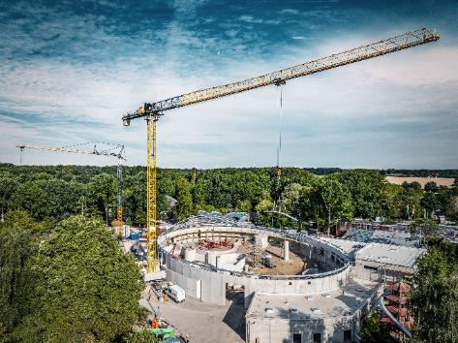
liebherr-172-ecb-hueffermann-muenster-01.jpg
A Liebherr 172 EC-B 8 helped build the new tropical enclosure at the Allwetterzoo in Münster.
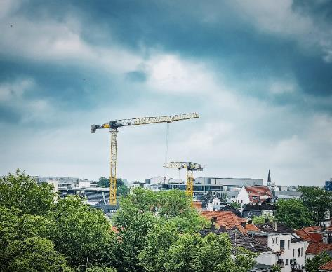
liebherr-172-ecb-hueffermann-oldenburg-02.jpg
A 172 EC-B 8 and a 125 EC-B 6 from Hüffermann’s crane fleet were used in Oldenburg for the construction of a residential and commercial building. Image: Hüffermann

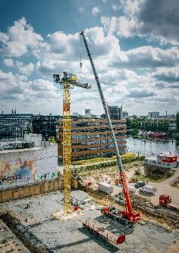
liebherr-172-ecb-hueffermann-bremen-03.jpg
In Bremen, a 172 EC-B 8 was assembled for the construction of an office building with the help of an LTM 1120.

Contact
Daniel Haefele
Global Communication
Phone: +49 7351 / 41 - 2330
Email: daniel.haefele@liebherr.com
Published by
Liebherr-Werk Biberach GmbH
Biberach / Germany
www.liebherr.com

