Press release

ONE-Dyas chooses LiMain remote maintenance

⸺
Oil and gas company ONE-Dyas orders new Ram Luffing Crane type RL 2600
The new offshore crane will operate on an unmanned platform and will be equipped with LiMain Module 4 for remote maintenance
Maintenance operations will be controlled from shore and reduce manned service calls significantly

The Dutch oil and gas company ONE-Dyas is the first customer to purchase a Liebherr offshore crane, type RL 2600, in combination with the recently launched service concept Liebherr Intelligent Maintenance, LiMain for short. It’s a fully digital, remote, and semi-automatic maintenance system that saves the platform operator significant investment and resources. Thanks to LiMain remote maintenance, ONE-Dyas can remotely maintain the crane on the unmanned platform.

Rostock (Germany), February 2023 – The Dutch company ONE-Dyas will install the first electrified gas production platform in the North Sea, which will run entirely on offshore wind power. The N05-A project is part of the so-called GEMS area, an area approximately 20 to 80 kilometres north of the Ems estuary. The N05-A platform will run entirely on renewable energy from the nearby Riffgat Offshore Wind Farm, which reduces the emissions to near zero. This project makes an active contribution to the energy transition and to achieving the EU goals of the climate Agreement, in a safe and responsible manner. It increases the security of the local supply of energy and contributes to the local economy.
ONE-Dyas will build a gas production platform, which will be equipped with a latest-generation Liebherr Ram Luffing Offshore Crane RL 2600. For the customer ONE-Days it was essential that the maintenance intervals of the crane did not negatively affect the maintenance concept of the platform. To avoid additional manned days, ONE-Dyas opted for Liebherr and the innovative service concept Liebherr Intelligent Maintenance, in short LiMain.
Minimise maintenance effort
Michel Mens, Lead Engineer E/I and Rotating Equipment at ONE-Dyas, explains: “We have made a strategic decision to purchase the RL 2600 in combination with LiMain’s innovative remote maintenance concept. Our aim is to minimise the maintenance effort significantly, but at the same time to ensure a service life of the crane of more than 20 years. With LiMain’s Module 4, Liebherr offers a solution that is unique on the market and precisely tailored to our crane, the RL 2600. The ability to operate the crane remotely helps to monitor the crane’s performance and prevents unforeseen issues during the maintenance visits.”
Liebherr Intelligent Maintenance
With LiMain, maintenance can be carried out remotely, from land. Manned service visits on site at the crane can thus be reduced to a minimum. This way of performing service with LiMain is contemporary because it reduces costs, protects the environment by significantly reducing travel expenses, and at the same time ensures a long and sustainable use of the unit. Maintenance independent of time and place is possible. Platform operators can choose from various modules and so determine the degree of autonomy and scope of intelligent maintenance for the crane. After delivery and assembly, the platform operator can subsequently monitor and maintain the entire offshore crane fleet from the office.
“The cooperation with ONE-Dyas so far has been highly professional and we look forward to a future partnership. The customer has recognised the tremendous benefits that LiMain offers platform operators in reducing operational costs. In addition, with its low height and small footprint, the ordered RL 2600 is the ideal crane for such platforms,” says Stefan Schneider, Global Application Manager General Purpose Offshore Cranes.
The latest generation of the RL 2600
The particularly weight-optimized and compact design is the characteristic feature of the RL series. On both fixed and floating offshore installations, especially in the wind power industry and in the oil and gas sector, RL cranes are mainly used for maintenance and supply work.
Based on customer feedback, Liebherr optimised the RL to become the most compact maintenance crane. This results in a reduced construction height and a small tail radius. The elimination of a machinery house allows the crane to operate in confined space conditions and environments. Additionally, the crane can be ex-certified (ATEX and IECEx).

About Liebherr-MCCtec Rostock GmbH
Liebherr-MCCtec Rostock GmbH is one of the leading European manufacturers of maritime handling solutions. The product range includes ship, mobile harbour and offshore cranes. Reach stackers and components for container cranes are also included in the product portfolio.
About the Liebherr Group
The Liebherr Group is a family-run technology company with a broadly diversified product range. The company is one of the largest construction machinery manufacturers in the world. However, it also offers high-quality, user-oriented products and services in many other areas. Today, the group comprises more than 140 companies on all continents. In 2021, it employed more than 49,000 people and generated a total consolidated turnover of over 11.6 billion euros. Liebherr was founded in 1949 in Kirchdorf an der Iller in southern Germany. Since then, the employees have pursued the goal of convincing their customers with sophisticated solutions and contributing to technological progress.
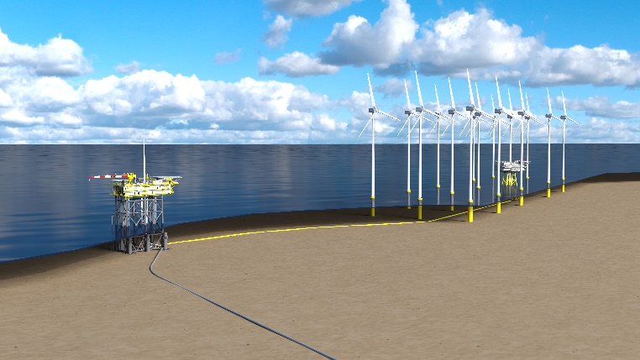
Images
liebherr-one-dyas-limain-rl-offshore-1.jpg
Artist impression of platform N05-A and the connection to windfarm Riffgat.
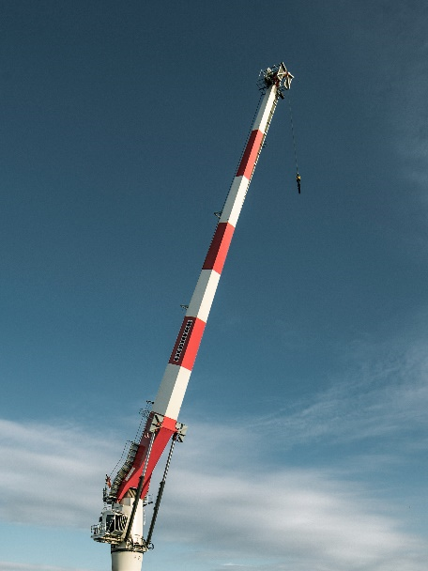
liebherr-one-dyas-limain-rl-offshore-2.jpg
The Dutch oil and gas company ONE-Dyas is the first customer to purchase a Liebherr offshore crane, type RL 2600, in combination with the innovative service concept Liebherr Intelligent Maintenance, LiMain, which enables remote maintenance of the crane on an unmanned platform.

Contact
Philipp Helberg
Tel: +49 381 6006 5024
Email: Philipp.helberg@liebherr.com

Published by
Liebherr-MCCtec Rostock GmbH
Rostock / Germany
www.liebherr.com

