Press release
Liebherr automates disassembly of battery packs

⸺
In 2030, the batteries of an estimated four million electric vehicles will reach the end of their useful life. The lithium-ion batteries contain valuable raw materials, and recycling them makes both ecological and economic sense. Up to now, however, the disassembly of the battery system has still been complex and expensive as the separation of the components is usually done manually. This is where Liebherr-Verzahntechnik GmbH comes in. The company is developing strategies and processes for the automated disassembly of battery packs and is a partner in the federal government-funded research project “ZIRKEL”, which investigates the entire circular economy of traction batteries.
Kempten (Germany), 02. March 2023 – Lithium-ion vehicle batteries are taken out of circulation once their total capacitance has reached about 70-80% of their original capacitance (state-of-health). The majority of these batteries are recycled and the raw materials are returned to the material cycle for the production of new batteries. Depending on their condition, a small proportion of the old batteries are reused in battery-electric vehicles (remanufacturing) or in second-life applications such as stationary battery storage systems. When they have finally reached the end of their useful life, the new EU Battery Regulation stipulates recycling quotas and minimum quantities of reused raw materials in new production. The industry must find the most efficient solutions possible for returning them to the material cycle, especially since the volumes of batteries returned will increase significantly in the future. The aim is to achieve a sustainable, CO₂-neutral battery production along the entire process chain with unlimited reuse of materials in a closed product life cycle. This is intended to minimize waste products and dependence on important primary materials.

High recycling rates through automation
Due to the relatively low quantities and large number of variants of diverse manufacturers and product generations, many disassembly and remanufacturing processes still take place manually today. “We are almost talking here about a batch size of 1 in the return flow of battery packs,” explains Jan Pollmann, development engineer for automation systems at Liebherr. In order to achieve a high recycling rate and to be able to process the increasing return volumes economically, it is necessary to automate the processes. Another aspect is occupational health and safety: automated disassembly ensures the health and safety of employees and excludes their exposure to high voltage, hazardous substances or fire risks.

Liebherr develops automated disassembly processes for battery packs
The “ZIRKEL” research project, funded by the German Federal Ministry of Education and Research (BMBF), involves an interdisciplinary consortium from research and industry to investigate the entire recycling management of batteries. As part of this project, Liebherr is developing strategies and processes for the automated disassembly of battery packs. The aim is to recover and recycle the highest possible proportion of raw materials by mechanically disassembling and sorting the components. By removing valuable components or those containing pollutants at an early stage, the cost- and energy-intensive pyro- and hydrometallurgical processing of the so-called black mass, i.e. the raw material mixture that remains after the batteries have been shredded, is reduced.

Automation challenges
In addition to the variety of batteries, a number of other challenges exist for an automated disassembly process: used batteries can be corroded, deformed or damaged. Contaminated components are sometimes difficult for vision systems to detect. Sealants, adhesives or heat-conducting pastes change their consistency and properties over time and may be difficult to remove. Risks such as high-voltage or hazardous substances must be taken into account. And finally, the disassembly of flexible parts such as cables or cooling hoses is difficult to automate. “In principle, the established assembly process runs backwards here, but it is many times more complex,” explains Viktor Bayrhof, Product Manager for Automation Systems at Liebherr.

Pilot plant for the “ZIRKEL” joint project
Liebherr's first pilot plant will be installed at the Open Hybrid LabFactory research campus in Wolfsburg in July 2023. Liebherr will continue to support the project there and carry out further test series. The results will be incorporated into a planned industry guideline for recyclable battery product design. “We are pleased to be able to contribute our process expertise in the field of automation to this future-oriented project,” explains Jan Pollmann.

About the Liebherr Group
The Liebherr Group is a family-run technology company with a highly diversified product portfolio. The company is one of the largest construction equipment manufacturers in the world. It also provides high-quality and user-oriented products and services in a wide range of other areas. The Liebherr Group includes over 140 companies across all continents. In 2021, it employed more than 49,000 staff and achieved combined revenues of over 11.6 billion euros. Liebherr was founded in Kirchdorf an der Iller in Southern Germany in 1949. Since then, the employees have been pursuing the goal of achieving continuous technological innovation, and bringing industry-leading solutions to its customers.

Images
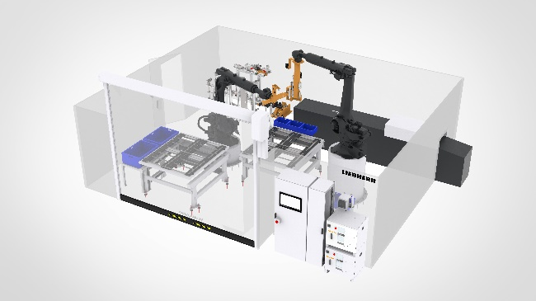

liebherr-layout-1.jpg
Pilot plant for the "ZIRKEL" joint project at the OHLF research campus in Wolfsburg

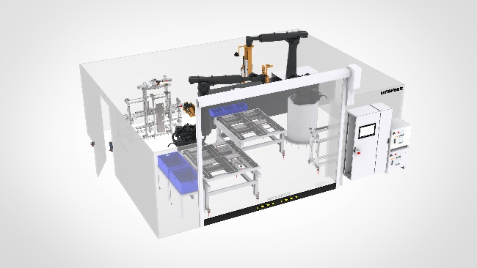

liebherr-layout-2.jpg
Pilot plant for the "ZIRKEL" joint project at the OHLF research campus in Wolfsburg

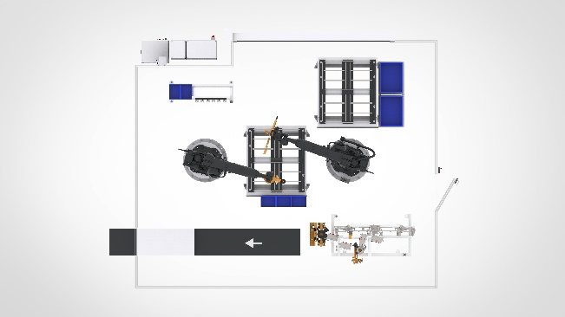

liebherr-layout-3.jpg
Pilot plant for the "ZIRKEL" joint project at the OHLF research campus in Wolfsburg

Contact
Thomas Weber
Head of Marketing
Telefon: +49 (831) 786 3285
E-Mail: thomas.weber@liebherr.com
Published by
Liebherr-Verzahntechnik GmbH
Kempten/Deutschland
www.liebherr.com

