Press release

The Liebherr R 945 G8 wows customer in New Caledonia

⸺
The R 945 sets the standard on performance and safety
Perfectly meets this customer’s special requirements with its great flexibility and versatility
The solid reputation of the Liebherr brand was a key factor in the purchase decision
Our New Caledonian customer YADAMWA chose the powerful R 945 crawler excavator, which is perfectly suited to particularly demanding open cast mining work. The company is a subcontractor for SLN (“Société Le Nickel”), the world’s largest producer of ferronickel, and uses the Liebherr tracked excavator primarily for the extraction of metal ores such as iron and nickel.
Colmar (France), 02 March 2023 - In 2022, YADAMWA, a mining contractor based in New Caledonia, the South Pacific island group belonging to France, has purchased its first Liebherr machine. The first R 945 excavator has now been followed by an additional order for other Liebherr machines.
Maximum performance and safety in extraction
The working environment of a mining site is particularly demanding. The R 945 belongs to the generation 8 of Liebherr crawler excavators. The powerful 220 kW motor and automatic power adjustment make it a high-performance machine equally at home on all types of ground.
The glazed operator’s cab of the R 945 offers a panoramic view of the working area, whatever the working situation. The windows are tinted to optimally protect the operator from the effects of temperature and glare. The cab has also been adapted to the standards in force on site. So, for example, a HEPA filtration system – mandatory on all mining sites in New Caledonia – has been installed to prevent asbestos particles from getting into the cab.
Follow-up orders placed by YADAMWA: our customer was convinced by the quality and reliability
Last year, our customer from New Caledonia purchased its first Liebherr machine for earthmoving at its open cast mine as well as for loading dump trucks, areas in which YADAMWA specialises. The R 945 has since been followed by two other Liebherr models. In addition, the customer opted to buy a used PR 724 bulldozer, which is operated by one of its subsidiaries. YADAMWA particularly appreciates the quality and reliability of Liebherr machines, which set them apart from the competition.

About Liebherr-France SAS
Liebherr-France SAS, based in Colmar, has been responsible for development and production of Liebherr Group crawler excavators since 1961. Its current product range includes around 30 excavator models, from the R 914 Compact to the R 980 SME, designed for earthmoving and rock quarrying. The range also includes a whole series of special attachments for specific tasks such as demolition work, transport of materials, work on bridges or in tunnels as well as electric excavators. With their operating weight of 14 to 100 tonnes, the crawler excavators are equipped with Liebherr engines with power ratings from 90 to 420 kW. Liebherr-France SAS has more than 1,400 employees and generates annual sales of EUR 692 million.
About the Liebherr Group
The Liebherr Group is a family-run technology company with a highly diversified product portfolio. The company is one of the largest construction equipment manufacturers in the world. It also provides high-quality and user-oriented products and services in a wide range of other areas. The Liebherr Group includes over 140 companies across all continents. In 2021, it employed more than 49,000 staff and achieved combined revenues of over 11.6 billion euros. Liebherr was founded in Kirchdorf an der Iller in Southern Germany in 1949. Since then, the employees have been pursuing the goal of achieving continuous technological innovation, and bringing industry-leading solutions to its customers.
Images
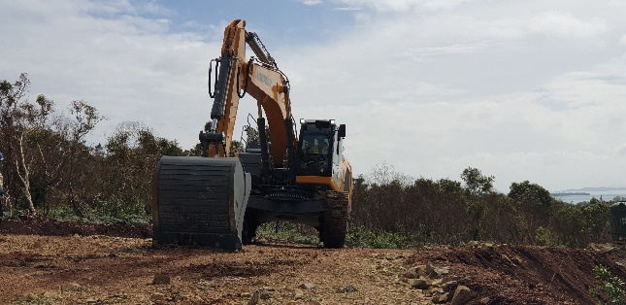
liebherr-excavator-r945-yadamwa-1.jpg
A robust machine at home on all terrains.

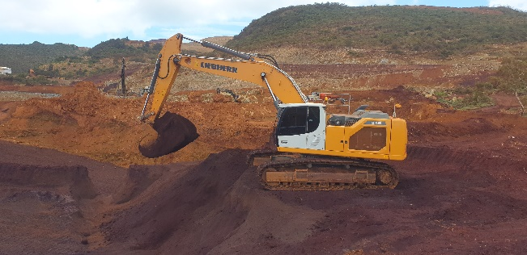
liebherr-excavator-r945-yadamwa-2.jpg
The R 945 is perfectly suited to mining operations and meets all of our customer’s requirements.
Contact
Alban Villaumé
Service Marketing & Communication
Telephone: +3 33 89 21 36 09
Email: alban.villaume@liebherr.com

Published by
Liebherr-France SAS
Colmar, France
www.liebherr.com

