Press release

Nine new Liebherr cranes for the next Wiesbauer generation

⸺⸺
- An LR 1700-1.0 is the first of nine new Liebherr cranes in the Wiesbauer fleet
- Wiesbauer remains convinced by Liebherr's service and quality
- Family business managed jointly by its third and fourth generation
Wiesbauer GmbH & Co.KG has added a Liebherr LR 1700-1.0 to its crawler crane fleet. At the end of December, the new 700-tonner was able to prove itself in its first operation in Marbach am Neckar. At the same time, the company based in Bietigheim-Bissingen has ordered eight mobile cranes with lifting capacities from 70 to 650 tonnes from Liebherr in order to rejuvenate and, in some cases, expand its fleet.
Ehingen (Donau) (Germany), 1 March 2023 – "As we already have a 650-tonne and a 1,000-tonne crawler crane in our fleet, the LR 1700-1.0 is the ideal addition to the mid-range of our crawler crane portfolio," explains Marco Wilhelm, authorised signatory and head of technology at Wiesbauer.
Wiesbauer has procured the LR 1700-1.0 for the assembly of wind turbines as well as for use in infrastructure and industrial projects. "We see this crane class and this type of crane as very future-oriented in terms of lifting capacity and innovative boom systems. We are also impressed by the clever design features that are standard with a Liebherr," adds Marco Wilhelm.
During the first operation, Wiesbauer used the new LR 1700-1.0 with its innovative derrick system. The V-frame ballasting system is a hydraulically adjustable folding frame which enables the ballast radius of the LR 1700-1.0 to be infinitely adjusted between 13 and 21 metres. A rigid ballast guide is thus no longer required for large radii. For the construction of an electrical power plant in Marbach am Neckar, the LR 1700-1.0 lifted a 230-tonne transformer off a ship. "We were very satisfied with the performance of the new LR 1700-1.0 during this first job," explains Jochen Wiesbauer, who planned this crawler crane operation.
The company has enjoyed a good partnership with Liebherr for decades. Florian Wiesbauer: "Together with Liebherr, we create goal-oriented solutions time and again. We believe in the quality and reliability of their cranes."
At the end of December, Wiesbauer ordered further cranes from Liebherr: two LTM 1070-4.2's, two LTM 1090-4.2's, two LTF 1060-4.1's, one LTM 1300-6.3 and one LTM 1650-8.1. They will rejuvenate Wiesbauer's fleet and in some cases also expand it. "Through these new purchases and when making our purchasing decision, we placed great emphasis on the fact that all the counterweight plates on the smaller cranes and the booms on the larger cranes can be easily and quickly dismantled in order to achieve lighter driving conditions for the cranes, as the topic of vehicle weight, axle load and driving permits is becoming increasingly controversial throughout Germany," explains the Wiesbauer team.
Management by the 4th generation: the crane family sticks together
Following the sudden, tragic death of Thomas Wiesbauer in April of last year, the Wiesbauer family business is now under the joint stewardship of its third and fourth generations. In Sissy and Florian Wiesbauer, the fourth generation of the family has taken over the operational management side and works closely with Sabine and Jochen Wiesbauer. With around 90 cranes and a workforce of 180, Wiesbauer GmbH & Co.KG is a major provider of crane and heavy haulage logistics services based in southern Germany.
Florian Wiesbauer: "We already initiated the handover to the new generation two years ago. However, the death of our father has accelerated our repositioning. We are glad that, as a strong crane family, our team can master the current challenges." Florian has already been working on the operational side of the business for five years. Sissy moved to Wiesbauer in July after gaining experience externally as a manager at another company. The great-grandchildren of the company founder Franz Wiesbauer want to provide new impetus and focus first and foremost on the topics of sustainability and digitalisation. "We aim to counteract the shortage of skilled workers through modern approaches. We are also analysing our product range and will make necessary adjustments. We are open to new ideas," says Sissy Wiesbauer.
About Liebherr-Werk Ehingen GmbH
Liebherr-Werk Ehingen GmbH is a leading manufacturer of mobile and crawler cranes. Its range of mobile cranes extends from 2-axle 35 tonne cranes to heavy duty cranes with a lifting capacity of 1200 tonnes and a 9-axle chassis. Its lattice boom cranes on mobile or crawler crane chassis deliver lifting capacities of up to 3000 tonnes. With universal boom systems and extensive additional equipment, they can be seen in action on construction sites throughout the world. The Ehingen site has a workforce of 3,800. Extensive, global service guarantees the high availability of Liebherr mobile and crawler cranes. In 2021, the Liebherr plant in Ehingen recorded a turnover of 2.33 billion euros.
About the Liebherr Group
The Liebherr Group is a family-run technology company with a highly diversified product portfolio. The company is one of the largest construction equipment manufacturers in the world. It also provides high-quality and user-oriented products and services in a wide range of other areas. The Liebherr Group includes over 140 companies across all continents. In 2021, it employed more than 49,000 staff and achieved combined revenues of over 11.6 billion euros. Liebherr was founded in Kirchdorf an der Iller in Southern Germany in 1949. Since then, the employees have been pursuing the goal of achieving continuous technological innovation, and bringing industry-leading solutions to its customers.

Images
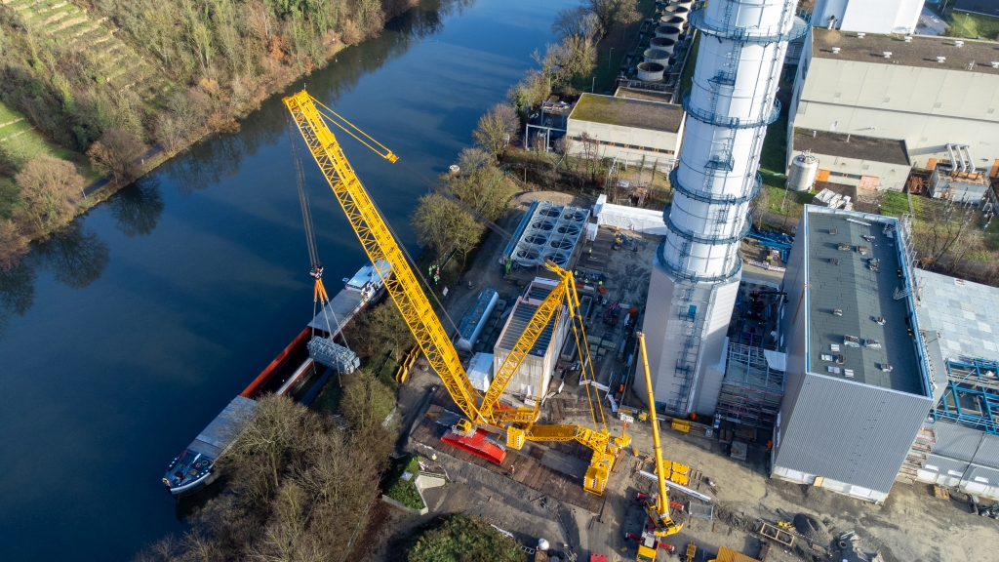
liebherr-lr1700-1-0-wiesbauer-01.jpg
During its first deployment, Wiesbauer's new LR 1700-1.0 lifted a 230-tonne transformer off a ship in Marbach am Neckar.

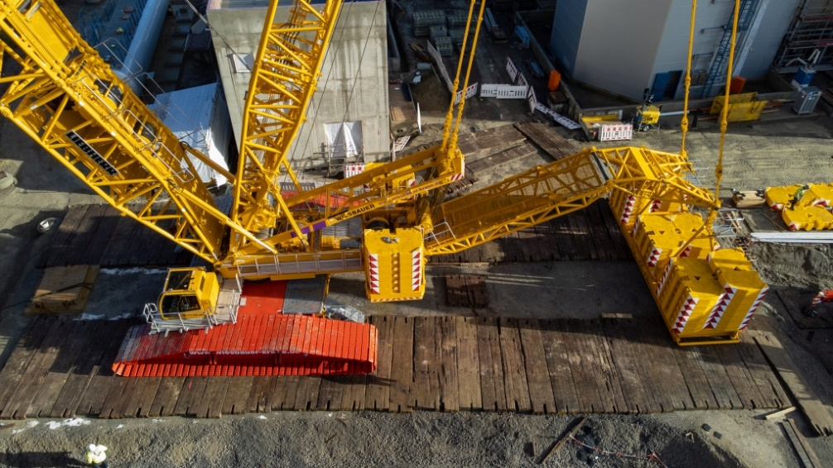
liebherr-lr1700-1-0-wiesbauer-02.jpg
The hydraulically adjustable V-Frame folding frame allows the ballast radius of the LR 1700-1.0 to be freely adjusted between 13 and 21 metres.

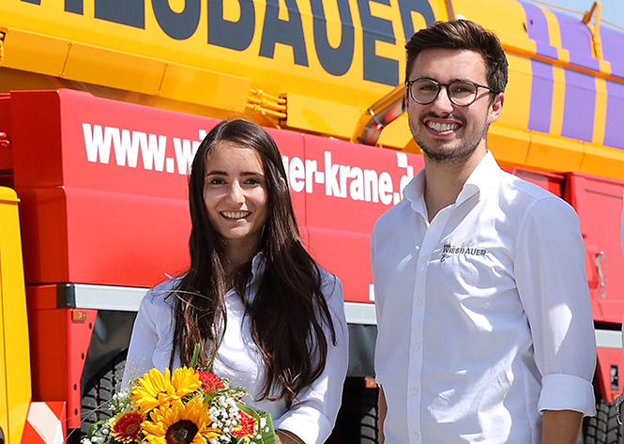
sissy-florian-wiesbauer.jpg
Sissy and Florian Wiesbauer represent the fourth generation of Wiesbauers to run the family business.

Contact
Wolfgang Beringer
Marketing and Communication
Phone: +49 7391/502 - 3663
Email: wolfgang.beringer@liebherr.com
Published by
Liebherr-Werk Ehingen GmbH
Ehingen (Donau), Germany
www.liebherr.com

