Press release

Liebherr receives major order including new flagship for MSG Krandienst

⸺
MSG purchases 13 Liebherr mobile cranes
The LTM 1750-9.1 becomes the customer's new flagship
Technology, design, value retention as well as uniform controls across all cranes were important factors behind the purchase decision
The crane company MSG Krandienst GmbH based in southern Germany has purchased 13 new mobile cranes from Liebherr. This major order also includes an 800-tonne LTM 1750-9.1 that will become MSG's new flagship. In addition to technical considerations, Liebherr's aftersales service and the long-term value retention of its cranes, Liebherr's universal control system, which is the same for all cranes, was a key factor in MSG's purchasing decision.
Ehingen (Donau) (Germany), 1st March 2023 – The major order placed by MSG Krandienst GmbH includes five LTM 1060-3.1 cranes, four LTM 1090-4.2, two LTM 1230-5.1, one LTC 1050-3.1 and one LTM 1750-9.1. Besides other criteria, the existence of a uniform crane control system across all models convinced MSG to choose Liebherr. "Above all, we wanted to standardise our 3- and 4-axle crane class. For our drivers, switching between Liebherr cranes is much easier because they all have the same control system. We can also create significant synergies in the workshop," explains Bjoern Jatz, Managing Director of MSG. The new cranes will partly replace MSG's older 3-axle models. In total, MSG is increasing its crane fleet to 50 machines, which are mainly used in industrial, plant, steel and commercial construction, as well as in precast concrete and petrochemical assembly.
LTM 1750-9.1 – the new flagship for MSG
As the largest and most powerful mobile crane in this large order, the LTM 1750-9.1 will become MSG's new flagship. "Future markets in infrastructure, bridge construction and renewable energy will come into focus and offer a lot of potential. That's why we decided to purchase a new crane for these areas, the LTM 1750-9.1. It will perfectly complement our existing heavy cranes, which include the LTM 1450-8.1 and LTM 1650-8.1." The 9-axle crane can carry the complete telescopic boom on public roads with a 12-tonne axle load. In addition, thanks to the removable boom, it can be unloaded to achieve an axle load of less than 10 tonnes, which offers advantages in terms of driving permits. "The LTM 1750-9.1 is the most powerful crane in its class and the 800-tonne upgrade makes it even more capable," says Jatz. "The machine is technically state-of-the-art and prepares us very well for the future."

Many reasons to choose Liebherr
High quality products, efficient order processing and a reliable, responsive aftersales service are key criteria for MSG. In addition to the uniform control system, Jatz cites other factors in his decision to work with Liebherr: "The VarioBase® and VarioBallast® technology, the machine design and the excellent value of the Liebherr cranes convinced us."
About MSG Krandienst GmbH
MSG Krandienst GmbH was founded in 1993 and currently employs around 120 people. MSG has long been broadly positioned in the small to medium crane class from 40 to 200 tonnes. In recent years, the company has also steadily expanded its fleet to include heavy-duty machines – up to and including the new Liebherr 800-tonner. The company, which operates two locations in Baden and one in Alsace, works across borders in Germany and France.

About Liebherr-Werk Ehingen GmbH
Liebherr-Werk Ehingen GmbH is a leading manufacturer of mobile and crawler cranes. Its range of mobile cranes extends from 2-axle 35 tonne cranes to heavy duty cranes with a lifting capacity of 1200 tonnes and a 9-axle chassis. Its lattice boom cranes on mobile or crawler crane chassis deliver lifting capacities of up to 3000 tonnes. With universal boom systems and extensive additional equipment, they can be seen in action on construction sites throughout the world. The Ehingen site has a workforce of 3,800. Extensive, global service guarantees the high availability of Liebherr mobile and crawler cranes. In 2021, the Liebherr plant in Ehingen recorded a turnover of 2.33 billion euros.
About the Liebherr Group

The Liebherr Group is a family-run technology company with a highly diversified product portfolio. The company is one of the largest construction equipment manufacturers in the world. It also provides high-quality and user-oriented products and services in a wide range of other areas. The Liebherr Group includes over 140 companies across all continents. In 2021, it employed more than 49,000 staff and achieved combined revenues of over 11.6 billion euros. Liebherr was founded in Kirchdorf an der Iller in Southern Germany in 1949. Since then, the employees have been pursuing the goal of achieving continuous technological innovation, and bringing industry-leading solutions to its customers.

Image
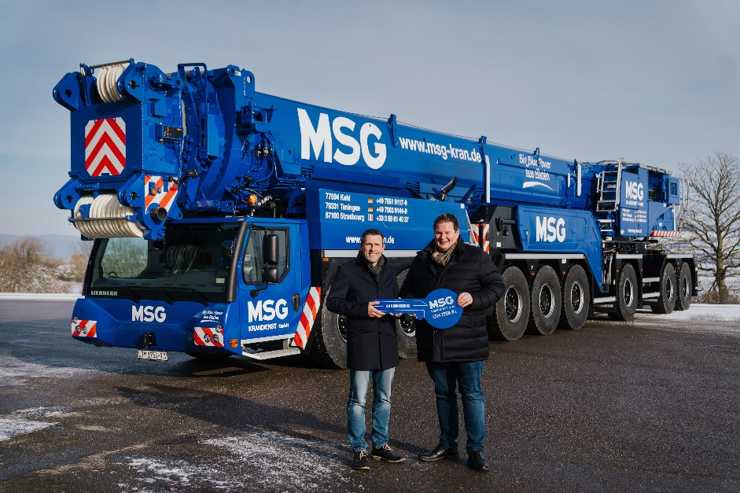
lwe-ltm-1750-9-1-handover-msg.jpg
Handover of the new flagship crane in the MSG fleet: Joachim Sommer (Liebherr-Werk Ehingen GmbH, left) hands over the symbolic key of the LTM 1750-9.1 to Bjoern Jatz (MSG Krandienst GmbH).
Contact
Wolfgang Beringer
Marketing and Communication
Phone: +49 7391/502 - 3663
Email: wolfgang.beringer@liebherr.com
Published by
Liebherr-Werk Ehingen GmbH
Ehingen (Donau) / Germany
www.liebherr.com

