Press release

First Liebherr LTM 1450-8.1 mobile crane in Serbia

⸺⸺
- RT-trans d.o.o. is the first Serbian company to receive an LTM 1450-8.1
- LTM 1450-8.1: high mobility worldwide, short set-up time and large load capacity
- Uniform operating concept, high safety and fast service swung the decision in favour of Liebherr
The first LTM 1450-8.1 in Serbia has been handed over to the crane and heavy haulage company RT-trans d.o.o. This powerful 8-axle crane with a long telescopic boom offers excellent mobility worldwide. For RT-trans, the uniform operating concept of Liebherr cranes, their safety features and the company's good working relationship with its local Liebherr sales and service partner were key factors behind its decision.
Ehingen (Donau) (Germany), 24 February 2023 – RT-trans d.o.o. is the first Serbian company to receive an LTM 1450-8.1 – the 450-tonne machine will expand its crane fleet. "Our volume of work and customer enquiries regarding this crane capacity have increased," explains company founder Rajko Tadic. "This crane is a good fit for our fleet as it offers additional benefits for us and our regular customers."
Powerful 8-axle crane with worldwide economical mobility
The LTM 1450-8.1 has been designed to ensure cost-effective mobility worldwide and fast, easy set-up on the construction site. Its powerful 7-section telescopic boom offers a maximum length of 85 metres. In addition, this large fast-erecting crane can travel on public roads with an axle load of 12 tonnes and a weight of 96 tonnes with the complete boom, all outriggers and the hoist winch.
For reduced axle loads and overall weights, crane components such as jib sections and outriggers can be removed quickly and easily. Dusko Tadic, Rajko Tadic's son and co-owner of RT-trans, says: "A very important feature of the LTM 1450-8.1 is that it can easily be brought down to a transport weight of under 72 tonnes. This will significantly reduce the cost of permits for oversized transports. It doesn't even require an auxiliary crane for assembly and disassembly."
Uniform operating concept and Liebherr service convince
In addition to the LTM 1450-8.1, RT-trans purchased an LTM 1050-3.1 and an LTM 1060-3.1 last year. "The uniform operating concept of Liebherr cranes, the positive feedback from our crane operators, the safety features and, above all, the cooperation with Liebherr sales and service partner DS Inženjering, who have supported us with excellent service for many years, all influenced our decision to choose Liebherr cranes," explains Dusko Tadic.
"It's important for us that the service team responds quickly so there are no interruptions and delays to our work. With the purchase of the new Liebherr crane, we have improved the most important aspect of our business, namely safety," adds Dusko Tadic. The new crane's main tasks at RT-trans will be in the areas of refinery and port handling, bridge construction and other current projects in Serbia.
A Liebherr mobile crane for the 30th anniversary
The family-owned company RT-trans d.o.o. based in Beograd, Serbia, was founded three decades ago and now has around 50 employees. "After 30 years of work, it was one of our birthday wishes that our company would treat itself to a gift like this," says Rajko Tadic, who is delighted with the purchase of the LTM 1450-8.1. The company's current fleet consists of 26 cranes with load bearing capacities from 35 to 450 tonnes. Twenty-two of these cranes were manufactured by Liebherr. The Serbian company offers a complete service in the field of crane rental and heavy transport. Its other main activities include the design, manufacture and use of special tools for lifting loads. RT-trans is mainly active in the construction of bridges, moving machines, formation factory lines and concrete and steel structures.

About Liebherr-Werk Ehingen GmbH
Liebherr-Werk Ehingen GmbH is a leading manufacturer of mobile and crawler cranes. Its range of mobile cranes extends from 2-axle 35 tonne cranes to heavy duty cranes with a lifting capacity of 1200 tonnes and a 9-axle chassis. Its lattice boom cranes on mobile or crawler crane chassis deliver lifting capacities of up to 3000 tonnes. With universal boom systems and extensive additional equipment, they can be seen in action on construction sites throughout the world. The Ehingen site has a workforce of 3,800. Extensive, global service guarantees the high availability of Liebherr mobile and crawler cranes. In 2021, the Liebherr plant in Ehingen recorded a turnover of 2.33 billion euros.
About the Liebherr Group
The Liebherr Group is a family-run technology company with a highly diversified product portfolio. The company is one of the largest construction equipment manufacturers in the world. It also provides high-quality and user-oriented products and services in a wide range of other areas. The Liebherr Group includes over 140 companies across all continents. In 2021, it employed more than 49,000 staff and achieved combined revenues of over 11.6 billion euros. Liebherr was founded in Kirchdorf an der Iller in Southern Germany in 1949. Since then, the employees have been pursuing the goal of achieving continuous technological innovation, and bringing industry-leading solutions to its customers.

Image
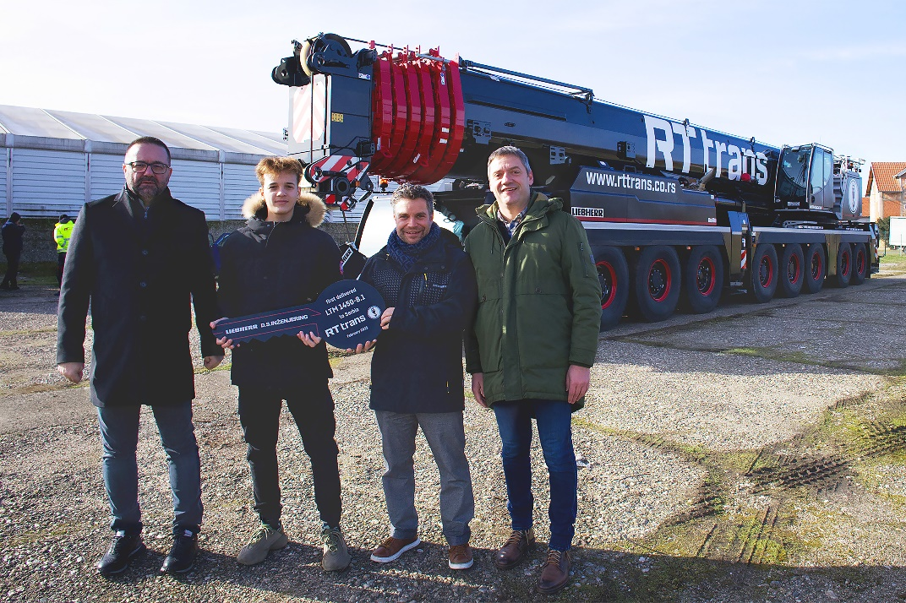
liebherr-ltm1450-8-1-handover-rt-trans.jpg
Handover of the LTM 1450-8.1 crane to RT-trans (from left to right): Dusko Tadic with his son Matija Tadic (both RT-trans), Thomas Fiesel (Liebherr-Werk Ehingen GmbH) and Nikola Savkovic (D.S. Inzenjering).

Contact
Wolfgang Beringer
Marketing and Communication
Phone: +49 7391 / 502 - 3663
Email: wolfgang.beringer@liebherr.com
Published by
Liebherr-Werk Ehingen GmbH
Ehingen (Donau), Germany
www.liebherr.com

